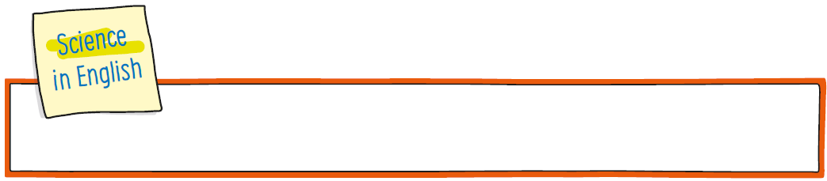
CLIL worksheet
Unit 1 The bodies of animals

Name: ______________________________________________________________ Class: 5 _____


- Stop and think .
What do animals look like?
One way of characterising an animal is its body symmetry.
Animals can have three different types of a body plan symmetry:
- radial symmetry
- bilateral symmetry
- asymmetry
Radial symmetry
These animals don’t have a left or right side. They have only got a top or bottom side.
They are usually marine organisms like jellyfish and corals.
Bilateral symmetry
Most animals have bilateral symmetry. This means that there is a line dividing their
bodies into two sides like a mirror image: the left and right side with a head, a tail and
a top and bottom (a butterfly, a crab or a human).
Note: An animal’s body symmetry can change as it grows. Sea stars larvae are bilaterally symmetrical but as adults they
are radially symmetrical.
The only animals that have an asymmetrical body plan are sponges.

- Look and draw a line.
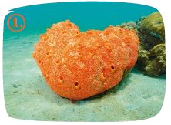 | 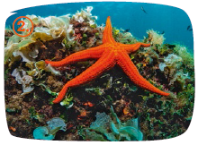 | 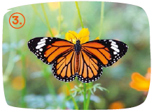
a. Radial symmetry | b. Bilateral symmetry | c. Asymmetry

- Read and write the type of symmetry.
- A lion has got ______________________________________________________________.
- Jellyfish and sea cucumbers have got ___________________________________________.
- All sponges are ____________________________________________________________.


CLIL worksheet
Unit 2 The five kingdoms of life on Earth

Nome: ______________________________________________________________ Class: 5 _____

- Stop and think .
What different types of organisms are there?
The microscope is an important tool for scientists. It allows them to discover new organisms. Thanks to the microscope, today we know that there are five different
kingdoms of organisms:
Look and discover how they are different.
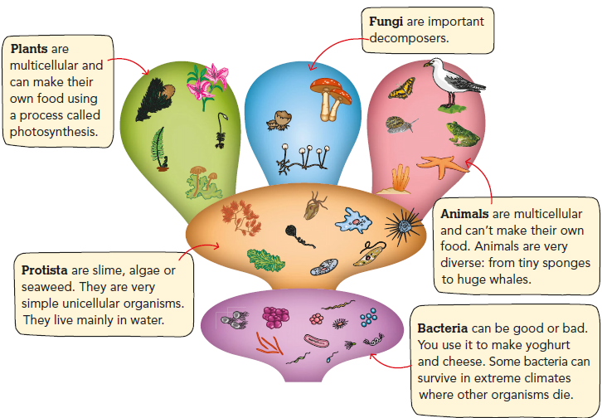
Read and write Yes or No.
  - There are five kingdoms of living organisms. ________________
  - Plants are single cell organisms. ________________
  - Animals are multicellular. ________________
  - Bacteria is very sensitive. ________________
  - Protista can live in ponds and rivers. ________________


CLIL worksheet
Unit 3 Animal diets

Nome: ______________________________________________________________ Class: 5 _____

- Stop and think .
What do different animals eat?

Animals can be carnivores, herbivores or omnivores depending on what they eat.
Food helps them grow, move, reproduce and maintain their body temperature. Some
physical characteristics are related to their different types of diets.

Carnivores
Animals like lions, eagles and some sharks mainly eat other animals. Frogs eat insects
so they are insectivores. The kingfisher eats fish and is called a piscivore. Vultures eat
carcasses and are called scavengers.

Herbivores
Animals like cows, sheep and deer are herbivores. They only eat plants. Squirrels eat
fruits and nuts and are called frugivores. Chickens are called granivores because they
eat grain like corn.

Omnivores
Animals like bears are omnivores. They eat plants and other animals. They have got a
varied diet.

- Look and identify the animals as carnivores, herbivores, granivores, frugivores, piscivores or omnivores. Then, write .

tiger | bear | rabbit | chicken | snake
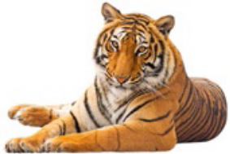 | 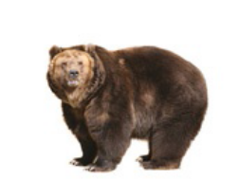 | 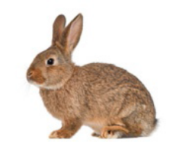 | 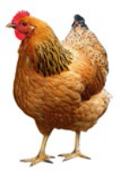 | 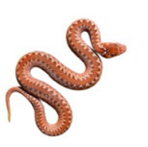
- ___________ | - __________ | - ___________ | - _________ | - _________
human | eagle | deer | squirrel | kingfisher
 | 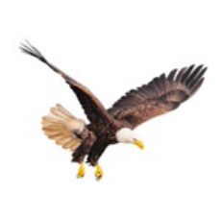 | 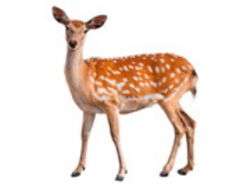 | 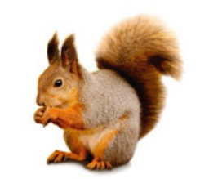 | 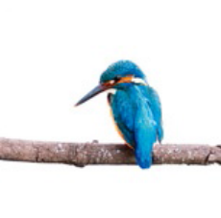
- ___________ | - __________ | - ___________ | - _________ | - _________


CLIL worksheet
Unit 4 Animal mating rituals

Nome: ______________________________________________________________ Class: 5 _____

- Stop and think .
Do all animals display and mate in the same way?
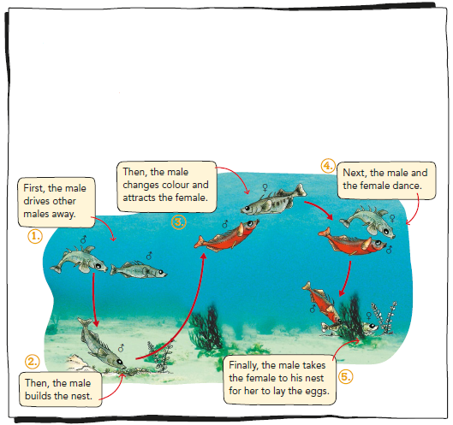
Animals display and have mating rituals to reproduce and have offspring every year.
Display rituals help males attract females to mate with them. Some males make
sounds to attract the females and some females emit odours to show the males that
they want to mate.
Mating rituals vary a lot among animals:
a. They can make sounds to attract the other animal.
b. They can emit smells to attract the other animal.
c. They can show colours and make special movements to attract the other animal.

- Look and write True (T) or False (F).

1. Display rituals are important for mating. ____________
2. One of the display rituals of males is to emit odours. ____________
3. All animals mate in the same way. ____________
4. There are three mating rituals. ____________
5. Fish show their colours and make special movements when they mate. ____________

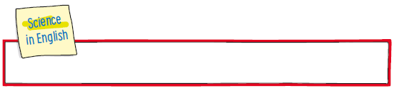
CLIL worksheet
Unit 5 Field trip around my school or area of residence

Name: ______________________________________________________________ Class: 5 _____

Organise a field trip around your school/area of residence and complete the following report.
Date: ____/____/____

- My school/area of residence is ________________:

a. in a rural area b. on the coast c. in an urban area d. in the interior

- The environment around my school and/or area of residence is:

a. aquatic b. terrestrial

- You can find the following rocks around my school and/or area of residence:

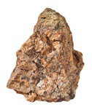 | 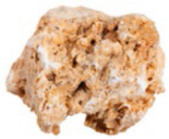 | 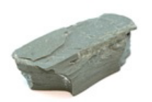 | 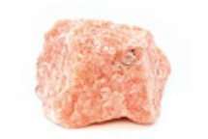 | 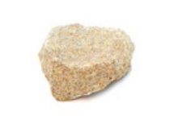 | 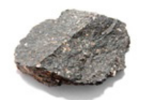
granite | limestone | slate | marble | sandstone | basalt

- In my school these objects are made of rocks:

the atrium |  | the bench(es)
the staircase(s) |  | the toilet(s)
the floor |  | others: _____________________________

- You can find… in my area of residence.

Name of place/area
high vegetation
undergrowth
shady areas
areas with lots of light

- You can find these living organisms in my school or area of residence:
___________________________________________________________________

