

CASA DA AULA
Name: ______________________________________
Class: _____ Number: _____ (_________________)
Date: ______________________________________
Teacher: __________________ Evaluation: ________________________________

English Test

A – Listen to the teacher and write their names. (Escuta a professora e escreve os seus nomes.)



1.1. ____ ____ ____ ____ 1.2. ____ ____ ____ ____ ____

B – Write the names of the school objects and colour them with the instructions of your teacher.
(Escreve os nomes dos objectos escolares e pinta-os de acordo com as instruções do teu professor)





_______________ _______________ _______________ _______________

C – Write the days of the week (follow the order) (Escreve os dias da semana – segue a ordem.)

Sunday ……………… Tuesday ………………

……………… Friday ………………


D – Write the correct greeting according to the picture. (Escreve a saudação correcta de acordo com a imagem)
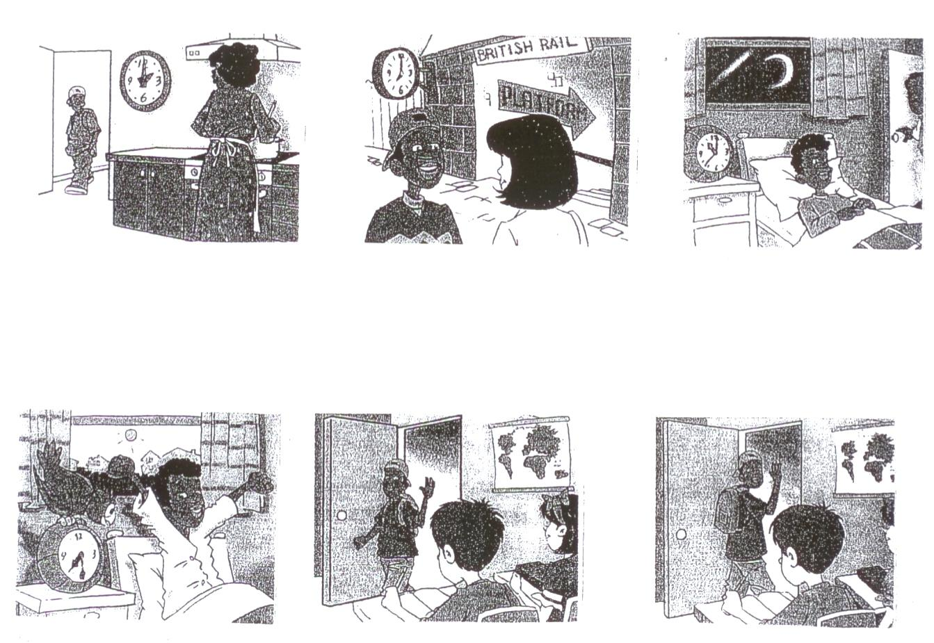

_____________________ _____________________ _____________________
_____________________ _____________________ _____________________

_____________________ _____________________ _____________________
_____________________ _____________________ _____________________

E – Write the numbers, in full, according to the order. (Escreve os números, por extenso, segundo a ordem.)

0 – ……………………. 7 – …………………….
1 – ……………………. 8 – …………………….
2 – ……………………. 9 – …………………….
3 – ……………………. 10 – …………………….
4 – ……………………. 11 – …………………….
5 – ……………………. 12 – …………………….

6 – …………………….

F – Answer to the question: (Responde à pergunta.)
______________________________________________________

What is your name?

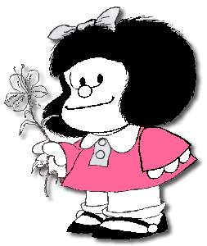

You

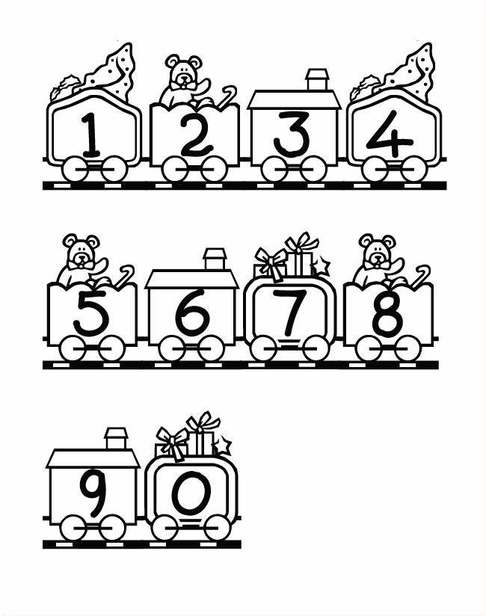
G – Paint according to the instructions. (Pinta de acordo com as instruções.)

1 is blue
5 is yellow
7 is black
9 is green
2 is orange
3 is red
8 is purple
4 is brown
6 is pink
0 is grey

