Name No. Class Date
Unit 1 10-minute test 1
A. Replace the underlined words by a personal pronoun.
1. Paul is eleven years old. .
2. Susan is a student. .
3. Mary and I are in the classroom. .
4. The dog is white. .
5. Robert and Sandra are very nice. .
B. Write the numbers in words.
1. 45 .  2. 12 .  3. 100 . | 4. 32 .  5. 58 .  6. 19 .

Name No. Class Date
Unit 1 10-minute test 2
A. Look at the information and complete the sentences.
 | Mary, 10  10/01 |  | 1. Her name is __________________________ She ______________ years old.  Her birthday is on ________________________________________________.

 | Daniel, 11  24/12 |  | 2. His ____________________________________. He __________ years old.  His birthday is on ________________________________________________.
B. Complete the sentences with the correct preposition of time: in, on.
1. My party is _____ Friday afternoon.
2. I like the park _____ the morning.
3. My garden is very nice _____ June.
4. The trees and the flowers are beautiful _____ the spring.
5. My birthday is ____ 11th June.
Name No. Class Date
Unit 1 10-minute test 3

A. Complete the sentences with the correct possessive determiners.
1. Sandra: What is _____________ surname, Alice?
Alice: _____________ surname is Smith.
2. They are teachers and _____________ school is in London.
3. We are twins and _____________ phone number is 020 2355 6540.
4. This is Anna. _____________ address is 35, Grove Street, Liverpool.
5. This is Thomas and _____________ surname is Russell.
B. Complete the sentences with the correct form of the verb to be.
1. How _____________ you? I _____________ fine, thanks.
2. The teacher _____________ (not) in the library. He _____________ in the classroom.
3. They _____________ (not) teachers. They _____________ students.
4. This _____________ the English teacher, Mrs Clark.
5. We _____________ (not) American. We _____________ Canadian.

A. Complete the sentences with the correct form of the verb to have got.
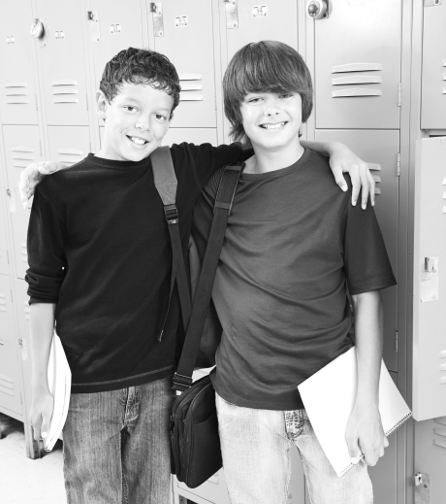
1. Helen: This is my friend, David. He ____________ blue eyes
Name No. Class Date
Unit 2 10-minute test 1
and he ____________ brown hair. He ___________ (not) a long nose.
2. __________________ you __________________ your dictionary?
No, I __________________.
3. We __________________ (not) our books.
4. My brother and I ___________ new schoolbags. They are fantastic.
B. Write the plural of the words.
1. boy | 2. child | 3. foot | 4. hero | 5. house | 6. nose
Name No. Class Date
Unit 2 10-minute test 2
A. Write correct sentences.
1. round / The / have / girls / got / glasses .
2. brown / My / are / eyes .
3. boy / is / He / funny / a .
4. wavy / got / not / I / hair / have .
5. very / is / John / not / tall .
B. Match the opposite adjectives.
1. noisy |  |  |  | a. handsome
2. lazy |  |  |  | b. rude
3. ugly |  |  |  | c. quiet
4. polite |  |  |  | d. hard-working

A. What are they? Write the names.
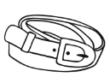 | 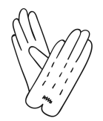 | 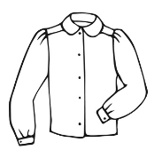 | 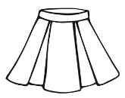 | 
1. _____________ | 2. ____________ | 3. _____________ | 4. ____________ | 6. _____________
B. Complete the sentences. Follow the example.
Name No. Class Date
Unit 2 10-minute test 3
1. Whose shoes are these? (James / shoes)
They are James’s shoes.__________________________________________________ .
2. Whose house is this? (grandparents / house)
It’s my__________________________________________________________________.
3. Whose hat is this? (Helen / hat)
It’s____________________________________________________________________ .
4. Whose uniforms are these? (men / uniforms)
They are the_____________________________________________________________.
Name No. Class Date
Unit 3 10-minute test 1
A. Name the parts of the house.
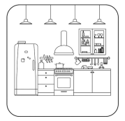 | 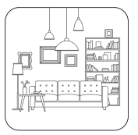 | 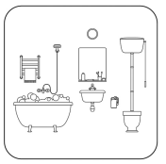 | 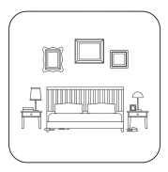
1. _________________ | 2. _________________ | 3. _________________ | 4. _________________
B. Complete the sentences with the correct form of the verb there to be.
1. _________________ flowers and trees in the garden.
2. How many bedrooms _________________ _________________?
3. _________________ (not) a garage.
4. _________________ a study upstairs.
Name No. Class Date
Unit 3 10-minute test 2
A. What are they? Write the names.
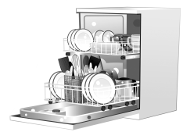 |  | 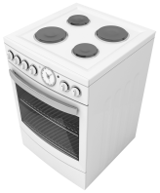 |  |  | 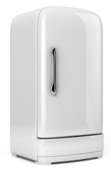
1. __________ | 2. __________ | 3. __________ | 4. __________ | 5. __________ | 6. __________
B. Complete the sentences with the correct preposition of place.
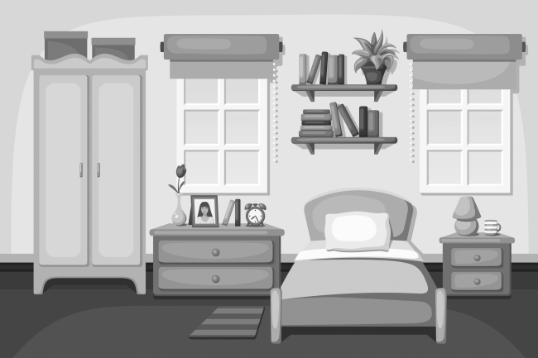
1. The bed is _____________ the bedside table
and the chest of drawers.
2. The lamp is ___________ the bedside table.
3. There is a wardrobe _____________ the
bedroom.
4. The rug is _______________ the bed.
Name No. Class Date
Unit 3 10-minute test 3
A. Circle the odd word out.
1. attic bath table washbasin chair
2. bedroom study basement sink garage
3. upstairs floor downstairs garden
4. armchair coffee table cooker sofa living room
5. sink table washbasin fridge cooker
B. Complete the sentences with a, an, the.
1. It’s ________ comfortable sofa.
2. Washington, DC is ________ capital of ________ United States of America.
3. It’s ________ armchair.
4. Look at ________ children in the garden!
5. This is ________ beautiful kitchen.

Name No. Class Date
Unit 4 10-minute test 1
A. Write in the negative form.
1. Sarah is doing the dishes. .
2. I’m watching TV with my friends at the moment. .
3. They’re playing football in the garden. .
B. Complete the sentences with the correct form of the Present Continuous.
1. What _______________ you _______________ (do) Peter?
I _____________________________ (study) English in my bedroom.
2. David _____________________________ (wash) his car now.
3. They _____________________________ (not ride) their bike now.
4. The teacher _____________________________ (write) the summary on the board.
Name No. Class Date
Unit 4 10-minute test 2
A. Write the names.
 |  |  | 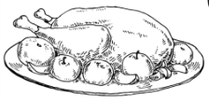 |  | 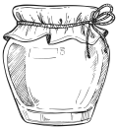
1. ___________ | 2. ___________ | 3 ___________ | 4. ____________ | 5. ____________ | 6. ____________
B. Complete the dialogue with the verb to like in the Present Simple.
Simon: (1)_________________ you _________________ vegetables, Laura?
Laura: Yes, I (2)_________________. I (3)________________ tomatoes and lettuce. I (4)_______________ (not) peas and cauliflower.
Simon: Really? My sister (5)______________ tomatoes too. She (6)_________________ (not) like lettuce.
Laura: (7)_________________ she _________________ cauliflower?
Simon: No, she (8)_________________.

A. Find the odd word out.
Name No. Class Date
Unit 4 10-minute test 3
1. turkey chicken sausages sugar meat
2. vegetables peas broccoli onion cherries
3. milk lemon water tea coffee
4. flour rice jam pasta lemonade
B. Complete the sentences with some or any.
1. There isn’t _______________ cheese in the fridge.
2. There are _______________ apples and pears.
3. Is there _______________ milk? Yes, there is.
4. There is _______________ lemonade in the cupboard.
5. Let’s go to the supermarket… There aren’t _______________ vegetables.

Name No. Class Date
Unit 5 10-minute test 1
A. What time is it?
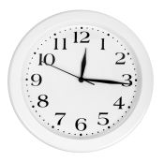 | 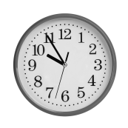 |  |  | 
1. _______________  _______________ | 2. _______________  _______________ | 3. _______________  _______________ | 4. _______________  _______________ | 5. _______________  _______________
B. Write the name of the daily activity.
  1 |   2 |   3 |  |   4 |   5
1. .  2. .  3. . |  |  | 4. .  5. .

Name No. Class Date
Unit 5 10-minute test 2
A. Write in the negative form.
1. My friends play football every day.
2. She goes to bed at ten o’clock.
3. I watch TV after school.
B. Complete the sentences with the correct form of the Present Simple.
1. Thomas ______________________________ (study) in the afternoon.
2. What time _______________ they _______________ (go) to school?
3. My best friend ______________________________ (not have) lunch in the canteen.
4. I _____________________________ (not like) football. I ____________________________ (prefer) basketball.
Name No. Class Date
Unit 5 10-minute test 3
A. Write the adverbs of frequency in the correct place.
1. I get up at six o’clock in the morning. (never)

2. My parents work on Saturday mornings. (sometimes)

3. These students are late. (always)

B. Complete the text with verbs in the Present Simple.
Helen always (1)_______________________________ (get up) at seven o’clock to go to school. She
(2)___________________________ (not have) a shower in the morning. She (3)_____________________ (have) a shower after school. She (4)______________________ (get dressed) and then she (5)____________________ (go) to the kitchen. Helen and her mother (6)___________________________ (have) breakfast. After breakfast Helen (7)_____________________ (make) her bed.
Name No. Class Date
Unit 5 10-minute test 4
A. Identify the free time activities.
 | 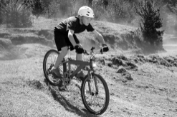 | 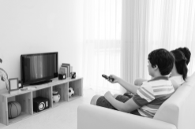 |  | 
1. _____________ | 2. _____________ | 3. _____________ | 4. _____________ | 5. _____________
B. Complete the sentences with Who, When, How, What, Where, How much.
1. _______________ is your bike? It’s in the garden.  2. _________________ are your favourite vegetables?  3. _________________ are you? I’m fine, thanks. | 4. _________________ money do you need?  5. _________________ is the new teacher?  6. _________________ do you do your homework? After school.

Name No. Class Date
Unit 5 10-minute test 5
Answer the questions with the help in the box.
dining room by car the new student chicken and potatoes
my sister before dinner two half past seven
1. What time does he get up?
2. Where do you have breakfast?
3. When do they do their homework?
4. How do they go to school?
5. What is your favourite food?
6. How many bedrooms are there in your house?
7. Who is he?
8. Whose bike is this?
Name No. Class Date
Unit 5 10-minute test 6
Rewrite the text using capital letters and punctuation marks.
David and his brother get up at seven o’clock they have a shower after their shower they get dressed and they make their bed then they have breakfast in the kitchen with their mother after breakfast they go to school at quarter past eight after their morning lessons David and his brother always have lunch in the canteen after their afternoon lessons they go home and they do their homework after their homework they play games

Answer key

Unit 1 – 10-minute test 1
A.
1. He is eleven years old. 2. She is a student. 3. We are in the classroom. 4. It is white. 5. They are very nice.
B.
1. forty-five 2. twelve 3. a hundred 4. thirty-two 5. fifty-eight
6. nineteen
Unit 1 – 10-minute test 2
A.
1. Her name is Mary. She is ten years old. Her birthday is on 10th January. 2. His name is Daniel. He is eleven years old. His birthday is on 24th December.
B.
1. on 2. in 3. in 4. in 5. on
Unit 1 – 10-minute test 3
A.
1. your; My 2. their 3. our 4. Her 5. his
B.
1. are; am 2. isn’t; is 3. aren’t; are 4. is 5. aren’t; are
Unit 2 – 10-minute test 1
A.
1. has got; has got; hasn’t got 2. Have / got; haven’t 3. haven’t got 4. have got
B.
1. boys 2. children 3. feet 4. heroes 5. houses 6. noses
Unit 2 – 10-minute test 2
A.
1. The girls have got round glasses. 2. My eyes are brown.
3. He is a funny boy. 4. I have not got wavy hair. 5. John is not very tall.
B.
1. c 2. d 3. a 4. b
Unit 2 – 10-minute test 3
A.
1. belt 2. gloves 3. shirt 4. skirt 5. watch
B.
2. grandparents’ house 3. Helen’s hat 4. men's uniforms
Unit 3 – 10-minute test 1
A.
1. kitchen 2. living room 3. bathroom 4. bedroom
B.
1. There are 2. are / there 3. There isn’t 4. There is
Unit 3 – 10-minute test 2
A.
1. dishwasher 2. cupboard 3. cooker 4. armchair 5. bookcase
6. fridge
B.
1. between 2. on 3. in 4. next to
Unit 3 – 10-minute test 3
A.
1. attic 2. sink 3. garden 4. cooker 5. washbasin
B.
1. a 2. the / the 3. an 4. the 5. a
Unit 4 – 10-minute test 1
A.
1. Sarah isn’t doing the dishes. 2. I’m not watching TV with my friends at the moment. 3. They aren’t playing football in the garden.
B.
1. are / doing; am studying 2. is washing 3. aren’t riding 4. is writing
Unit 4 – 10-minute test 2
A.
1. strawberries 2. peas 3. broccoli 4. chicken 5. lettuce 6. jam
B.
(1) Do / like; (2) do; (3) like; (4) don’t like; (5) likes;
(6) doesn’t (7) Does / like; (8) doesn’t
Unit 4 – 10-minute test 3
A.
1. sugar 2. cherries 3. lemon 4. lemonade
B.
1. any 2. some 3. any 4. some 5. any
Unit 5 – 10-minute test 1
A.
1. It’s quarter past twelve. 2. It’s five to ten. 3. It’s half past eight. 4. It’s five past six. 5. It’s quarter to two.
B.
1. brush teeth 2. have a shower 3. have breakfast 4. get dressed 5. do homework
Unit 5 – 10-minute test 2
A.
1. My friends don’t play football every day. 2. She doesn’t go to bed at ten o’clock. 3. I don’t watch TV after school.
B.
1. studies 2. do… go 3. doesn’t have 4. don’t like; prefer

Unit 5 – 10-minute test 3
A.
1. I never get up at six o’clock in the morning. 2. My parents sometimes work on Saturday mornings. 3. These students are always late.
B.
(1) gets up; (2) doesn’t have; (3) has; (4) gets dressed;
(5) goes; (6) have; (7) makes
Unit 5 – 10-minute test 4
A.
1. reading 2. riding a bike 3. watching TV 4. playing basketball 5. swimming
B.
1. Where 2. What 3. How 4. How much 5. Who 6. When
Unit 5 – 10-minute test 5
1. He gets up at half past seven. 2. We/I have breakfast in the dining room. 3. They do their homework before dinner.
4. They go to school by car. 5. My favourite food is chicken and potatoes. 6. There are two bedrooms. 7. He is the new student. 8. It’s my sister’s bike.
Unit 5 – 10-minute test 6
David and his brother get up at seven o’clock. They have a shower. After their shower they get dressed and they make their bed. Then they have breakfast in the kitchen with their mother. After breakfast they go to school at quarter past eight. After their morning lessons David and his brother always have lunch in the canteen. After their afternoon lessons they go home and they do their homework. After their homework they play games.

Teacher’s notes

