Listening

Name No. Class Date
Evaluation _____________________ Teacher _________________ Parent _________________
English – 5th Form
____ / 6
- Listen. Tick the numbers you hear.

13 |  |  | 90 |  |  | 2nd |  |  | 71st
15 |  |  | 1st |  |  | 45 |  |  | 3rd

____ / 4
- Listen to the text. When is their birthday? Match.

Maggie |  |  | - April 16th
Edward |  |  | - July 9th
Robert |  |  | - July 19th
Tina |  |  | - November 11th

____ / 8
- Listen again. What is their phone number?

Maggie
Edward
Robert
Tina

Reading

Kathy and Mark are students. She is ten and he is eleven years old. They are from New York, USA. Her surname is Smith and his surname is Barnes.

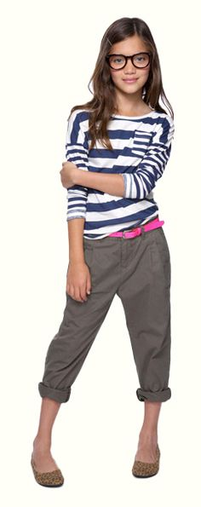

Kathy – Hello, Mark. This is my friend Sophie.
Mark – Nice to meet you, Sophie. Where are you from?
Sophie – I’m from Paris, France. Are you from the USA?
Mark – Yes, I am.
Kathy – Mark, her birthday is on January 19th.
Mark – Oh, my birthday is on January 19th too!
Sophie – How old are you?
Mark – I’m eleven. And you?
Sophie and Kathy – We are ten.

____ / 4
- Match the columns.

Kathy is |  |  | - her friend.
Her surname is |  |  | - ten years old.
She is |  |  | - American.
Sophie is |  |  | - Smith.
____ / 21
- Answer the questions.

- How old is Mark? ______________________________________________________________
- Is he from New York? ___________________________________________________________
- What nationality is he? __________________________________________________________
- Where is Sophie from? __________________________________________________________
- What nationality is she? _________________________________________________________
- When is her birthday? __________________________________________________________
- How old are Kathy and Sophie? ___________________________________________________

Vocabulary
____ / 6
- What’s this? Write the name of these objects.
 |  | 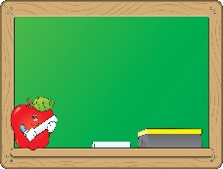
- ___________________ | - ___________________ | - ___________________
 | 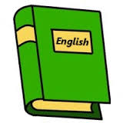 | 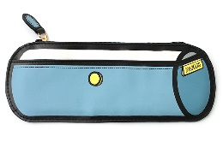
- ___________________ | - __________________ | - _________________
____ / 6
- What nationality are they?
  China |   Scotland |   The Netherlands
- ___________________ | - ___________________ | - ___________________
  Canada |   Spain |   Portugal
- ___________________ | - ___________________ | - ___________________

Grammar
____ / 7
- Choose the correct option.

- A / An apple.
- The / A boys.
- A / An door.
- An / The Japanese girl.
- A / An elephant.
- The / An telephone.
- A / The teachers.
- Complete the sentences. Use the verb to be.
____ / 10

- She ____________ a French girl.
- This ____________ my friend Andrew.
- How ____________ you? I ____________ fine, thank you.
- Jack ____________ American. He ____________ from Portugal.
- My dog ____________ black. Its name ____________ Blackie.
- ____________ you Swiss? No, I ____________.
____ / 7
- Complete the sentences. Use possessive determiners.

- Kathy is American. Sophie is ____________ friend.
- This is Bill. ____________ car is red.
- They are students. These are ____________ books.
- We are Jim and John. ____________ surname is Jackson.
- This is my cat. ____________ name is Whiskers.
- Ann: Sue, what’s ____________ favourite colour?
Sue: ____________ favourite colour is pink.

Writing
____ / 21
- Write a text about Isabella.
Name: Isabella  Surname: Laurent  Age: 12    Address: 15, Via Garibaldi, Rome  Phone number: 597 324 672  Favourite colour: Blue  Nationality: Italian | _______________________________________________  _______________________________________________  _______________________________________________  _______________________________________________  _______________________________________________  _______________________________________________  _______________________________________________

