I – Listening

Name No. Class Date
Evaluation _____________________ Teacher _________________ Parent _________________
English – 5th Form
____ / 14
- Listen to Ann. Who are they?

Lewis grandfather

1. Velma  2. Rick  3. Jane | 4. Paul  5. Bob  6. Sue  7. Jim
Listen and tick (). Who is…
____ / 6
- Lewis?
  A |   B |   C
- Emily?
  A | 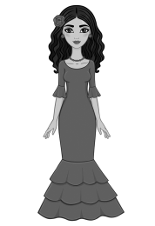  B |   C

II – Reading

Read the text.
Meet the Wilsons!
The Wilsons are a Scottish family. Sean is the father. He is forty-two years old and he is a police officer. He has got short curly black hair and a moustache. He is tall and slim. His wife is Marian. She is tall and thin and she has got long wavy brown hair. She is an architect and she is forty years old. They have got two children. Their daughter is Lara and she is five years old. She is short and very pretty. She has got medium wavy brown hair and freckles. Their son is Mark. He is a student and he is eleven years old. He has got a round face and he wears glasses. He has got short straight black hair and he is medium-height and slim.

A. Write their names.
____ / 4
Father
1.
Mother
2.

Daughter
3.
Son
4.

____ / 6
B. True or False?
- Sean is 42 years old. ____
- He is an architect. ____
- Marian has got blonde hair. ____
- Sean and Marian have got a son and a daughter. ____
- Mark has got freckles. ____
- He is tall. ____

C. Answer the questions.
____ / 10
1. How old is Sean?
2. What’s his job?
3. What is his wife’s name?
4. How many children have they got?
5. Has Lara got curly hair?

III – Vocabulary
A. What’s this? Write the words.
____ / 8
  1.___________ | 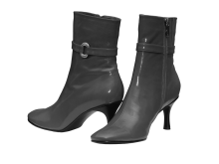  2. | 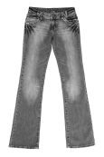  3. |   4.

  5. | 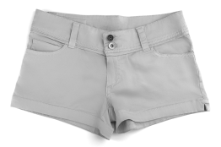  6. |   7. |   8.
B. What are they like? Describe their hair.
____ / 6
  1.She has got  hair. |   2. She has got  . |  |   3. She  .
  4. He has got  hair. |  |   5. He has got  . |  |   6. He

C. What are their jobs?
____ / 6
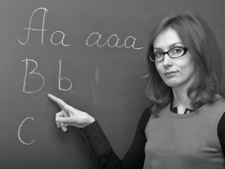  1. She |   2. . |   3.

  4. |   5. . |   6.

IV – Grammar
- Complete the sentences. Use a possessive determiner.
____ / 7
1. I’m English. ____________ family lives in England.
2. Kate Middleton and Prince William are English too. ____________ son is Prince George.
3. Prince George has got a sister. ____________ name is Charlotte.
4. Prince William has got a brother. ____________ name is Harry.
5. Queen Elizabeth lives in a palace. ____________ name is Buckingham Palace.
6. We like the Royal Family. ____________ favourite is Prince George.
7. And you? Who is ____________ favourite member of the Royal Family?
B. Look at the table. Complete the sentences. Use the verb have got.
____ / 5
 | Dog | Car | Mobile phone
Mary
Henry
John and Susan

1. Mary ____________ a dog and a mobile phone.
2. ____________ Henry ____________ a dog? No, he ____________.
3. John and Susan ____________ a dog and a phone but they ____________ a car.
C. Look at the table. Answer the questions.
____ / 2
1. Has Mary got a dog?
2 Have John and Susan got a car?

D. Look at the tables. Complete the sentences. Use the possessive case.
____ / 6
The girls Jeans  Karl Cat  Mrs Brown Books |  | My parents House  Jack and Jill Car  James Coats
1. They’re books. 4. It’s car.
2. They’re jeans. 5. They’re coats.
3. It’s cat. 6. It’s house.

V – Writing
E. Write a text about a member of your family.
____ / 20
Complete the notes. Then write.
Name:
Surname:
Age:
Birthday:
Job:
Physical description:

