I – Listening

Name No. Class Date
Evaluation _____________________ Teacher _________________ Parent _________________
English – 5th Form

Name No. Class Date
Evaluation _____________________ Teacher _________________ Parent _________________
English – 5th Form – 4rd Test
- Listen and choose the correct option.
- Who is Patricia?
 |  | 
A | B | C

- Who is her mother?
 |  | 
A | B | C

- Who is her sister?
 |  | 
A | B | C

- Who is her father?
 |  | 
A | B | C

- What are her father’s presents?
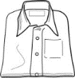 |  | 
A | B | C
____ / 10
- Listen to Patricia talking about her favourite artist. Fill in the blanks.
My favourite artist is Emma Watson. She is a very 1 ______________ actress and she is Hermione in the Harry Potter films. Her birthday is on 15th 2 ______________. She is medium-height and 3 ______________ and she has got 4 ______________ brown hair and brown eyes. Emma is very 5 ______________ and energetic. She has got two cats. Their names are Bubbles and Domino.
____ / 10
II – Reading
- Read the text.
Meet the Beckhams
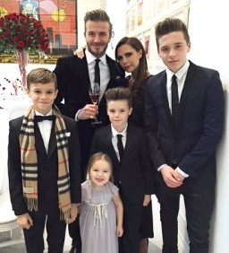
The Beckhams are a very famous family. David and Victoria Beckham are from the United Kingdom but they live in Los Angeles USA.
David Beckham, the father, can play football very well and he can cook too. Victoria, his wife, can sing but she can’t play basketball.
They have got three sons and a daughter. Brooklyn is 18 years old, he is very shy and he likes football. Romeo is a model and he is 14. He is very active and he can play tennis. Cruz is 12 and he can play the guitar very well. Harper is the daughter and she can dance. She likes ballet. She can’t read and write because she is only 5 years old.
They live in a very big house. There are fourteen bedrooms, nine bathrooms and a big garden. Victoria’s favourite room is the living room, but David prefers the kitchen. Brooklyn loves his bedroom because it has got a big balcony.

- True (T) or False (F)?
 | T | F
1. David and Victoria Beckham are American.
2. David is Victoria’s husband.
3. They have got five children.
4. Romeo is very shy.
5. Their house has got a big garden. |  | ____ / 5

- What can they do? Match the names and the pictures.
-  David | a. 
-  Victoria | b. 
-  Romeo | c. 
-  Cruz | d. 
-  Harper | d.   ____ / 5

- Answer the questions.

- What is David’s nationality?
________________________________________________________________________

- Where is their house?
________________________________________________________________________

- Who is very active?
________________________________________________________________________

- How many daughters have David and Victoria got?
________________________________________________________________________

- What is David’s favourite part of the house?
________________________________________________________________________
____ / 10

III – Vocabulary
- Write the parts of the house.
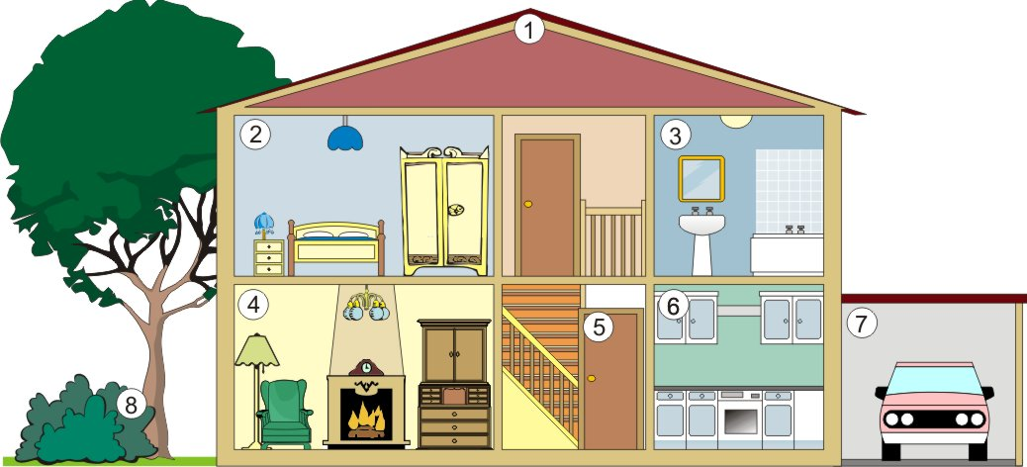 | - ______________  - ______________  - ______________  - ______________  - ______________  - ______________  - ______________  - ______________
____ / 8
- Put the furniture in the correct room.
Bathroom | Kitchen | Living room |  | Shower  Armchair  Cupboard  Fridge  Toilet  Table | Coffee table  Bath  Sofa  Washbasin  Cooker  Television
_______________  _______________  _______________  _______________ | _______________  _______________  _______________  _______________ | _______________  _______________  _______________  _______________ |  | Shower  Armchair  Cupboard  Fridge  Toilet  Table | Coffee table  Bath  Sofa  Washbasin  Cooker  Television
____ / 12
IV – Grammar
- Write the plural of the words.

- Bus ________________
- Child _______________
- Box ________________
- Foot _______________
____ / 2

- Write the sentences in the plural.
- She is a famous person. _____________________________________________
- He has got a cat. ___________________________________________________
____ / 2
- Complete. Use a demonstrative pronoun/determiner.
 |  | 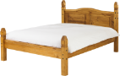 | 
- ___________ are my books. | - ____________ is my mother’s bookcase. | - ________ bed is big. | - __________ dogs are very energetic!
____ / 4
- Put the adjective in the right place.
- Kate is a student. (good) ______________________________________________________
- Mark and Molly are architects. (excellent) _______________________________________
- I have got a dog. (big) ________________________________________________________
- Mr Lewis is a teacher. (nice) ___________________________________________________
____ / 4
- What can they do? Look at the table and complete the sentences.
 |  |  | 
Susie | ✗ | ✗ | ✓
Mel | ✗ | ✓ | ✓
- Susie _________ play the guitar and ____________ but she ___________ sing.
- Mel __________ dance and ___________ but he ____________ play the guitar.
____ / 3
- What is there in Mary’s bedroom? Use the verb there to be.
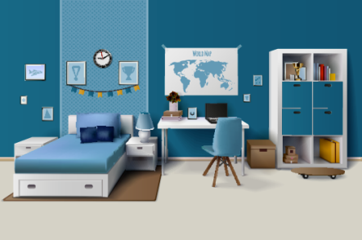 | - ____________ a bed.  - __________ two bedside tables.  - _________ an armchair.  - _________ any toys?  No, _____________.  ____ / 5

V – Writing
- Describe your favourite room in your house.
__________________________________________________________________________________
__________________________________________________________________________________
__________________________________________________________________________________
__________________________________________________________________________________
__________________________________________________________________________________
__________________________________________________________________________________
____ / 20

