at eight o’clock and we go to bed at te

Name No. Class Date
Evaluation _____________________ Teacher _________________ Parent _________________
Progress test

Name No. Class Date
Evaluation _____________________ Teacher _________________ Parent _________________
English – 5th Form – 4rd Test

I. Reading
A. Read the text.

My Daily routine
I’m Patricia Nelson and this is my daily routine. I get up at 7 o’clock when I go to school. I go to the bathroom. It’s not a very big bathroom but it’s very nice because there’s a big window. I go downstairs to have breakfast. I really love cereal with fruit and milk.
I go to school by bus at quarter to eight. My morning lessons start at twenty past eight. I have lunch in the school canteen with my best friends, David and Emma, at quarter to one.
School finishes at half past three and I go home. At home I have a snack and I play computer games. Then I do my homework in the kitchen. My grandmother prepares dinner. At seven o’clock my parents are at home and we have dinner in the kitchen. After dinner, I watch TV with my parents and my grandmother reads her book. I go to bed at ten.

B. True (T) or False (F)?
F
T
1. Patricia likes her bathroom.
2. Patricia’s bedroom is downstairs.
3. School starts at quarter to eight.
4. Patricia has lunch at 12.45.
5. Patricia plays games after dinner.
6. Patricia’s grandmother watches TV in the evening.

C. Correct the false sentences in exercise B.
______________________________________________________________________________________________________________________________________________________________________________________________________________________________________________________________________________________________________________________________________________________________________________________________________________________________________________________________________________

D. Answer the questions. Write complete sentences.
1. What time does Patricia get up?

2. Is her bathroom big?

3. Where does she have breakfast?

4. Who are Patricia’s best friends?
5. Does Patricia have lunch at home?

6. Where does she do her homework?

II. Vocabulary
A. Identify the daily routine activities. Follow the example.
 |  |  | 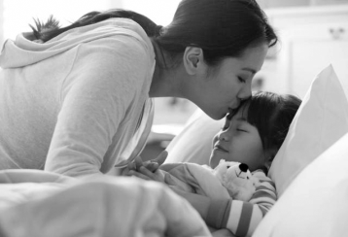
1. ____________________  Brush my teeth | 2. ____________________ |  | 3. ____________________
 |  |  | 
4. ____________________ | 5. ____________________ |  | 6. ____________________
 |  | 
7. ____________________ |  | 8. ____________________
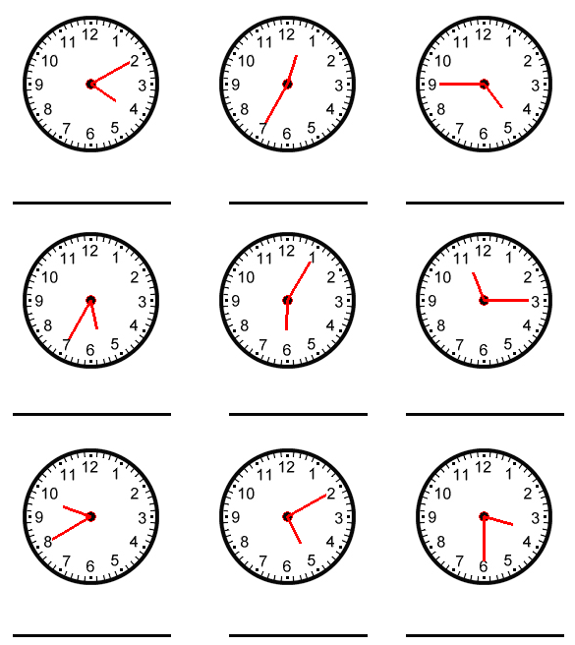

B. What time is it?


1. It’s ___________________ 2. ____________________ 3. ____________________

4. ______________________ 5. ____________________ 6. ____________________

III. Grammar
A. Complete the sentences with the Present Simple.
1. Patricia _______________ (be) a very nice girl and she _________________ (have got) a very nice family.
2. Patricia _________________ (not go) to school by car. She __________________ (go) to school by bus.
3. They _________________ (be) in year 5. They _________________ (like) their school.
4. You __________________ (not study) in the morning.
5. Patricia ________________ (study) in the kitchen.
B. Put the words in the correct order.
1. watch / do / TV / school / you / after / ?

2. football / with / I / friends / play / my / .

3. got / she / English / has / morning / in the / .

4. don’t / a snack / we / in the / have / afternoon / .

C. Complete with the connectors and, but, so, because.
1. He doesn’t have breakfast in the morning ___________ he is always hungry.
2. I go to bed at 10 ______________ I’m sleepy.
3. I can sing ____________ I can’t dance.
4. My sister is tall ___________ thin.
D. Put the adverbs of frequency in the right place.
1. I walk to school. (never)

2. I watch TV before I go to bed. (sometimes)

3. Lessons finish at 3.30. (usually)

4. My mother is happy. (always)

IV. Writing
A. Write a text about your daily routine. Don’t forget to mention the time of the actions.

