Name |  | No. | Class
Date | Mark | Teacher

 Listen to part 1 and tick () the correct column.
A
A
 |  | Jack | Alison
1. | is tall and thin?
2. | has got wavy hair?
3. | has got brown eyes?
4. | is funny?
5. | is good at sports?
6. | is not lazy?
Who…

Listen again. Underline and correct the wrong information.
B
1. Jack has got long hair. | __________________
2. His eyes are blue | __________________
3. He plays basketball. | __________________
4. Alison is tall. | __________________
5. She is lazy. | __________________
Listen to part 2 and complete the sentences.
C
1. Jack and Alison’s parents are _____________________ years old.
2. Jessica’s hair is long and _____________________. She has got blue _____________________.
3. Jessica is a _____________________ and Donald is a police officer.
4. Jessica is very active and Donald is _____________________ and _____________________.

Name |  | No. | Class
Date | Mark | Teacher


I – Reading
Read the text.

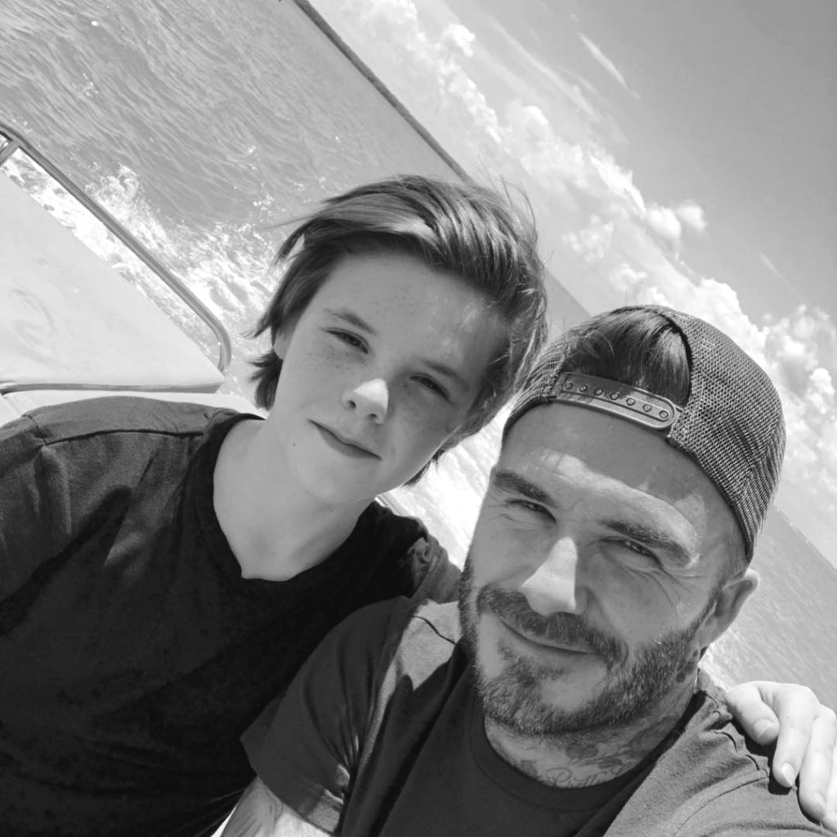
Cruz Beckham
Hello! I’m Cruz Beckham and I am thirteen years old. I live in the USA with my family but I’m English.
My father is David Beckham, a famous ex-football player, and my mother is Victoria Beckham, a fashion designer and a singer. My parents have got four children: three sons and a daughter.
My brother Brooklyn is nineteen and he is a model. He is tall and thin and he has got brown hair and brown eyes. Today he is wearing jeans, a blue shirt and white trainers. My brother Romeo is sixteen and he has got straight brown hair and brown eyes. He is thin, too. He is very active. My sister Harper is nine years old and she has got long blond hair and green eyes. She is very funny.
I am very happy because we have got a new member in our family. It’s Fig, our black dog.
Complete the table. Follow the example.
A
1. father’s name | David
2. Cruz’s nationality
3. mother’s job
4. Brooklyn’s clothes
5. Romeo’s age
6. Harper’s physical description
Are the sentences True (T) or False (F)? Correct the false ones.
B
 | T | F
1. David and Victoria Beckham have got three children. |  |  | _______________________________
2. Cruz has got a sister and  two brothers. |  |  | _______________________________
3. Fig is the new member of  the Beckham family. |  |  | _______________________________

Answer the questions about the text.
C
1. How old is Cruz? __________________________________________________________________.
2. What is Brooklyn’s job? ___________________________________________________________.
3. What is Romeo like? ______________________________________________________________.
4. Has Harper got green eyes? _______________________________________________________.

II – Vocabulary
Write the words in the box in the correct column.
A
aunt chef cousin scarf mechanic
skirt shorts nurse grandparents
1. family members | 2. jobs | 3. clothes
Look at the pictures and choose the correct option.
B
 |  |  | 
1. He is tall / short. | 2. She has got straight /  wavy hair. | 3. He has got a moustache / freckles. | 4. She is active / lazy.
Write the words in the correct order.
CC
1. and / she / short / is / fat / . ________________________________________________________
2. straight / have got / hair / they / short / . ___________________________________________
3. eyes / got / he / blue / hasn’t / . ____________________________________________________

III – Grammar
Complete with the verb have got.
A
1. My parents _____________ two sons and a daughter.
2. _____________ Alice _____________ a brother? Yes, she _____________.
3. Melissa _____________ (not) green eyes.
4. I _____________ curly hair.
5. The twins _____________ (not) freckles.
Use the possessive case ’ or ’s. Follow the example.
’s
B
1. Sophia____ new T-shirt is blue. 4. Look, the teacher ____ dress is green.
2. The kids ____ dog is black. 5. Henry ____ favourite clothes are jeans and shorts.
3. This is James ____ sister.
Circle the correct possessive pronoun.
C
1. This is Lucas’s anorak. It’s his / ours.
2. My mother has got a beautiful scarf. It’s mine / hers.
3. The girls have got new dresses. They’re theirs / its.
4. I have got orange gloves. They’re his / mine.
5. You have got a new mobile phone. It’s yours / his.

IV – Writing
Describe this girl. Use the information in the box.
Student Card  Name / Age: Melissa Jordan / 11  Body: short / thin  Hair: long / wavy  Eyes: brown  Personality: active / funny  Clothes: white T-shirt / shirt / jeans / pink hat  Favourite object: skateboard | This is

