Name |  | No. | Class
Date | Mark | Teacher


I – Reading
Read the text.
 | Grandma’s visit
5  10 | My name is Mia and I’m 10 years old. My grandmother is staying with us for the weekend. We love her. She’s funny and very active. When she is around, we are always doing something.  Today is cleaning day and we are very busy! My brother Lucas is making his bed in his bedroom. My mother is washing the car in the garden. My sister Alice is laying the table. My father is cooking a special lunch for the family in the kitchen. He is preparing vegetarian pizzas and grilled fish for grandma because she doesn’t like pizza very much. For dessert he is making chocolate and strawberry cake. I love it!    At the moment I am with grandma. Can you guess what we are doing? We are riding our bikes and having a great time!
Match the columns. There is an extra option.
A
This weekend grandma is | 1 | • |  | • | a | in his bedroom.
They are all very busy | 2 | • |  | • | b | chocolate and strawberry cake.
Lucas is making his bed | 3 | • |  | • | c | are having a great time.
Mia loves | 4 | • |  | • | d | visiting the family.
Grandma and Mia | 5 | • |  | • | e | in the garden.
 |  |  |  | • | f | when grandma is around.

Are the sentences True (T) or False (F)? Correct the false ones.
B
 | T | F
- Mia is eleven years old. | x
2. They are all doing things because it’s cleaning day.

3. Alice is in the kitchen.

4. Mia’s father is washing the car.

5. Grandma is preparing a special lunch in the kitchen.

Answer the questions about the text.
C
1. What is grandma like? .
2. What is Mia’s mother doing? .
3. Does grandma like pizza? .

II – Vocabulary
Write the names of these activities at home.
A
1. __________________ | 2. __________________ | 3. __________________ | 4. _________________
Look at the pictures and complete the bubbles.
B
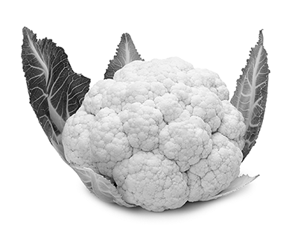
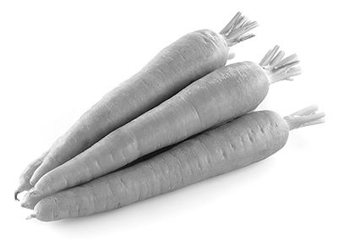
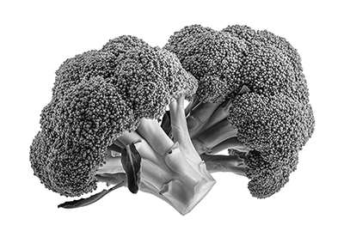
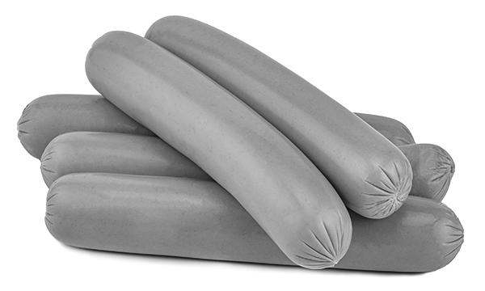
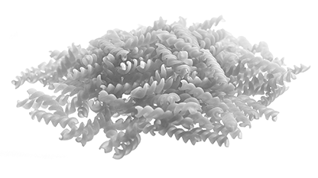
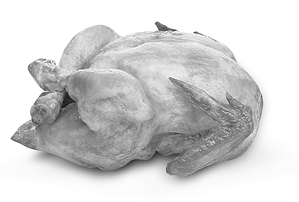
Hi! I’m Lucas. I like 1.____________
and 2.______________ but I
don’t like 3.______________ .
Hello! I’m Alice. I like 4.__________
and 5.______________ but I don’t like 6.______________ .

III – Grammar
Complete with the Present Continuous of the verbs in brackets.
A
1. They ____________________ (have) a great time.
2. I ____________________ (cook) a delicious chocolate cake.
3. ____________________ the boy ____________________ (ride) his bike?
4. Anne ____________________ (not listen) to music.
5. We ____________________ (study) for the test.
6. ____________________ you ____________________ (eat) pizza?

Circle the correct option.
B
1. Mia like / likes orange juice. | 4. I don’t / doesn’t like pineapple.
2. Her mother don’t / doesn’t like cereal. | 5. They like / likes cheese.
3. Do / Does grandma like tea?

Write sentences in the Present Simple.
C
1. you / like / lettuce / ?

___________________________________________________________________________________________
2. The kids / not like / mushrooms / .

___________________________________________________________________________________________
3. My father / like / spinach soup / .

___________________________________________________________________________________________
4. I / like / grilled fish / .

___________________________________________________________________________________________
5. Nick / not like / lemonade / .

___________________________________________________________________________________________

IV – Writing
Write about Mia’s best friend.
 | Name: Charlotte  Age: 10  Nationality: Canadian |  | Her name
 | Food and drinks she likes and doesn’t like: |  | She
 |  | yoghurt, grilled chicken,  fruit salad, orange juice | She
 |  | pasta, hamburgers,  melon, coffee | She
 |   What she’s doing at the moment: |  | At the moment

