Listening
Progress Test A

Name |  | No. | Class
Date | Mark | Teacher

 Listen to Karen. Complete the fact file about her. [áudio aqui]
A
A

Name | ____________________________________________ | 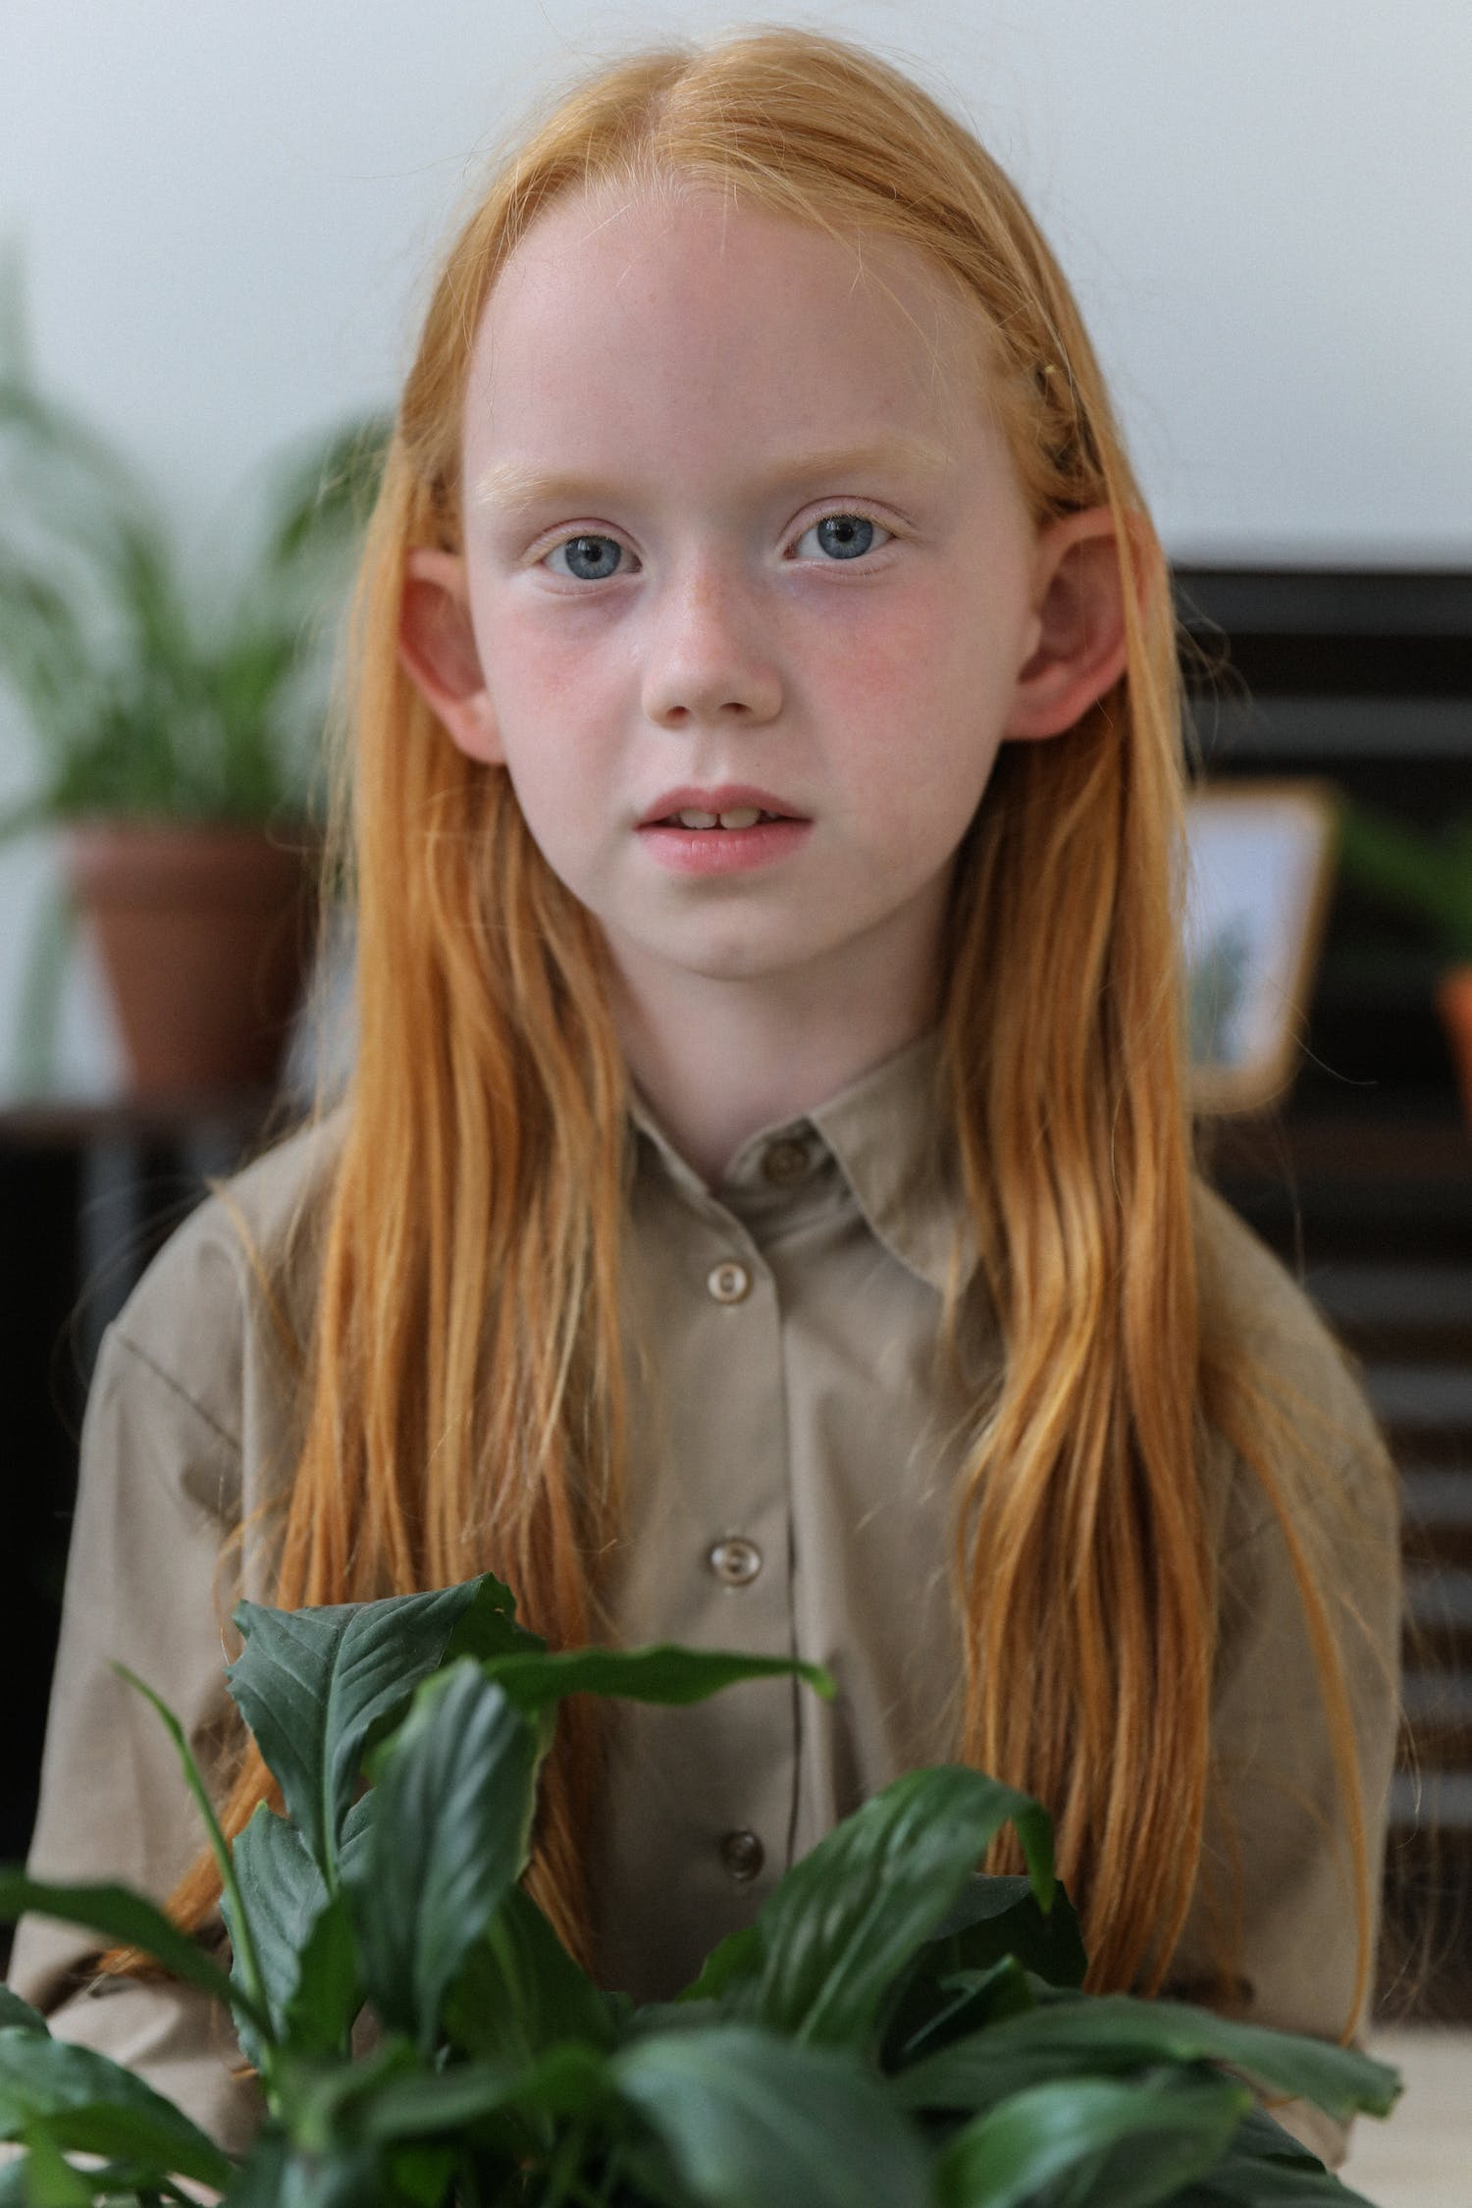
Surname | ____________________________________________
Age | ____________________________________________
Address  Phone number  Favourite colour  Pets | ____________________________________________  ____________________________________________  ____________________________________________  ____________________________________________
Listen to part 2. Match the names with their birthdays. [áudio aqui]
B

1. Anne  2. Lucas  3. Alana  4. Derek | 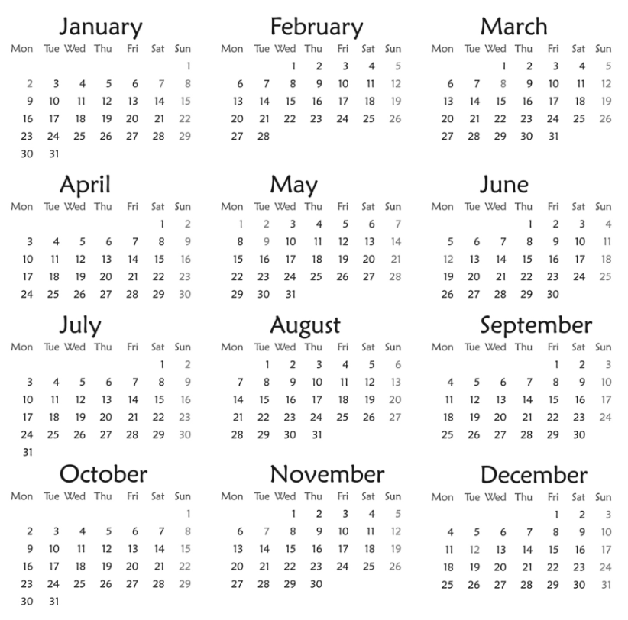 | 5. Chloe  6. Harry  7. Lucy

Listen to part 3 and complete the dialogue. [áudio aqui]
C

Dad: Good morning, Sue! Do you know what day it is today?
Sue: _______________?
Dad: Yes! And it’s 28th _______________.
Sue: It’s my birthday!
Dad: That’s right! Happy birthday!
Sue: Can I have a party next _______________?
Dad: Of course! And next week we’ll have another birthday party.
Sue: On _______ October, mum’s birthday!
Dad: And on _______ it’s Halloween!
Sue: I love parties! I can’t wait for ____________ for more parties!

Reading
Progress Test A

Name |  | No. | Class
Date | Mark | Teacher

Read the text about James.

Hello! My name is James Hemingway and I live in Liverpool, England. I’m English like my dad, but my mum is Scottish. I’m ten years old and I’m in year 5.
My address is 239, Liberty Street, Liverpool and my phone number is 0231 7449 65.
My e-mail is james10@yahoo.com.
I have got a brown dog called Muffin and a black cat called Olive. I like lots of different colours: black, red, white… But my favourite colour is blue.
My birthday is on the ninth of September.

Are these sentences True (T) or False (F)? Correct the false ones.
A
 | T | F
1. His full name is James Hemingway.
2. He lives in London, England.
3. James is Scottish.
4. He has got a black dog and a brown cat.
5. His birthday is on 9th September.

Answer the questions about the text.
B
1. How old is James?
.
2. Are his parents English?
.
3. What’s his address?
.
4. What’s his e-mail?
.
5. What’s his favourite colour?
.

Vocabulary and Grammar
Progress Test A

Name |  | No. | Class
Date | Mark | Teacher


Vocabulary

Write the numbers in full.
A

1. 7 ___________________________
2. 9th __________________________
3. 11 __________________________
4. 1st _____________________________
5. 14 __________________________
6. 3rd _____________________________
7. 20 _____________________________
8. 2nd _____________________________

Write the words in the correct column.
B
Sunday spring December Saturday March Monday winter July January Wednesday summer Friday August autumn April
1. Days of the week | 2. Months | 3. Seasons

Complete the table with the countries or nationalities.

C
Country | Nationality
Portugal
 | Greek
Spain
 | French
Germany
 | Irish
Brazil
 | Canadian
China
 | Japanese

Grammar

Complete with the correct form of the verb to be.
A
1. I __________ (not) a teacher. I __________ a student.
2. Pierre __________ German. He __________ (not) Italian.
3. They __________ (not) 12 years old. They __________ 11.
4. Jim: __________ Mary Brazilian?
Sue: No, she __________. She __________ from Argentina.
5. We __________ good students. We __________ (not) noisy.
6. My father and I __________ at home.

Complete the sentences with the correct prepositions of time.
B
1. We are ____ 2022.
2. My birthday is ____ 12th November.
3. Halloween is ____ October.
4. English lessons are ____ Tuesdays and Thursdays.
5. School starts _____ 8:20.

Complete the sentences with the correct personal pronouns or possessive determiners.
C
1. _____ have got a cat. _____ cat is white.
2. I love my mother. _____ is very nice. _____ name is Margaret.
3. My father is Australian. _____ is from Australia. _____ name is Peter.
4. Hello! How are ______? Is that ______ bike?
5. I’m Kate and this is my sister Rebecca. _____ are twins. This is _____ house.

Writing
Progress Test A

Name |  | No. | Class
Date | Mark | Teacher

Read the fact file about Billie Eilish and write a text about her.
A

 | Full name: Billie Eilish Pirate Baird O'Connell  Age: 20  Country/Nationality: USA/American  Birthday: 18th December

_____________________________________________________________________
_____________________________________________________________________
_____________________________________________________________________
_____________________________________________________________________
_____________________________________________________________________
_____________________________________________________________________
_____________________________________________________________________
_____________________________________________________________________

