Listening
Progress Test B

Name |  | No. | Class
Date | Mark | Teacher

 Listen to Karen. Complete the fact file about her. [áudio aqui]
A
A

Name | ____________________________________________ | 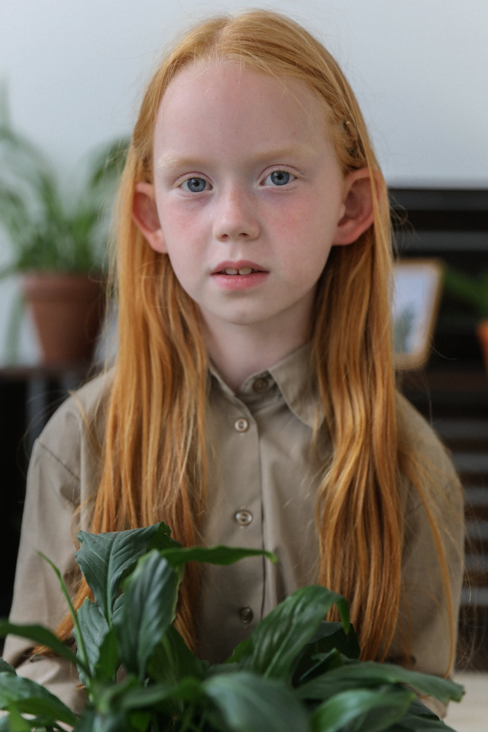
Surname | ____________________________________________
Age | ____________________________________________
Address  Phone number  Favourite colour  Pets | _____________________ , Marble _________, ____  0231 __________________ 97  _____________________________________________  rabbit and ____________________________________________
Listen to part 2. Match the names with their birthdays. Follow the example. [áudio aqui]
B

1. Anne  2. Lucas  3. Alana  4. Derek | 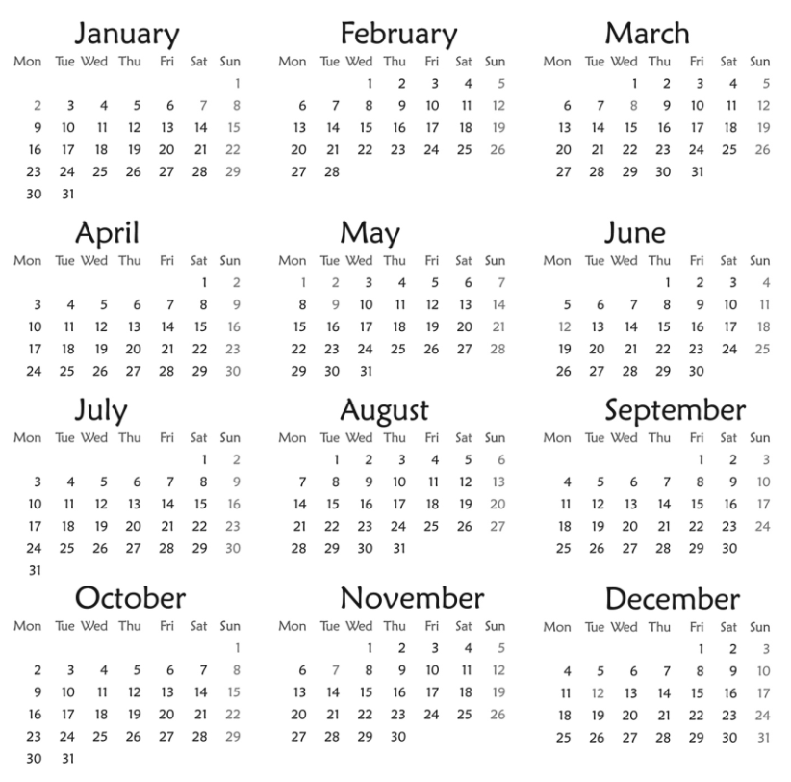 | 5. Chloe  6. Harry  7. Lucy

Listen to part 3 and complete the dialogue with the [áudio aqui] words/expressions in the box.
C
31st December Saturday 2nd September Wednesday

Dad: Good morning, Sue! Do you know what day it is today?
Sue: _______________?
Dad: Yes! And it’s 28th _______________.
Sue: It’s my birthday!
Dad: That’s right! Happy birthday!
Sue: Can I have a party next _______________?
Dad: Of course! And next week we’ll have another birthday party.
Sue: On _______ October, mum’s birthday!
Dad: And on _______ it’s Halloween!
Sue: I love parties! I can’t wait for ____________ for more parties!

Reading
Progress Test B

Name |  | No. | Class
Date | Mark | Teacher

Read the text about James.

Hello! My name is James Hemingway and I live in Liverpool, England. I’m English like my dad, but my mum is Scottish. I’m ten years old and I’m in year 5.

My address is 239, Liberty Street, Liverpool and my phone number is 0231 7449 65.
My e-mail is james10@yahoo.com.
I have got a brown dog called Muffin and a black cat called Olive. I like lots of different colours: black, red, white… But my favourite colour is blue.
My birthday is on the ninth of September.

Are these sentences True (T) or False (F)?
A
 | T | F
1. His full name is James Hemingway.
2. He lives in London, England.
3. James is Scottish.
4. He has got a black dog and a brown cat.
5. His birthday is on 9th September.

Answer the questions about the text.
B
1. How old is James?
James is .
2. Are his parents English?
His father is .
3. What’s his address?
His address is .
4. What’s his e-mail?
His e-mail is .
5. What’s his favourite colour?
His favourite colour is .

Vocabulary and Grammar
Progress Test B

Name |  | No. | Class
Date | Mark | Teacher


Vocabulary

Write the numbers in full.
A

1. 7 ___________________________
2. 9th __________________________
3. 11 __________________________
4. 1st _____________________________
5. 14 __________________________
6. 3rd _____________________________
7. 20 _____________________________
8. 2nd _____________________________

Write the words in the correct column.
B
Sunday spring December Saturday March Monday winter July January Wednesday summer Friday August autumn April
1. Days of the week | 2. Months | 3. Seasons

Complete the table with the countries or nationalities.

C
Country | Nationality
Portugal
 | Greek
Spain
 | French
Germany
 | Irish
Brazil
 | Canadian
China
 | Japanese

Grammar

Circle the correct form of the verb to be.
A
1. I am not / aren’t Spanish. I am / are Portuguese.
2. Pierre are / is French. He aren’t / isn’t Italian.
3. They aren’t / am not 12 years old. They are / am 11.
4. Jim: Are / Is Mary Brazilian?
Sue: No, she aren’t / isn’t. She are / is from Argentina.
6. We am / are good students. We am not / aren’t noisy.
6. My father and I are / is at home.

Complete the sentences with the correct prepositions of time. Use the words in the box.
B
in on at

1. We are ____ 2022.
2. My birthday is ____ 12th November.
3. Halloween is ____ October.
4. English lessons are ____ Tuesdays and Thursdays.
5. School starts _____ 8:20.

Circle the correct personal pronouns or possessive determiners.
C
1. I / My have got a cat. I / My cat is white.
2. I love my mother. She / Her is very nice. She / Her name is Margaret.
3. My father is Australian. He / His is from Australia. He / His name is Peter.
4. Hello! How are you / your? Is that you / your bike?
5. I’m Kate and this is my sister Rebecca. We / Our are twins. This is we / our house.

Writing
Progress Test B

Name |  | No. | Class
Date | Mark | Teacher

Read the fact file about Billie Eilish and write a text about her.
A

 | Full name: Billie Eilish Pirate Baird O'Connell  Age: 20  Country/Nationality: USA/American  Birthday: 18th December

Her full name __________________________________________________________
She ____________________________________________ old. She _______________
_____________________________________________________________________
_____________________________________________________________________
_____________________________________________________________________
_____________________________________________________________________
_____________________________________________________________________
_____________________________________________________________________

