A. Complete the fact file with the information from the box. Then complete the text about Robert.
Name No. Class Date
Unit 1.1 Hello, friends!
Writing A
14, Oak Street, New York robertmiller@myemail.com 212 699 5603 17 Robert Miller
  Name | _______________________ | His (1)_____________ is Robert and his surname is (2)____________. He is (3)______________ years old. His (4)______________ is 14, Oak Street, New York. His phone (5)_________________ is 212 699 5603 and (6)______________ email is robertmiller@myemail.com.
Surname | _______________________
Age | _______________________
Address | _______________________
Phone number | _______________________
Email | _______________________
B. Complete the text about Kate.
  Name | Kate | Her name (1) __________ and her  (2) __________________ Walker. She  (3) ______________________ old. Her  (4) _____________________, Sydney.  (5) ________________ 028 4778 4590 and (6) ________________________  katewalker@myemail.com.
Surname | Walker
Age | 15
Address | 35, Ocean Road, Sydney
Phone number | 028 4778 4590
Email | katewalker@myemail.com
C. Write a text about Matt.
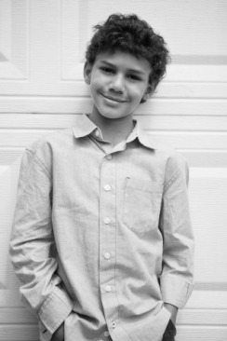  Name | Matt | _________________________________  _________________________________  _________________________________  _________________________________  _________________________________  _________________________________
Surname | Young
Age | 11
Address | 46, Western Bay, Cape Town
Phone number | 084 765 7588
Email | mattyoung@myemail.com

Name No. Class Date
Unit 1.1 Hello, friends!
Writing B
A. Complete the fact file with the information from the box. Then circle the correct option.
Completa os dados com a informação da caixa. Depois, faz um círculo na opção correta.
14, Oak Street, New York robertmiller@myemail.com 212 699 5603 17 Robert Miller
Name | _______________________ | His (1) name / surname is Robert and his surname is (2) Dylan / Miller. He is (3) seven / seventeen years old. His (4) address / phone number is 14, Oak Street, New York. His phone (5) address / number is 212 699 5603 and (6) his / my email is robertmiller@myemail.com.
Surname | _______________________
Age | _______________________
Address | _______________________
Phone number | _______________________
Email | _______________________
B. Complete the text about Kate.
Completa o texto sobre a Kate.
Name | Kate | Her name is (1) _____________________ and her surname is (2)____________________. She is (3)__________________ years old. Her address is (4)____________________. Her phone number is (5)_________________________ and her email is (6)__________________________.
Surname | Walker
Age | 15
Address | 35, Ocean Road, Sydney
Phone number | 028 4778 4590
Email | katewalker@myemail.com
C. Complete the text about Matt.
Completa o texto sobre o Matt.
Name | Matt | His name (1)__________________ and his (2)_______________________ Young. He (3)_______________________ old. His (4)_____________________, Cape Town. (5)____________________ 084 765 7588 and (6)________________________________  mattyoung@myemail.com.
Surname | Young
Age | 11
Address | 46, Western Bay, Cape Town
Phone number | 084 765 7588
Email | mattyoung@myemail.com

A. Read the invitation. Complete the information.
Name No. Class Date
Unit 1.2 Special Days
Writing A
1. When?  Birthday:  Party:  Time:  2. Where?  3. Phone number |   You’re invited to my birthday party!  Hello!  My birthday is on Wednesday, 18th April. I’m 12! My birthday party is on Saturday, 21st April. It’s in the afternoon, at 3 p.m. The party is at my house, on 29, Barnes Road, London.  Can you come? My phone number is  020 3779 1624.  Mark
B. Read the information. Complete the invitation.
When?  Birthday:  Thursday, 6th October  Party: Saturday, 8th October  Time:  In the afternoon / 5 p.m.  Where?  Peter’s restaurant, on 32, Gordon Terrace,  London  Phone number  020 3792 6175 |   You’re invited to my birthday party!  Hello!  My birthday is on (1)__________________. I’m 11! My birthday party is on (2)____________. It’s in the (3)__________, at (4)______________ p.m. The party is at (5)_______________, on (6)______________, London.  Can you come? My phone number is (7)__________________________.  Daisy

C. Read the information. Write the invitation.
When?  Birthday:  Tuesday, 31st January  Party:  Saturday, 4th February  Time: In the afternoon / 4 p.m.  Where?  My house, on 3,  Evergreen Avenue,  London  Phone number  020 7319 6146 |   You’re invited to my birthday party!  Hello!  My birthday is (1) .  I’m 10! My birthday party (2)  .  It’s (3) .  The (4)  .  Can (5) ?  My (6) .  Alan
D. Write the information and the invitation for your birthday party.
When?  Birthday:  .  Party:  .  Time:  .  Where?  .  Phone number  . |   You’re invited to my birthday party!

Name No. Class Date
Unit 1.2 Special Days
Writing B
A. Read the invitation. Choose the correct answer.
Lê o convite. Escolhe a resposta correta.
You’re invited to my birthday party!
Hello!
My birthday is on Wednesday, 18th April. I’m 12! My birthday party is on Saturday, 21st April. It’s in the afternoon, at 3 p.m. The party is at my house, on 29, Barnes Road, London.
Can you come? My phone number is 020 3779 1624.
Mark
1. When is Mark's birthday?  a) Wednesday, 18th April  b) Saturday, 21st April  2. When is the party?  a) Wednesday, 18th April  b) Saturday, 21st April | 3. What time is the party?  a) In the afternoon, at 3 p.m.  b) In the morning, at 10 a.m.  4. What’s his phone number?  a) 020 3779 1534  b) 020 3779 1624
B. Read the information. Complete the invitation.
Lê a informação. Completa o convite.
When?  Birthday:  Thursday, 6th October  Party:  Saturday, 8th October  Time:  In the afternoon / 5 p.m.  Where?  Peter’s restaurant,  on 32, Gordon Terrace,  London  Phone number  020 3792 6175 |   You’re invited to my birthday party!  Hello!  My birthday is on Thursday, (1)___________. I’m 11! My birthday party is on Saturday (2)____________. It’s in the (3)__________, at (4)________ p.m. The party is at (5)_________ restaurant, on 32, (6)____________, London.  Can you come? My phone number is (7)____________.  Daisy
C. Read the information. Write the invitation.
Lê a informação. Escreve o convite.
When?  Birthday:  Tuesday, 31st January  Party: Saturday,4 ^{th} February  Time: In the  afternoon /  4 p.m.  Where?  My house, on 3,  Evergreen Avenue,  London  Phone number  020 7319 6146 |   You’re invited to my birthday party!  Hello!  My birthday is on (1) .  I’m 10! My birthday party is on  (2) .  It’s in (3)  .  The party is at my (4)  .  Can (5) ?  My phone number is  (6) .  Alan
D. Write the information and the invitation for your birthday party.
Escreve a informação e o convite para a tua festa de anos.
When?  Birthday:  .  Party:  .  Time:  .  Where?  .  Phone number  . | You’re invited to my birthday party!  Hello!  My birthday is on (1)  .  I’m (2)_____!  My birthday party is on (3) .  It’s in (4)  .  The party is (5)  .  Can (6) ?  My phone number is (7)  .

Name No. Class Date
Unit 1.3 Where are you from?
Writing A
A. Write the words in the correct order.
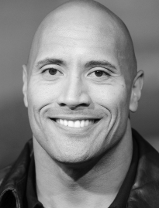 | Full name: Dwayne Douglas Johnson  Nickname: The Rock  From: California, USA  Birthday: 2nd May
1. full name / his / Dwayne Douglas Johnson / is / .

2. “The Rock” / nickname / his / is / .
3. from / he / in / California / is / the United States of America / .

4. is / American / he / .
5. on / is / birthday / 2nd May / his / .
B. Complete the sentences about Zayn Malik.
 | Full name: Zain Javadd Malik  Nickname: Zayn  From: Bradford, England  Birthday: 12th January | 1. His ______________________ Zain Javadd Malik.  2. His nickname ________________________________.  3. He _______________________________, in England.  4. He is __________________________________.  5. His birthday _________________________________.
C. Write a text about Bruno Mars.
Full name: Peter Gene Hernandez  Artistic name: Bruno Mars  From: Hawaii, USA  Birthday: 8th October |  | His full name is…

Name No. Class Date
Unit 1.3 Where are you from?
Writing B

A. Write the words in the correct order.
Escreve as palavras na ordem correta.
Full name: Dwayne Douglas Johnson
Nickname: The Rock
From: California, USA
Birthday: 2nd May

1. His full name / Dwayne Douglas Johnson / is / .
2. “The Rock” / His nickname / is /.
3. from California / He / is / in the United States of America / .
__________________________________________________________________________________
4. is / American / He / .
5. on / is / His birthday / 2nd May / .
B. Complete the sentences about Zayn Malik.
Completa as frases sobre o Zayn Malik.
 | Full name: Zain Javadd Malik  Nickname: Zayn  From: Bradford, England  Birthday: 12th January | 1. His full name is .  2. His nickname is .  3. He is from , in England.  4. He is .  5. His birthday is on .

C. Complete the text about Bruno Mars.
Completa o texto sobre o Bruno Mars.
Full name: Peter Gene Hernandez  Artistic name: Bruno Mars  From: Hawaii, USA  Birthday: 8th October |  | His (1)___________________________ Peter Gene Hernandez. (2)___________________________ Bruno Mars. (3)___________________ Hawaii, in the United States of America. (4)________________ American. (5)______________ ________________________ 8th October.

A. Look at the family tree. Complete the text with the words in the box.
Name No. Class Date
Unit 2.1 Meet my family
Writing A
journalist father grandparents 32 aunt mother nurse chef 36 sisters cousins uncle mechanic grandmother farmer grandfather scientist

Oliver
ME, 8
Farmer

Mary, 60
chef

Tess, 11

Bonnie, 4

Arthur, 2

Anne, 36, scientist

Ellie, 40
nurse

Nate, 65
farmer

Peter, 42
journalist

Mike, 32
mechanic

Emma, 5

Hi! My name is Oliver and this is my family. Tess and Emma are my (1)_____________________. Ellie is my (2)_____________________. She is 40 years old and she is a (3)_____________________. Peter is my (4)_____________________. He is 42 years old and he is a (5)_____________________. Arthur and Bonnie are my (6)_____________________. My (7)_____________________ is Anne. She is a (8)_____________________ and she is (9)_____________________ years old. My (10)__________________ is Mike. He is a (11)_____________________ and he is (12)_____________________ years old. My
(13)_____________________ are Nate and Mary. Nate, my (14)_____________________, is a (15)_____________________. Mary, my (16)_____________________, is a (17)_____________________.
B. Draw your family tree. Write a text.

Name No. Class Date
Unit 2.1 Meet my family
Writing B
A. Look at the family tree. Circle the correct option.
Observa a árvore genealógica. Faz um círculo na opção correta.
Oliver
ME, 8
Farmer

Nate, 65
farmer

Mary, 60
chef

Arthur, 2

Ellie, 40
nurse

Anne, 36
scientist

Tess, 11

Emma, 5

Bonnie, 4

Mike, 32
mechanic

Peter, 42
journalist

Hi! My name is Oliver and this is my family. Tess and Emma are my (1) sisters / cousins. Ellie is my (2) mother / sister. She is 40 years old and she is a (3) nurse / doctor. Peter is my (4) father / brother. He is 42 years old and he is a (5) mechanic / journalist. Arthur and Bonnie are my (6) brothers / cousins. My (7) aunt / uncle is Anne. She is a (8) nurse / scientist and she is (9) 36 / 46 years old. My (10) aunt / uncle is Mike. He is a (11) farmer / mechanic and he is (12) 36 / 32 years old. My (13) parents / grandparents are Nate and Mary. Nate, my (14) grandfather / father, is a (15) journalist / farmer. Mary, my
(16) grandmother / grandfather, is a (17) teacher / chef.
B. Draw your family tree. Write a text.

Name No. Class Date
Unit 2.2 Good looks
Writing A

A. Can you help the detective? Complete the description of the suspects with words from the boxes.
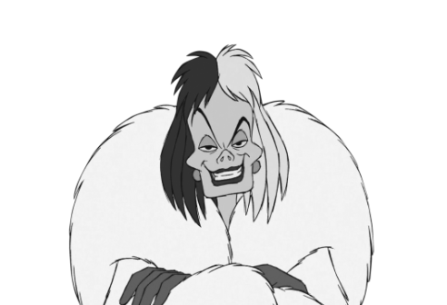 | Cruella de Vil is (1)____________ (height). She is (2)____________ (weight) and (3)____________ (appearance). She has got big green (4)____________ and an ugly (5)____________. Her hair is (6)____________ (length) (7)____________ (style) and (8)____________ (colours). She is very rude.

Height:  - tall  - short | Weight:  - thin  - fat | Appearance:  - ugly  - pretty  - handsome | Eyes:  - big / small  - blue / green / brown / black… | Hair:  - short / medium / long  - straight / wavy / curly  - brown / blonde /  black / white…

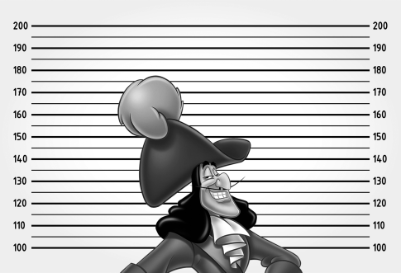 | Captain Hook is (9)____________ (height) and (10)____________ (weight). He has got (11)____________ (size) (12)____________ (colour) eyes, a big nose and a (13)____________ . He has got (14)____________ (length) (15)____________ (style) (16)____________ (colour) hair.
B. Describe the Queen of Hearts. Use the words in the box.
big brown noisy short big head small mouth small nose thin long wavy red

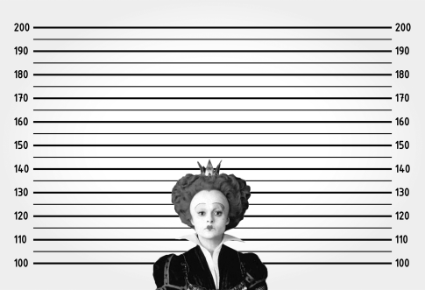 | The Queen of Hearts is (1)_________________ and (2)_______________. She has got a (3)_______________. She has got (4)_____________________ hair and (5)____________________ eyes. She has got a (6)__________________ and a (7)__________________. She is very (8)__________________.

Name No. Class Date
Unit 2.2 Good looks
Writing B
A. Can you help the detective? Circle the correct option.
Consegues ajudar o detetive? Faz um círculo na opção correta.
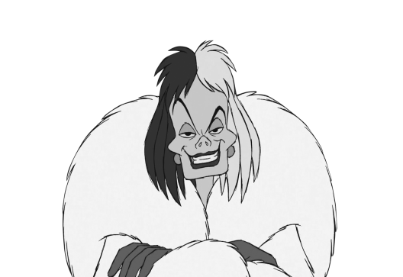 | Cruella de Vil is (1) tall / short. She is (2) fat / thin and (3) pretty / ugly. She has got big green  (4) eyes / hair and an ugly (5) nose / eyes. Her hair is (6) long / medium and (7) curly / straight. She is very rude.

Captain Hook is (8) tall / short and (9) fat / thin. He has got (10) big / small black eyes, a (11) big / small nose and (12) a moustache / glasses. He has got (13) long / medium (14) wavy / straight hair.
B. Describe the Queen of Hearts. Use the words in the box.
Descreve a Rainha de Copas. Usa as palavras da caixa.
short big head big brown small nose thin wavy red small mouth noisy

The Queen of Hearts is (1)_________________ and (2)_______________. She has got a (3)_______________. She has got (4)_____________________ hair and (5)____________________ eyes. She has got a (6)__________________ and a (7)__________________. She is very (8)__________________.

Name No. Class Date
Unit 2.3 I like my clothes
Writing A
A. Read the fact file and the text about Ed Sheeran.
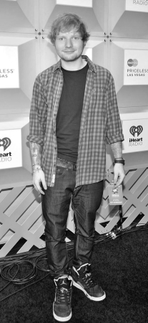 |  |  | This is Ed Sheeran. He is a British singer. He has got short straight red hair and green eyes. He is tall and thin.  Ed is wearing grey trainers, black trousers, a black T-shirt and a red and black shirt. He has got a watch.
 | Name: | Ed Sheeran
 | Nationality: | British
 | Job: | singer
 | Hair colour: | red
 | Eyes: | green
 | Height: | 1.73 m
 | Weight: | 80 kg
B. Colour the picture. Complete the text.
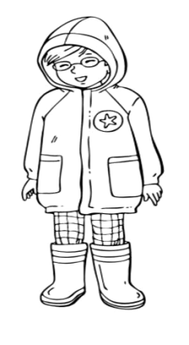 | Name: | Sarah Smith | This is (1)___________________. She is an (2)____________________. She has got (3)__________________ hair and she has got (4)_____________________. She is (5)_______________________ and (6)____________________. Sarah is wearing (7)_______________ boots, (8)_______________ trousers and a (9)________________ hoodie.
 | Nationality: | Australian
 | Job: | student
 | Hair colour: | brown
 | Glasses
 | Height: | 1.10 m
 | Weight: | 20 kg
C. Colour the picture. Complete the fact file. Write a text.
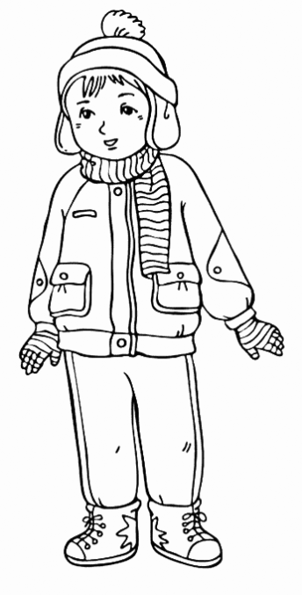 | Name: | ___________
 | Nationality: | ___________
 | Job: | ___________
 | Hair colour: | ___________
 | Eyes: | ___________
 | Height: | ___________
 | Weight: | ___________

Name No. Class Date
Unit 2.3 I like my clothes
Writing B

A. Read the fact file and the text about Ed Sheeran.
Lê a informação e o texto sobre o Ed Sheeran.
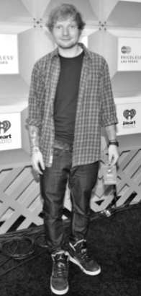 |  |  | This is Ed Sheeran. He is a British singer. He has got short straight red hair and green eyes. He is tall and thin.  Ed is wearing grey trainers, black trousers, a black T-shirt and a red and black shirt. He has got a watch.
 | Name: | Ed Sheeran
 | Nationality: | British
 | Job: | singer
 | Hair colour: | red
 | Eyes: | green
 | Height: | 1.73 m
 | Weight: | 80 kg
B. Colour the picture. Complete the text.
Pinta o desenho. Completa o texto.
 | Name: | Sarah Smith | This is (1)_____________. She is an (2)____________________. She has got (3)_____________ (colour) hair and she has got (4)_____________________. She is (5)_________________ (height) and (6)_____________ (weight). Sarah is wearing (7)____________ (colour) boots, (8)___________ (colour) trousers and a (9)_____________ (colour) hoodie.
 | Nationality: | Australian
 | Job: | student
 | Hair colour: | brown
 | Glasses
 | Height: | 1.10 m
 | Weight: | 20 kg
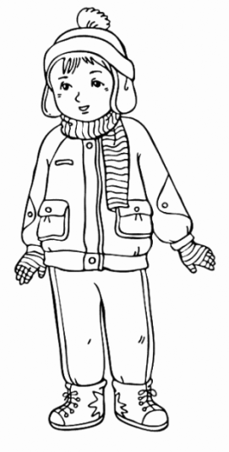
C. Colour the picture. Complete the fact file. Write a text.
Pinta o desenho. Completa a informação. Escreve um texto.
 | Name: | ____________ | This is __________________________________. He is ____________________________________  ________________________________________.  He has got _____________________________  _____________________________________ hair and___________ eyes. He is __________ and ______________.
 | Nationality: | ____________
 | Job: | ____________
 | Hair colour: | ____________
 | Eyes: | ____________
 | Height: | ____________
 | Weight: | ____________
 | He is wearing

A. Look at the house. Complete the text.
Name No. Class Date
Unit 3.1 Our house
Writing A
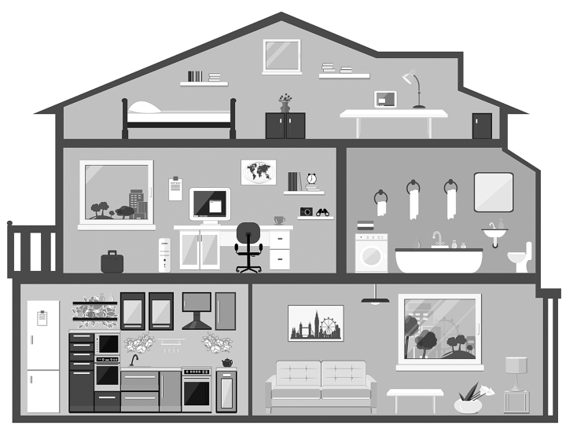
There are two floors in my house. On the ground floor there is a (1)_________________ and a (2)______________________. On the first floor there is a (3)_____________________________ and a (4)_____________________________ . In the attic, there is a (5)____________________________ My house is small but it’s very cosy!

B. Look at the house. Complete the text.
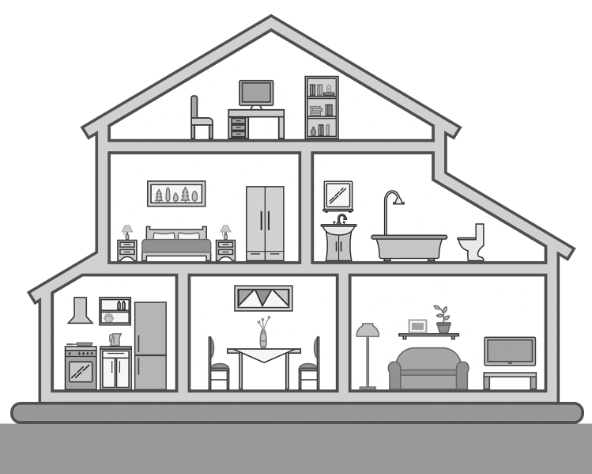
(1)________________________ two floors in my house. (2)_____________________, there is (3)_____________________, (4)_____________________ and (5) ________________________. On the first floor, there is (6) _________________________ and (7)________________________. In the attic, there is (8)________________________. My house is very comfortable and I love it!

C. Draw a house. Then write a text about it.

A. Look at the house. Circle the correct option.
Olha para a casa. Faz um círculo na opção correta.
Name No. Class Date
Unit 3.1 Our house
Writing B
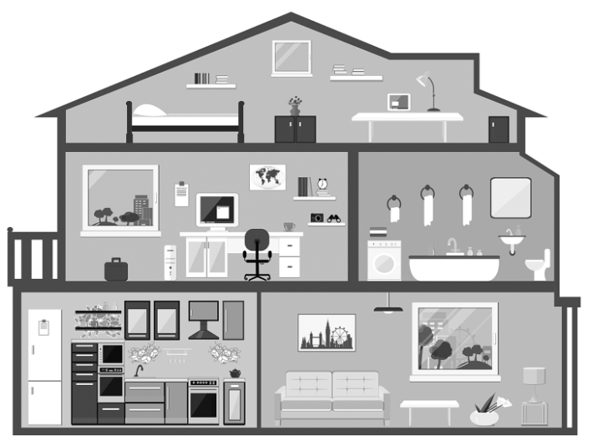
There are two floors in my house. On the ground floor, there is a (1) study / living room and a (2) kitchen / bedroom. On the first floor, there is a (3) bedroom / study and a (4) bathroom / dining room. In the attic, there is a (5) living room / bedroom. My house is small but it’s very cosy!

B. Look at the house. Circle the correct option.
Olha para a casa. Faz um círculo na opção correta.
There are (1) two / four floors in my house. On the ground floor, there is a
(2) toilet / kitchen, a (3) dining room / bedroom and a (4) study / living room. On the first floor, there is a (5) garden / bedroom and a (6) bathroom / kitchen. In the attic, there is a (7) bathroom / study. My house is very comfortable and
I love it!

C. Draw a house. Then write a text about it.
Desenha uma casa. Depois, escreve um texto sobre ela.

A. Read the text and complete the second column.
Name No. Class Date
Unit 3.2 There’s no place like home!
Writing A
What?  1 big bed  1 lamp  2 rugs  1 wardrobe  1 bookcase | Where?  ________________________  ________________________  ________________________  ________________________  ________________________ |   Welcome to my bedroom! This is my favourite place in the house. There is a big bed between two bedside tables. On the bedside table, there is a lamp. There are two rugs next to the bed. There’s a wardrobe near the window and there’s a bookcase opposite the bed.  Otto, 15, Germany
B. Read the information on the left. Write the text.
What?  1 small bed  1 desk  1 chair  books  1 wardrobe  1 rug  toys  1 lamp | Where?  between the wall and the bedside table  opposite the bed  near the desk  on the desk  next to the desk  under the desk  in the wardrobe  above the desk | .    Ginny, 12, Australia
C. What is there in your bedroom? Complete the information on the left. Then write a text.
What? | Where?

Name No. Class Date
Unit 3.2 There’s no place like home!
Writing B
A. Read the text and underline the information from the columns on the left.
Lê o texto e sublinha a informação das colunas da esquerda.
What?  1 big bed  1 lamp  2 rugs  1 wardrobe  1 bookcase | Where?  between 2 bedside tables  on the bedside table  next to the bed  near the window  opposite the bed | Welcome to my bedroom! This is my favourite place in the house. There is a big bed between two bedside tables. On the bedside table, there is a lamp. There are two rugs next to the bed. There’s a wardrobe near the window and there’s a bookcase opposite the bed.  Otto, 15, Germany
B. Read the information on the left. Complete the text.
Lê a informação do lado esquerdo. Completa o texto.
What?  1 small bed  1 desk  1 chair  books  1 wardrobe  1 rug  toys  1 lamp | Where?  between the wall and the bedside table  opposite the bed  near the desk  on the desk  next to the desk  under the desk  in the wardrobe  above the desk | This is my bedroom. I like it very much! There is a (1)_________________ between (2)__________________________. Opposite (3)_________________ there’s a (4)_______________ and (5)____________ the desk there’s (6)_____________. There are some (7)________________ the desk. The (8)_________________ is next to the desk and there’s a rug (9)__________________________. I have got some (10)_____________ in (11)_____________________. There’s a lamp (12)______________.  Ginny, 12, Australia
C. What have you got in your bedroom? Complete the information on the left. Then write a text.
O que tens no teu quarto? Completa a informação do lado esquerdo. Depois, escreve um texto.
What? | Where?

Name No. Class Date
Unit 3.3 Activities at home
Writing A
A. Look at the picture. What are they doing? Where are they? Write a text.
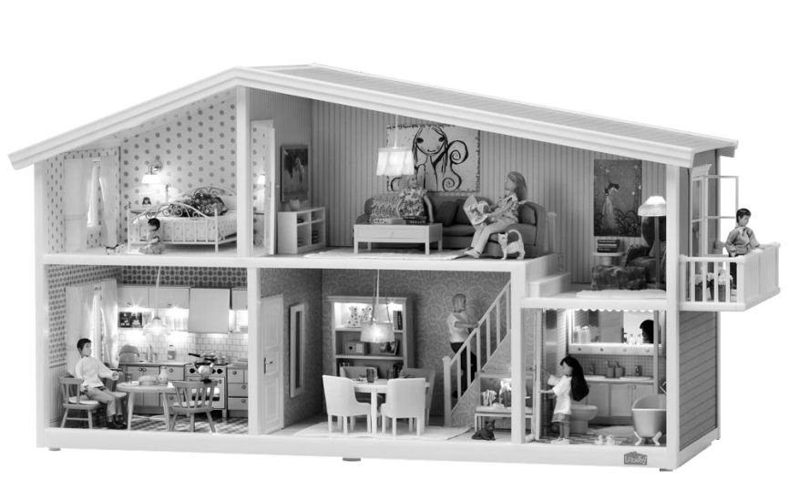
Mary

Mr Burton

Grandma Marge

Grandpa Nate

Lisa

Mrs Burton



It’s Sunday! The Burtons are at home. Lisa is singing in the bathroom.…….……………..……….

Name No. Class Date
Unit 3.3 Activities at home
Writing B
A. Look at the picture. What are they doing? Where are they? Write a text. Use the verbs in the box.
Observa a ilustração. O que estão a fazer? Onde estão? Escreve um texto. Usa os verbos da caixa.
singing eating reading going upstairs playing with the dog sitting on the sofa
Mary

Mr Burton

Grandma Marge

Grandpa Nate

Lisa

Mrs Burton

It’s Sunday! The Burtons are at home. Lisa is singing in the bathroom.…………….……..……….

Name No. Class Date
Unit 4.1 Food and drink
Writing A

A. Complete the text.
Mary’s favourite food is (1)___________________________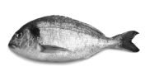, her favourite drink is (2)___________________________ and her favourite fruit is (3)_________________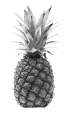. She doesn’t like (4)__________________  or (5)___________________ 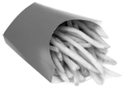 but she likes (6)______________________ 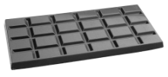.
B. Complete the text.
Tom’s favourite food is (1)____________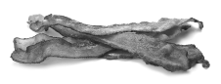 and (2)___________ 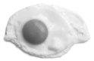 and his favourite dessert is (3)_____________________________________________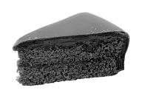. He likes (4)____________________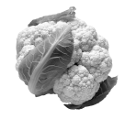and (5)________________________  but he doesn’t like (6)____________________  or (7)____________________ .
C. And you? Write a text about your food preferences.

Name No. Class Date
Unit 4.1 Food and drink
Writing B

A. Complete the text. Use the words in the box. One word is not necessary.
Completa o texto. Usa as palavras da caixa. Uma palavra não é necessária.
orange juice hamburgers pineapple chips fish melon chocolate
Mary’s favourite food is (1)_____________________________, her favourite drink is (2)_______________________ and her favourite fruit is (3)_________________. She doesn’t like (4)__________________ or (5)___________________ but she likes (6)______________________ .
B. Complete the text. Use the words in the box. One word is not necessary.
Completa o texto. Usa as palavras da caixa. Uma palavra não é necessária.
cake yoghurt onion eggs peaches peas bacon cauliflower
Tom’s favourite food is (1)____________ and (2) _________________ and his favourite dessert is (3)_______________________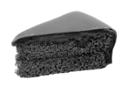. He likes (4)_________________and (5)____________________ but he doesn’t like (6)____________________ or (7)____________________ .
C. And you? Write a text about your food preferences.
E tu? Escreve um texto sobre as tuas preferências alimentares.
My favourite food is _______________________________________, my favourite drink is ____________________________________ , my favourite fruit is ________________________________ and my favourite dessert is ___________________________________________________. I don’t like ______________________________________ or ______________________________________ but I like ____________________________.

Name No. Class Date
Unit 4.2 Nice meals
Writing A

A. Choose food from the box to complete the table.
vegetable soup orange juice rice carrot soup apple strawberries
ham sandwich roast chicken potatoes grilled fish cheesecake
jam on toast tomato salad lemonade broccoli
breakfast | lunch | snack | dinner
______________  ______________ | ______________  ______________  ______________  ______________  ______________  ______________ | ______________  ______________ | ______________  ….grilled fish….  ______________  ______________  ______________  ______________
B. Complete the text about Michelle. Use the information in A.
Michelle is a student. She has breakfast before she goes to school. She eats (1)______________ and she drinks (2)______________. She has lunch at school. Today, lunch is (3)______________, (4)______________ with (5)______________ and (6)______________. She drinks (7) ______________ and for dessert she eats an (8)______________. In the afternoon she has a snack. She eats a (9)______________ and drinks (10)______________. She has dinner at home. Dinner today is (11) ___________ and (12)_____________ with (13)_____________ and (14)_____________. The dessert is (15)______________.
C. Complete the table about you. Write a text.
breakfast | lunch | snack | dinner
______________  ______________ | ______________  ______________  ______________  ______________ | ______________  ______________ | ______________  ______________  ______________  ______________

Name No. Class Date
Unit 4.2 Nice meals
Writing B

A. Choose food from the box to complete the table.
Escolhe comida da caixa para completar a tabela.
vegetable soup orange juice rice carrot soup apple strawberries ham sandwich roast chicken potatoes grilled fish cheesecake jam on toast tomato salad lemonade broccoli chips
breakfast | lunch | snack | dinner
______________  ______________ | ______________  ______________  ______________  ______________  ______________  ______________ | ______________  ______________ | ______________  ….grilled fish….  ______________  ______________  ______________  ______________
B. Complete the text about Michelle. Use the information in A.
Completa o texto sobre a Michelle. Usa a informação em A.
Michelle is a student. She has breakfast before she goes to school. She eats (1)_________________ and she drinks (2)_________________. She has lunch at school. Today, lunch is (3)_________________, (4)_________________ with (5)_________________ and (6)_________________. She drinks (7)_________________ and for dessert, she eats (8)_________________. In the afternoon she has a snack. She eats (9)_________________ and drinks (10)_________________. She has dinner at home. Dinner today is (11)_______________ and (12)______________ with (13)______________ and (14)______________. The dessert is (15)______________.
C. First complete the table about you. Then complete the text.
Primeiro completa a tabela sobre ti. Depois, completa o texto.
breakfast | lunch | snack | dinner
______________  ______________ | ______________  ______________  ______________  ______________ | ______________  ______________ | ______________  ______________  ______________  ______________
I’m a student. I have breakfast _____________________________. I eat _________________ and I drink ___________________. I have lunch at ____________________. Today, lunch is ___________________________________________________________. I drink __________________ and for dessert I eat __________________. In the afternoon I have a snack. I eat _____________________ and drink ___________________. I have dinner at home, at ____________________. Dinner today is _______________________________________________. The dessert is _________________.

Name No. Class Date
Unit 5.1 My day
Writing A

A. Read Mark’s daily planner. Complete the information.
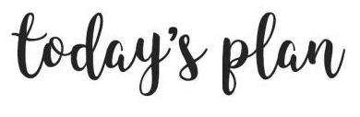 | Mark (1)_______________ at seven o’clock. He (2)___________ a shower, (3)_______________ and has (4)_________________. He eats cereal and milk and butter on toast. He (5)________________ his teeth and (6)___________________ by bus at eight o’clock. Lessons (7)_______________ at half (8)______________. At (9)________________ one, he (10)_____________ in the school (11)____________ with Max and Harry. In the afternoon, lessons (12)______________ at (13)____________ three. He (14)_________________ at half (15)__________________ and he (16)_____________ homework. He (17)___________ at (18)____________ seven. At half (19)____________, he (20)__________ pyjamas and he (21)_______________ TV. He (22)_______________ at (23)____________.
  7.00 | get up, have shower, get dressed, have breakfast, brush his teeth
  8.00 | go to school by bus
  8.30 | lessons start
  10.00
  11.00
  12.00
  13.15 | have lunch in the canteen
  14.45 | lessons start
  15.00
  16.00
  17.30 | go home, do the homework
  18.00
  19.30 | have dinner
  20.30 | put on pyjamas, watch TV
  21.00 | go to bed
B. Complete the daily planner with your daily routine. Write a text about you.
7.00
8.00
8.30
10.00
11.00
12.00
13.15
14.45
15.00
16.00
17.30
18.00
19.30
20.30
21.00

Name No. Class Date
Unit 5.1 My day
Writing B

A. Read Mark’s daily planner. Complete the information.
Lê o horário do Mark. Completa a informação.
has start (2x) does his past eight (2x) quarter past gets dressed has lunch puts on his
gets up goes home has dinner watches breakfast goes to bed nine o’clock brushes
past five goes to school quarter to half past canteen
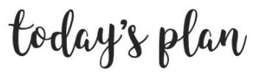 | Mark (1)_______________ at seven o’clock. He (2)___________ a shower, (3)_______________ and has (4)_________________. He eats cereal and milk and butter on toast. He (5)________________ his teeth and (6)___________________ by bus at eight o’clock. Lessons (7)_______________ at half (8)______________. At (9)________________ one, he (10)_____________ in the school (11)____________ with Max and Harry. In the afternoon, lessons (12)______________ at (13)____________ three. He (14)_________________ at half (15)__________________ and he (16)_____________ homework. He (17)___________ at (18)____________ seven. At half (19)____________, he (20)__________ pyjamas and he (21)_______________ TV. He (22)_______________ at (23)____________.
  7.00 | get up, have shower, get dressed, have breakfast, brush teeth
  8.00 | go to school by bus
  8.30 | lessons start
  10.00
  11.00
  12.00
  13.15 | have lunch in the canteen
  14.45 | lessons start
  15.00
  16.00
  17.30 | go home, do the homework
  18.00
  19.30 | have dinner
  20.30 | put on pyjamas, watch TV
  21.00 | go to bed
B. Complete the daily planner with your daily routine. Write a text about you.
Completa o horário com a tua rotina diária. Escreve um texto sobre ti.
7.00
8.00
8.30
10.00
11.00
12.00
13.15
14.45
15.00
16.00
17.30
18.00
19.30
20.30
21.00

Name No. Class Date
Unit 5.2 Free time activities
Writing A

A. Look at the pictures about Mark’s holidays. Complete the text.
Mark is a very active teenager. Even when he doesn’t have school, he’s still very busy. He gets up early, at (1)_____________________ 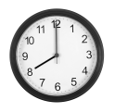 and he goes to the beach. He likes (2)___________________ 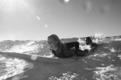. At the beach, he (3)__________________  with his friends. In the afternoon, he goes (4)__________________  in the park, then he goes home and he plays (5)__________________ . In the evening, he spends time with his family and he (6)__________________ TV .
B. What do you do during the summer holidays?
Write a text about a perfect summer day to you.
Ideas:

On a perfect summer day I get up
at11111111111111111111111111111111111111111111

I love the summer holidays! 1111111111
- go to the beach / swimming pool
- go surfing / running / swimming / skateboarding
- read a book / the newspaper / a magazine
- ride my bike
- play football / volleyball
- watch TV
- play video games / computer games
- go to the cinema / to a summer camp
- spend time with my family / friends

Name No. Class Date
Unit 5.2 Free time activities
Writing B

A. Look at the pictures about Mark’s holidays. Complete the text. Use the words in the box. One is not necessary.
Observa as fotografias das férias do Mark. Completa o texto. Usa as palavras da caixa. Uma não é necessária.
skateboarding surfing rides his bike watches eight o’clock
video games plays volleyball

Mark is a very active teenager. Even when he doesn’t have school, he’s still very busy. He gets up early, at (1)_____________________ and he goes to the beach. He likes (2)___________________ . At the beach, he (3)__________________ with his friends. In the afternoon, he goes (4)__________________ in the park, then he goes home and he plays (5)__________________ . In the evening, he spends time with his family and he (6)__________________ TV .
B. What do you do during the summer holidays? Write a text about a perfect summer day to you.
O que fazes nas férias de verão? Escreve um texto sobre um dia de verão perfeito para ti.
Ideas:

On a perfect summer day I get up
at11111111111111111111111111111111111111111111

Then, I
In the afternoon, I1111111111111111111111
In the evening, I1111111111111111111111111
I love the summer holidays! 1111111111
- go to the beach / swimming pool
- go surfing / running / swimming / skateboarding
- read a book / the newspaper / a magazine
- ride my bike
- play football / volleyball
- watch TV
- play videogames / computer games
- go to the cinema / to a summer camp
- spend time with my family / friends

