Name No. Class Date
Placement test
A. What do you say? Match the pictures to the sentences.
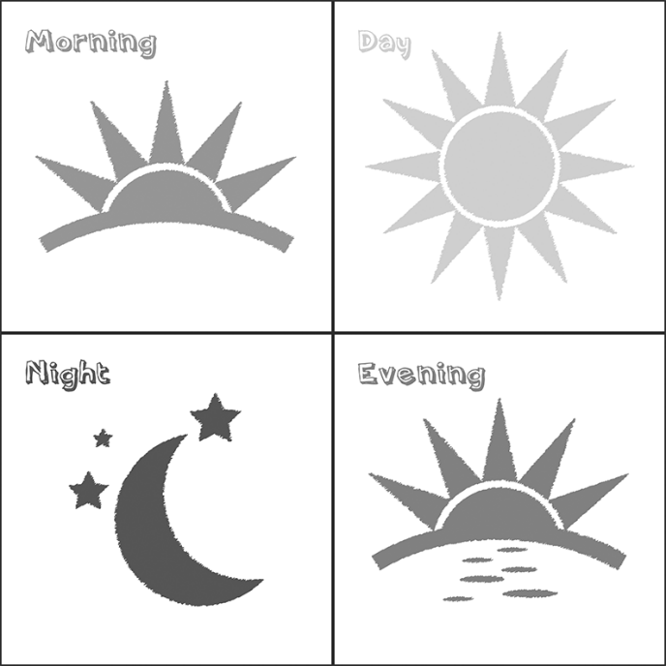  a | b | c | d
1. Good night | 2. Good evening | 3. Good morning | 4. Good afternoon

B. Match the columns.
1. My name is |  |  | a. football.
2. Hello! I am fine, |  |  | b. Simon Wilson.
3. My favourite colour is |  |  | c. blue.
4. I like |  |  | d. on 15th November.
5. My birthday is |  |  | e. shining.
6. The sun is |  |  | f. thanks.
C. Circle the correct option.
 | 
1. The rabbit is on / behind the tree. | 2. The dog is under / on the table.
 | 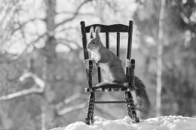
3. The cat is next to / in the box. | 4. The squirrel is on / in the chair.

D. True (T) or False (F)?
 |  | T | F
 | 1. The dog is black.
 | 2. She has got long hair.
 | 3. This is an apple.
 | 4. I have got a hat.
 | 5. This is a chicken.
E. Find the name in the box.
bike sun shoes flower ice cream dress eyes pen
 |  |  | 
1. ______________ | 2. ______________ | 3. ______________ | 4. ______________
 |  | 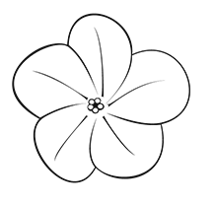 | 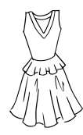
5. ______________ | 6. ______________ | 7. ______________ | 8. ______________
F. Write the words in the correct order.
1. Baker / name / His / is / John / .
2. is / years / John / ten / old / .
3. got / He / a / dog / has / .
4. playing / He / football / is / .
Name No. Class
Date Mark Teacher
Unit 1 Listening Test

A. Part 1. Listen and choose the correct option. CD 3 Track 15
1. This is class
a. 5A. |  | b. 5B. |  | c. 5C.
2. His name
a. Alice. |  | b. Olivia. |  | c. Oliver.
3. His surname is
a. Gordon. |  | b. Grant. |  | c. Brown.
4. He is
a. English. |  | b. Spanish. |  | c. American.
5. His birthday is on
a. 4th July. |  | b. 31st October. |  | c. 1st January.
B. Part 1. Listen again and match the columns. CD 3 Track 15
1. The teacher’s name is |  |  | a. new student.
2. He is the |  |  | b. 11 years old.
3. He is from |  |  | c. Alice Grant.
4. He is |  |  | d. New York.
C. Part 2. Listen and complete the dialogue. CD 3 Track 16
At the Library
Teacher: What’s (1)_____________________ (2)_____________________?
Tessa: Tessa, Tessa Wilson.
Teacher: What’s your (3)_____________________?
Tessa: It’s Park Avenue, (4)_____________________.
Teacher: And (5)_____________________ your (6)_____________________ number?
Tessa: It’s (7)_____________________.
Name No. Class
Date Mark Teacher
Unit 1 Progress Test
Personal ID / Personal pronouns / Verb to be / Possessive determiners
A
I – Reading

A. Read the text.
 | My favourite singer
5 | Hi! I’m Cindy Hudson and I am a student. I am 10 years old and I love music. My favourite singer is Shawn Mendes. He is Canadian. He is from Toronto. His mother is English and his father is Portuguese. His birthday is on 8th August and his official email address is info@shawnmendesofficial.com. His concert is next Saturday here in London. I’m so excited about it!
B. True (T) or False (F)?
 | T | F
1. Her full name is Cindy Mendes.
2. Shawn is her favourite singer.
3. Shawn is from London.
4. He is Portuguese.
5. Cindy is excited about the concert in London.
C. Answer the questions.
1. What is her name?

2. How old is she?

3. Is Shawn Mendes her favourite singer?

4. Is Shawn’s mother Portuguese?

5. When is the concert in London?

II – Vocabulary
A. Write the numbers in full.
8  15  33  42  57 | 69  71  87  96  100
B. Write the words in the box in the correct column.
Chinese May Ireland Thursday Scottish Brazil October Germany
Friday August Greek Wednesday March France Russian
1. Months | 2. Days of the week | 3. Nationalities | 4. Countries
III – Grammar
A. Complete with personal pronouns.
1. Derek is Australian. ___________ is 10 years old.
2. Gary and I are friends. ___________ are in class 5A.
3. Mrs Gordon is very nice. ___________ is the maths teacher.
4. This is a dog. ___________ is black and white.
5. David and Sophie are the new students. ___________ are French.
B. Complete with the verb to be.
1. Where ___________ you from? We ___________ from Madrid.
2. I ___________ (not) a student. I ___________ a teacher.
3. What nationality ___________ she? She ___________ Italian.
4. How old ___________ they? They ___________ 9 years old.
5. ___________ they Canadian? No, they ___________.
C. Complete with possessive determiners.
1. Jasmine and I are sisters. ___________ surname is Foster.
2. This is my brother. ___________ name is Jake.
3. The kids have got a cat. ___________ name is Peanut.
4. The girls are Japanese. ___________ names are Aiko and Fuji.
5. You are 11 years old. ___________ birthday is in July.
IV – Writing
A. Write about Mateo Gibson.
Library Member Card
Name: Mateo
Surname: Gibson
Nationality: English
Age: 11
Birthday: 23rd November

Address: 25, Beaumont St, Oxford
Phone number: 1865 879 146

Name No. Class
Date Mark Teacher
Unit 1 Progress Test
Personal ID / Personal pronouns / Verb to be / Possessive determiners
B
I – Reading
A. Read the text.
 | My favourite singer
5 | Hi! I’m Cindy Hudson and I am a student. I am 10 years old and I love music. My favourite singer is Shawn Mendes. He is Canadian. He is from Toronto. His mother is English and his father is Portuguese. His birthday is on 8th August and his official email address is info@shawnmendesofficial.com. His concert is next Saturday here in London. I’m so excited about it!
B. Complete the ID card.

Singer’s ID Card
Name:
Surname:
Nationality:
Email:
Birthday:
C. Match the columns. Two do not apply.
1. Her name is |  |  | a. is Shawn Mendes.
2. She is |  |  | b. is Portuguese.
3. Her favourite singer |  |  | c. 11 years old.
4. Shawn’s father |  |  | d. about the concert.
5. Cindy is excited |  |  | e. English.
 |  |  | f. Cindy.
 |  |  | g. 10 years old.

II – Vocabulary
A. Write the numbers.
eight  fifteen  thirty-three  forty-two  fifty-seven | ________  ________  ________  ________  ________ | sixty-nine  seventy-one  eighty-seven  ninety-six  a hundred | ________  ________  ________  ________  ________
B. Write the words in the box in the correct column.
Chinese May Ireland Thursday Scottish Brazil October Germany
Friday August Greek Wednesday March France Russian
1. Months | 2. Days of the week | 3. Nationalities | 4. Countries
III – Grammar
A. Complete with the personal pronouns in the box.
she they he it we
1. Derek is Australian. ___________ is 10 years old.
2. Gary and I are friends. ___________ are in class 5A.
3. Mrs Gordon is very nice. ___________ is the maths teacher.
4. This is a dog. ___________ is black and white.
5. David and Sophie are the new students. ___________ are French.
B. Circle the correct form of the verb to be.
1. Where are / is you from? We am / are from Madrid.
2. I am / is not a student. I is / am a teacher.
3. What nationality are / is they? They is / are Italian.
4. How old is / am she? She is / am 9 years old.
5. Are / Am they Canadian? No, they aren’t / isn’t.
C. Complete with the possessive determiners in the box.
their your our his its
1. Jasmine and I are sisters. ___________ surname is Foster.
2. This is my brother. ___________ name is Jake.
3. The kids have got a cat. ___________ name is Peanut.
4. The girls are Japanese. ___________ names are Aiko and Fuji.
5. You are 11 years old. ___________ birthday is in July.
IV – Writing
A. Complete the text about Mateo Gibson.
Library Member Card  Name: Mateo  Surname: Gibson  Nationality: English  Age: 11  Birthday: 23rd November  Address: 25, Beaumont St, Oxford  Phone number: 1865 879 146 | His name is (1)______________________ and his (2)______________________ Gibson.  He is (3)______________________.  He (4)______________________ 11 years old and  his birthday (5)_________________________________.  His address is (6)___________________________  ______________________ and (7)___________________  is 1865 879 146.

Unit 1 – Listening Test
Instrumento de Avaliação – Compreensão oral
Objetivos | Domínio Intercultural | Estrutura | Cotações | Critérios  de Correção
• Compreender discursos simples, articulados  de forma clara  e pausada | Conhecer-se a si e ao outro  Identificar-se a si e ao outro | A. Escolha múltipla  B. Associação  C. Completamento  de espaços | 5 x 6 = 30  4 x 7 = 28  7 x 6 = 42 | Certo / Errado  Certo / Errado  Certo / Errado
 | Conhecer-se a si e ao outro  Identificar-se a si e ao outro |  | Total: 100 | Certo / Errado  Certo / Errado  Certo / Errado

Unit 1 – Progress Test A
Instrumento de Avaliação – Leitura, léxico, gramática e escrita
Objetivos | Domínio Intercultural | Estrutura | Cotações | Critérios  de Correção
• Compreender textos breves  e simples: reconhecer informação  que lhe é familiar | Conhecer  o seu meio  e o dos outros para compreender  a diversidade  Identificar-se a si e ao outro | I  B. Verdadeiro / Falso  (sem referência  e correção  das afirmações falsas)  C. Resposta curta | 5 x 2 = 10  5 x 3 = 15 | Certo / Errado  Certo / Errado
- Aplicar itens lexicais relacionados com as áreas temáticas previstas no Domínio Intercultural (identificar-se a si  e ao outro) |  | II  A. Completamento de espaços  B. Preenchimento  de uma tabela | 10 x 1 = 10  15 x 1 = 15 | Certo / Errado  Certo / Errado
- Aplicar estruturas elementares  do funcionamento  da língua nas áreas temáticas previstas no Domínio Intercultural (to be; personal pronouns; possessive determiners) |  | III  A. Completamento de espaços  B. Completamento de espaços  C. Completamento de espaços | 5 x 2 = 10  10 x 1 = 10  5 x 2 = 10 | Certo / Errado  Certo / Errado  Certo / Errado
- Produzir um texto simples (escrever frases a partir  de informação dada) |  | IV  Produção de texto | 20 | Competência pragmática: 12 Competência linguística: 8  (ver níveis  de desempenho  na página 314)
 |  | IV  Produção de texto | Total: 100

Unit 1 – Progress Test B
Instrumento de Avaliação – Leitura , léxico, gramática e escrita
Objetivos | Domínio Intercultural | Estrutura | Cotações | Critérios  de Correção
• Compreender textos breves e simples: reconhecer informação que lhe é familiar | Conhecer o seu meio e o dos outros para compreender  a diversidade  Identificar-se a si e ao outro | I  B. Recolha  de informação  C. Associação | 5 x 2 = 10  5 x 3 = 15 | Certo / Errado  Certo / Errado
- Aplicar itens lexicais relacionados com as áreas temáticas previstas no Domínio Intercultural (identificar-se a si e ao outro) |  | II  A. Completamento  de espaços  B. Preenchimento  de uma tabela | 10 x 1 = 10  15 x 1 = 15 | Certo / Errado  Certo / Errado
- Aplicar estruturas elementares  do funcionamento  da língua nas áreas temáticas previstas no Domínio Intercultural (to be; personal pronouns; possessive determiners) |  | III  A. Completamento  de espaços  B. Seleção  de alternativa  C. Completamento  de espaços | 5 x 2 = 10  10 x 1 = 10  5 x 2 = 10 | Certo / Errado  Certo / Errado  Certo / Errado
- Produzir um texto simples (escrever frases a partir  de informação dada) |  | IV  Produção de texto | 20 | Competência pragmática: 12 Competência linguística: 8  (ver níveis de desempenho  na página 314)
 |  | IV  Produção de texto | Total: 100

Name No. Class
Date Mark Teacher
Unit 2 Listening Test
A. Part 1. Listen to Steve. Fill in the family tree. Follow the example. CD 3 Track 17
  (1) ___________ – ___________ |  |  |   (2) ___________ – ___________
  Rose – mother |   (3) _________ – _________ |  |   (4) _________ – _________ |   (5) _________ – _________
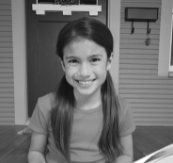  (6) _________ – _________ |  |   Steve – me |   (7) _________ – _________
B. Part 2. Listen to Jenny and fill in the blanks. CD 3 Track 18
Meet my family. My (1)_____________, Mark Parker, has got short (2)_____________ and a (3)_____________ face. He’s an (4)_____________. My mum has got long (5)_____________ hair and green eyes. She has got new clothes: a yellow (6)_____________ and a brown (7)_____________. She is a (8)_____________ at a hotel.
I have got (9)_____________ brown hair and an oval face. I am happy because I have got a new (10)____________.
C. Part 3. Listen to Meg and Zack. Tick () the correct answer. CD 3 Track 19
1. Meg likes
a. skirts and tops. |  | b. dresses and tops. |  | c. shorts and skirts.
2. Zack’s favourite accessories are
a. belts and watches. |  | b. scarves and caps. |  | c. scarves and gloves.

Name No. Class
Date Mark Teacher
Unit 2 What are they like?
Family / Jobs / Physical appearance and personality
To have got / Possessive case / Possessive pronouns
A

I – Reading
A. Read the text.
 | This is my family
5  10 |   My name is Paul and this is a picture of my family. Look at it! It’s my father’s birthday.  John is my father and Carol is my mother. My father is tall and thin. He has got short straight hair. He is a vet. He has got new clothes: trousers, two T-shirts and a sweater.  My mum is very nice. She has got long straight hair. Her eyes are blue. She’s a taxi driver.  My parents have got two children, my sister Lily and I. I’ve got blonde hair and blue eyes. My sister Lily is five years old. She’s beautiful and very funny. We have got two pets: a dog, Toby, and a cat, Kitty.  My grandparents are friendly. They have got a daughter. She is my aunt Laura.
B. Match the two columns to make true sentences.
1. John and Carol are |  |  | a. a taxi driver.
2. Paul’s father has got new |  |  | b. clothes.
3. Carol is |  |  | c. Paul’s parents.
4. Paul’s parents have got |  |  | d. a son and a daughter.
C. Complete the sentences.
1. John and Carol have got two ______________________: Paul and Lily.
2. John’s new clothes are: ______________________, ______________________ and _____________________.
3. Lily ______________________ sister.
4. Paul’s grandparents are ______________________________.
D. Answer the questions.
1. What is John’s job?
2. What’s Paul’s mum like?
3. How old is Lily?
4. What are the family pets?
II – Vocabulary
A. Complete.
1. My father’s parents are my .  2. My mother’s mother is my . | 3. My uncle’s wife is my .  4. My uncle’s son is my .
B. Complete the words.
 | 
1. l __ __ g st __ __ __ __ __ __ hair | 2. s __ __ __ __ w __ __ __ hair
C. What are their jobs? Label the pictures.
 | 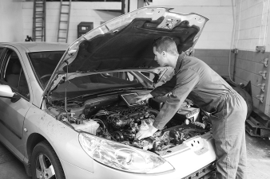 | 
1. ___________________ | 2. ___________________ | 3. ___________________
III – Grammar
A. Write questions for the underlined words.
1. ?
Yes, she has. Carol has got a brother.
2 ?
Lily has got blonde hair and blue eyes.
3. ?
This is Paul’s anorak.
B. Fill in the blanks with the correct form of the verb to have got.
1. Lily _______________ (not) new trainers. She _______________ new shoes.
2. _______________ Paul and Lily _______________ two pets? Yes, they _______________.
3. Paul and his mum _______________ blue eyes but they _______________ (not) curly hair.
4. _______________ Lily _______________ a sister? No, she _______________.

C. Use the possessive case ’s or ’.
1. John ________ new trousers are brown.
2. Paul: My grandparents ________ dog is white.
3. Paul is Charles ________ best friend.
D. Fill in the blanks with the correct possessive pronoun.
1. Paul: Lily, is this cap ________?
Lily: No, it isn’t ________. It’s Roger’s. It’s ________.
2. John: This is our house. It’s ________.
3. This is my sister’s skirt. It’s ________.
4. John’s children have got new mobile phones. They are ________.
IV – Writing
Describe a member of your family.
Name / age |  | My __________________________________
Physical appearance:  – tall, short... /  fat, thin…  – short, long… / straight, wavy... / brown… hair  – blue, brown… eyes |  | My __________________________________
Personality:  friendly, nice, lazy, active, calm,  hard-working… |  | My __________________________________

Name No. Class
Date Mark Teacher
Unit 2 Progress Test
Family / Jobs / Physical appearance and personality
To have got / Possessive case / Possessive pronouns
B
I – Reading
A. Read the text.
 | This is my family
5  10 | My name is Paul and this is a picture of my family. Look at it! It’s my father’s birthday.  John is my father and Carol is my mother. My father is tall and thin. He has got short straight hair. He is a vet. He has got new clothes: trousers, two T-shirts and a sweater.  My mum is very nice. She has got long straight hair. Her eyes are blue. She’s a taxi driver.  My parents have got two children, my sister Lily and I. I’ve got blonde hair and blue eyes. My sister Lily is five years old. She’s beautiful and very funny. We have got two pets: a dog, Toby, and a cat, Kitty.  My grandparents are friendly. They have got a daughter. She is my aunt Laura.
B. Match the two columns to make true sentences.
1. Paul’s father is tall and |  |  | a. a taxi driver.
2. He has got new trousers |  |  | b. two T-shirts and a sweater.
3. Paul’s mum is |  |  | c. two children.
4. Paul’s parents have got |  |  | d. thin.
C. True (T) or False (F)? T F
1. John and Carol are Paul’s father and mother.
2. Paul’s father has got a new skirt.
3. Paul’s parents have got two daughters.
D. Answer the questions.
1. What is John’s job? He is a .
2. What’s Paul’s mum like? She is nice and she has got .
3. How old is Lily? years old.
II – Vocabulary
A. Complete with grandmother, aunt, cousin and grandparents.
1. My father’s parents are my .  2. My mother’s mother is my . | 3. My uncle’s wife is my .  4. My uncle’s son is my .
B. Complete. Choose from the box.
wavy straight short long
1. _________________ _________________ hair | 2. ________________ ________________ hair
C. What are their jobs? Label the pictures.
1. F11111111111111111111111 | 2. M1111111111111111111111 | 3. P111111111111111111111
III – Grammar
A. Write questions for the underlined words. Use the words in brackets to help you.
1. ? (Have got / Carol / brother)
Yes, she has. Carol has got a brother.
2. ? (What / Lily / like)
Lily has got blonde hair and blue eyes.
3. ? (Whose / anorak)
This is Paul’s anorak.
B. Fill in the blanks with have got, has got, haven’t got or hasn’t got.
1. Lily _____________________ (not) new trainers. She _____________________ new shoes.
2. _____________________ Paul and Lily _____________________ two pets?
3. Paul and his mum _____________________ blue eyes but they _____________________ (not) curly hair.
4. _____________________ Lily _____________________ a sister?
5. John _____________________ new clothes but Carol _____________________ new shoes.
C. Use the possessive case ’s or ’.
1. John _______ new trousers are brown.
2. Paul: My grandparents _______ dog is white.
3. Charles _______ best friend is Paul.
D. Fill in the blanks with the correct possessive pronoun. Choose from the box.
his hers ours theirs mine yours
1. Paul: Lily, is this cap ______________?
Lily: No, it isn’t ______________. It’s Roger’s. It’s ______________
2. John: This is our house. It’s ______________.
3. This is my sister’s pullover. It’s ______________.
4. John’s children have got new mobile phones. They are ______________.
IV – Writing
Describe a member of your family.
Name / age |  | My __________________________________________  My ______________________________ name is ______________________________.  He/she ______________________________ years old.  He/she is ______________________________ and ______________________________  He/she has got hair.  He/she has got eyes.  He/she is
Physical appearance:
– tall, short... /
fat, thin…
– short, long… / straight, wavy... / brown… hair
– blue, brown… eyes
Personality:
friendly, nice, lazy, active, calm,
hard-working…

Unit 2 – Listening Test
Instrumento de Avaliação – Compreensão oral
Objetivos | Domínio  Intercultural | Estrutura | Cotações | Critérios  de Correção
• Compreender discursos simples, articulados  de forma clara  e pausada | Conhecer o seu meio e o dos outros para compre-ender a diversidade: laços de parentesco, profissões, características elementa-res de personalidade e físicas e peças de vestuário | A. Preenchimento  de diagrama  B. Preenchimento  de espaços  C. Seleção  de informação | 7 x 4 = 28  10 x 6 = 60  2 x 6 = 12 | Certo / Errado  Certo / Errado
 |  |  | Total: 100 | Certo / Errado  Certo / Errado
Unit 2 – Progress Test A
Instrumento de Avaliação – Leitura, léxico, gramática e escrita
Objetivos | Domínio Intercultural | Estrutura | Cotações | Critérios  de Correção
• Compreender textos breves  e simples: reconhecer informação  que lhe é familiar | Conhecer o seu meio e o dos outros para compreender  a diversidade: identificar laços  de parentesco; profissões; características elementares,  de personalidade  e físicas | I  B. Associação  C. Completamento de espaços  D. Respostas  a perguntas sobre o texto | 4 x 3 = 12  4 x 3 = 12  4 x 3 = 12 | Certo / Errado  Certo / Errado  Certo/Parcialmente certo /Errado  (Conteúdo certo: 3 pontos  Conteúdo parcialmente certo: 1 a 2  Conteúdo errado: 0)
- Aplicar itens lexicais relacionados com as áreas temáticas previstas no Domínio Intercultural |  | II  A. Completamento de frases  B. Preenchimento  de espaços  C. Legendagem  de imagens | 4 x 2 = 8  2 x 1 = 2  3 x 1 = 3 | Certo / Errado  Certo / Errado  Certo / Errado
- Aplicar estruturas elementares  do funcionamento  da língua nas áreas temáticas previstas no Domínio Intercultural (to have got; possessive case; possessive pronouns) |  | III  A. Completamento de frases  B. Preenchimento  de espaços  C. Preenchimento  de espaços  D. Preenchimento de espaços | 3 x 2 = 6  8 x 2 = 16  3 x 1 = 3  6 x 1 = 6 | Certo / Errado  Certo / Errado  Certo / Errado  Certo / Errado
- Produzir um texto simples |  | IV  Produção de texto | 20 | Competência pragmática: 12 Competência linguística: 8  (ver níveis  de desempenho  na página 314)
- Produzir um texto simples |  | IV  Produção de texto | Total: 100

Unit 2 – Progress Test B
Instrumento de Avaliação – Leitura, léxico, gramática e escrita
Objetivos | Domínio Intercultural | Estrutura | Cotações | Critérios  de Correção
• Compreender textos breves e simples: reconhecer informação que lhe é familiar | Conhecer o seu meio e o dos outros para compreender  a diversidade: identificar laços  de parentesco; profissões; características elementares,  de personalidade  e físicas | I  B. Associação  C. Verdadeiro / Falso  D. Completamento de espaços | 4 x 3 = 12  3 x 3 = 9  3 x 5 = 15 | Certo / Errado  Certo / Errado  Certo / Parcialmente certo / Errado  (Conteúdo certo: 3 pontos  Conteúdo parcialmente certo: 1 a 2  Conteúdo errado: 0)
- Aplicar itens lexicais relacionados com as áreas temáticas previstas no Domínio Intercultural (Identificar laços  de parentesco; profissões; caracterís-ticas elementares,  de personalidade  e físicas; peças de vestuário) |  | II  A. Completamento de frases  B. Preenchimento  de espaços  C. Legendagem  de imagens | 4 x 2 = 8  2 x 1 = 2  3 x 1 = 3 | Certo / Errado  Certo / Errado  Certo / Errado
- Aplicar estruturas elementares do funcionamento da língua nas áreas temáticas previstas no Domínio Intercultural (to have got; possessive case; possessive pronouns) |  | III  A. Completamento de frases  B. Preenchimento  de espaços  C. Preenchimento  de espaços  D. Preenchimento de espaços | 3 x 2 = 6  8 x 2 = 16  3 x 1 = 3  6 x 1 = 6 | Certo / Errado  Certo / Errado  Certo / Errado  Certo / Errado
- Produzir um texto simples |  | IV  Produção de texto | 20 | Competência pragmática: 12 Competência linguística: 8  (ver níveis  de desempenho  na página 314)
- Produzir um texto simples |  | IV  Produção de texto | Total: 100

Name No. Class
Date Mark Teacher
Unit 3 Listening Test

A. Part 1. Listen to Logan and tick () the correct answer. CD 3 Track 20
1. Logan’s garage is
a. next to the garden. b. behind the house. c. next to the house.

2. Logan’s favourite room is
a. the kitchen. b. the study. c. the living room.

3. His favourite room is
a. upstairs. b. next to the kitchen. c. next to the bathroom.

4. The sofa is
a. brown. b. black. c. white.

5. The TV is on
a. the desk. b. a table. c. the bookcase.

B. Part 2. Listen to Emily. Are the sentences True (T) or False (F)? CD 3 Track 21
 | T | F
1. There are two floors in Emily’s house.
2. There is a dining room downstairs.
3. The kitchen is small.
4. There is a garden.
5. The study is on the first floor.

Name No. Class Date
Date Mark Teacher
Unit 3 Progress Test
House and furniture / There to be / Prepositions of place and movement / Present Continuous
A
I – Reading
A. Read the text.
 | Our house
5  10 | We’re the Robson family. We’re from Sydney in Australia. I’m Thomas and my wife is Susan. We’ve got two daughters.    We’ve got a house with a small garden. Upstairs there is our bedroom, a bathroom and one bedroom for the girls. Downstairs there is a kitchen, a living room and a toilet. We have lunch and dinner in the kitchen because there isn’t a dining room in our house. Behind the house there is the garden with two trees. We’re very happy with our garden. The garage is next to the house.  My wife is in the garden and she is reading a book. Our dog, Lucky, is playing with a ball in the garden. I’m in the kitchen with the girls. We’re cooking lunch and a chocolate cake. Today is Susan’s birthday.
B. True (T) or False (F)? Correct the false sentences.
 | T | F
1. Thomas Robson and his family are English.
2. Their house has got one floor.
3. There are two bedrooms for the girls.
4. They have got a pet.
5. Susan isn’t cooking at the moment.

C. Answer the questions about the text.
1. Where is Mr and Mrs Robson’s house?

2. How many floors are there?

3. Where is the bathroom?

4. Is there a garage?

5. Are the girls in the garden?

6. What is Mr Robson doing?

II – Vocabulary
A. Write the name of the object under the picture.
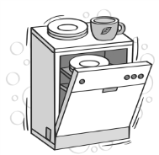 |  |  |  |  | 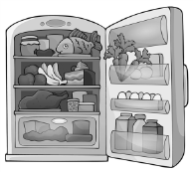
1. ________________ | 2. ________________ |  | 3. ________________ |  | 4. ________________
 |  |  |  | 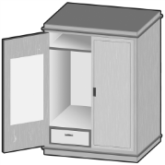
5. ________________ |  | 6. ________________ |  | 7. ________________
III – Grammar
A. Ask the questions.
1. ?
Yes, there is. There is a small garden.
2. ?
There are two bedrooms in my house.
3. ?
My mother is reading a book.
4. ?
She is in the garden.
B. Look at the picture. Complete the sentences with the correct prepositions.
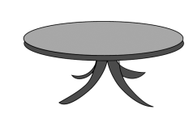    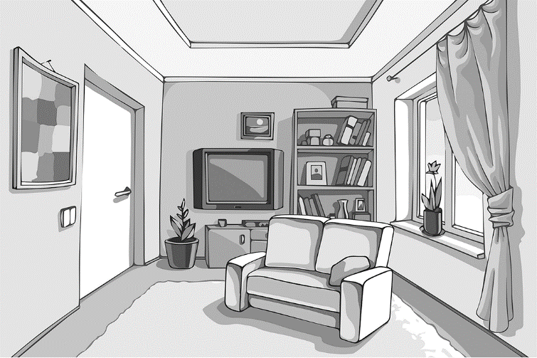 | 1. The bookcase is ___________ the sofa.  2. The window is ____________ the door.  3. The TV is ____________ the door and the bookcase.  4. The pot plant is ___________ the door.  5. There is a lamp ___________ the coffee table.
C. Complete the sentences with the Present Continuous of the verbs in brackets.
1. ____________________ Susan ____________________ her husband in the kitchen? (help)
No, she ____________________. She ____________________ a book. (read)
2. Susan ____________________ because it’s her birthday. (not cook)
3. Thomas and his children ____________________ the dishes at the moment. (not do)
They ____________________ the birthday party. (prepare)
4. Lucky, the dog, ____________________ with a ball in the garden. (play) He ____________________ a lot of noise. (make)
IV – Writing
Look at the picture. Describe the room and write what the people are doing.
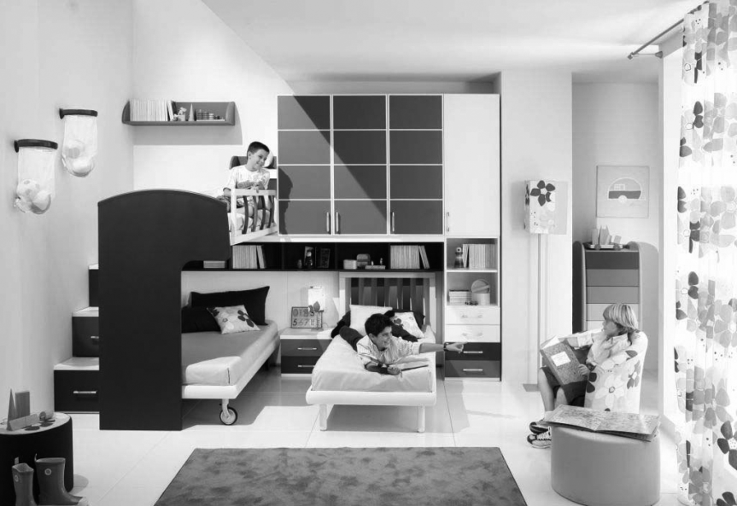

Name No. Class Date
Date Mark Teacher
Unit 3 Progress Test
House and furniture / There to be / Prepositions of place and movement / Present Continuous
B
I – Reading
A. Read the text.
 | Our house
5  10 | We’re the Robson family. We’re from Sydney in Australia. I’m Thomas and my wife is Susan. We’ve got two daughters.  We’ve got a house with a small garden. Upstairs there is our bedroom, a bathroom and one bedroom for the girls. Downstairs there is a kitchen, a living room and a toilet. We have lunch and dinner in the kitchen because there isn’t a dining room in our house. Behind the house there is the garden with two trees. We’re very happy with our garden. The garage is next to the house.  My wife is in the garden and she is reading a book. Our dog, Lucky, is playing with a ball in the garden. I’m in the kitchen with the girls. We’re cooking lunch and a chocolate cake. Today is Susan’s birthday.
B. Complete the table.
 | Family |  |  | House
1. surname |  |  | 4. number of floors
2. country |  |  | 5. number of bedrooms
3. name of the pet
C. Match the columns. There is one extra option.
1. Thomas and Susan have got |  |  | a. small garden.
2. There is a |  |  | b. trees in the garden.
3. The bathroom is |  |  | c. in the kitchen.
4. There are two |  |  | d. on the first floor.
5. Susan isn’t |  |  | e. two children.
6. Thomas’s daughters are |  |  | f. a dining room.
 |  |  | g. sleeping.

II – Vocabulary
A. Write the correct name under the picture.
bedside table armchair dishwasher wardrobe washbasin bath fridge
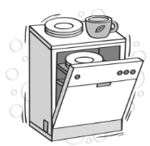 |  |  | 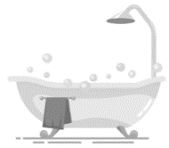 |  | 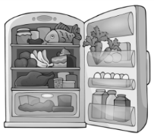
1. ________________ | 2. ________________ |  | 3. ________________ |  | 4. ________________
 |  |  |  | 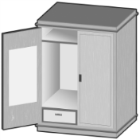
5. ________________ |  | 6. ________________ |  | 7. ________________
III – Grammar
A. Ask the questions.
1. ? (There to be / a / small garden)
Yes, there is. There is a small garden.
2. ? (How many / bedrooms / there to be)
There are two bedrooms in my house.
3. ? (What / your mother / do)
My mother is cooking lunch.
4. ? (Where / your mother / be)
She is in the kitchen.
B. Look at the picture. Complete the sentences with the words in the box.
on behind next to between opposite

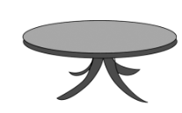  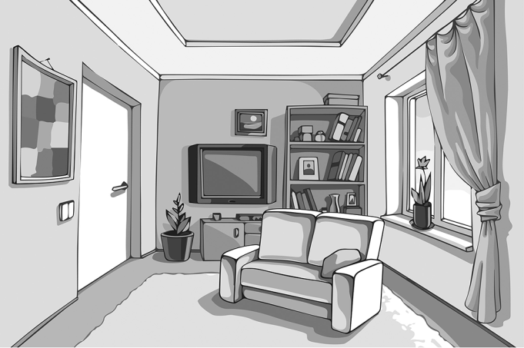 | 1. The bookcase is __________ the sofa.  2. The window is ___________ the door.  3. The TV is ____________ the door and the bookcase.  4. The pot plant is __________ the door.  5. There is a lamp ___________ the coffee table.

C. Complete the sentences with the Present Continuous of the verbs in brackets.
1. Thomas ____________________ the dishes at the moment. (do)

Remember this!
am, is, are +
verb + -ing

2. ____________________ you ________________ TV now? (watch)
No, I ________________. I _________________ a book. (read)
3. The girls _______________________ in the garden. (not play)
4. They _______________________ their father in the kitchen. (help)
5. She _______________________ her bed now. (make)
IV – Writing
Look at the picture. Describe the room and write what the people are doing. Use the words in the box.
bed bedside table bookshelf wardrobe lamp rug armchair
reading talking laughing

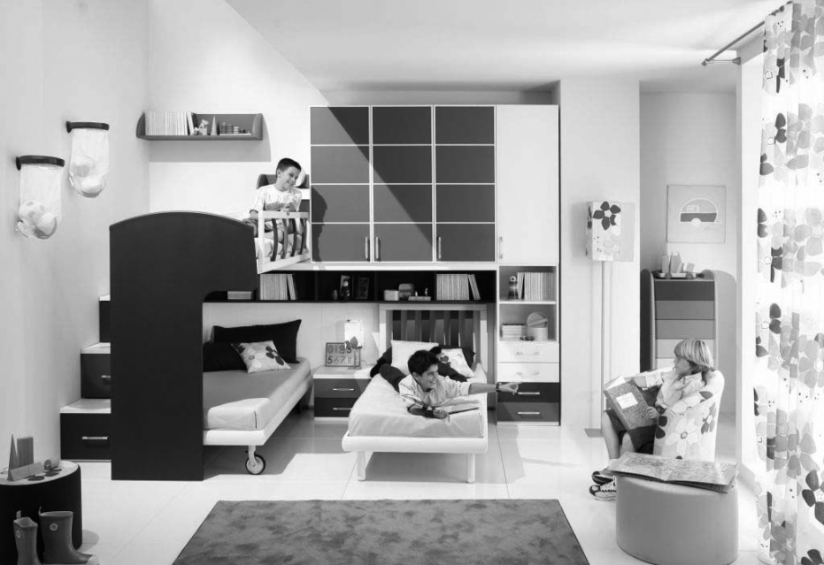

Unit 3 – Listening Test
Instrumento de Avaliação – Compreensão oral
Objetivos | Domínio Intercultural | Estrutura | Cotações | Critérios  de Correção
- Compreender discursos simples, articulados  de forma clara  e pausada | Conhecer o seu meio e o dos outros para compreender  a diversidade: identificar as divisões da casa e o mobiliário | A. Escolha múltipla  B. Verdadeiro / falso | 5 x 10 = 50  5 x 10 = 50 | Certo / Errado  Certo / Errado
 |  | A. Escolha múltipla  B. Verdadeiro / falso | Total: 100 | Certo / Errado  Certo / Errado
Unit 3 – Progress Test A
Instrumento de Avaliação – Leitura, léxico, gramática e escrita
Objetivos | Domínio Intercultural | Estrutura | Cotações | Critérios  de Correção
• Compreender textos breves e simples: reconhecer informação que lhe é familiar | Conhecer o seu meio e o dos outros para compreender  a diversidade: identificar  as divisões  da casa  e o mobiliário | I  B. Verdadeiro / falso com correção das afirmações falsas  C. Respostas  a perguntas sobre  o texto | Afirmações verdadeiras e sem referência: 2 x 1 = 2  (B. 4; B. 5)  Afirmações falsas  3 x 2 = 6  (B. 1; B. 2; B. 3)  6 x 4 = 24 | Certo / Errado  Certo / Parcialmente Certo / Errado  (Conteúdo certo: 4 pontos  Conteúdo parcialmente certo: 1 a 3  Conteúdo errado: 0)
- Aplicar itens lexicais relacionados com as áreas temáticas previstas no Domínio Intercultural (divisões da casa e mobiliário) |  | II  Legendagem de imagens | 7 x 2 = 14 | Certo / Errado
- Aplicar estruturas elementares do funcionamento da língua nas áreas temáticas previstas no Domínio Intercultural (there to be; prepositions of place and movement; Present Continuous) |  | III  A. Completamento de frases  B. Completamento de frases  C. Completamento de frases | 4 x 2 = 8  5 x 2 = 10  8 x 2 = 16 | Certo / Errado  Certo / Errado  Certo / Errado
- Produzir um texto simples (descrever  uma imagem) |  | IV  Produção de texto | 20 | Competência pragmática: 12 Competência linguística: 8  (ver níveis  de desempenho  na página 314)
- Produzir um texto simples (descrever  uma imagem) |  | IV  Produção de texto | Total: 100

Unit 3 – Progress Test B
Instrumento de Avaliação – Leitura, léxico, gramática e escrita
Objetivos | Domínio Intercultural | Estrutura | Cotações | Critérios  de Correção
• Compreender textos breves e simples: reconhecer informação que lhe  é familiar | Conhecer o seu meio e o dos outros para compreender  a diversidade: identificar  as divisões  da casa  e o mobiliário | I  B. Preenchimento  de tabela  C. Associação | 5 x 2 = 10  6 x 4 = 24 | Certo / Errado  Certo / Errado
- Aplicar itens lexicais relacionados com as áreas temáticas previstas no Domínio Intercultural (divisões da casa e mobiliário) |  | II  Legendagem de imagens | 7 x 2 = 14 | Certo / Errado
- Aplicar estruturas elementares do funcionamento da língua em as áreas temáticas previstas no Domínio Intercultural (there to be; prepositions of place and movement; Present Continuous) |  | III  A. Completamento  de frases  B. Completamento  de frases  C. Completamento  de frases | 4 x 2 = 8  5 x 2 = 10  7 x 2 = 14 | Certo / Errado  Certo / Errado  Certo / Errado
- Produzir um texto simples (descrever uma imagem) |  | IV  Produção de texto | 20 | Competência pragmática: 12 Competência linguística: 8  (ver níveis  de desempenho  na página 314)
- Produzir um texto simples (descrever uma imagem) |  | IV  Produção de texto | Total: 100

Name No. Class Date
Date Mark Teacher
Unit 4 Listening Test
A. Listen to Megan and tick () the food she likes and cross (✗) the food she doesn’t like. CD 3 Track 22
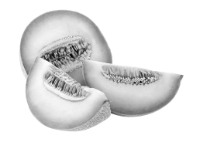 |  | 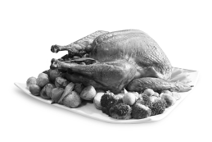 | 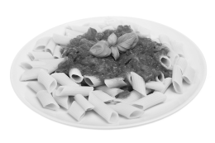
1. melon | 2. water | 3. roast chicken | 4. pasta with tomato
 |  |  | 
5. peaches | 6. fish and chips | 7. orange juice | 8. sausages
 | 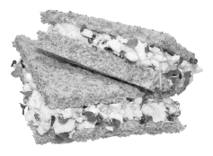
9. strawberry pudding | 10. sandwiches

B. Listen and circle the correct word. CD 3 Track 22
1. Megan has lunch in the school canteen / at home every day.
2. She doesn’t like / likes sandwiches.
3. Her favourite food is pasta / pizza with tomato.
4. She likes bananas and peaches / melon.
5. She sometimes has fruit /pudding for dessert.
C. Listen and complete. CD 3 Track 22
1. Megan doesn’t like fish and chips and __________________.
2. She likes roast __________________.
3. She likes water and __________________ juice but she __________________ orange juice.
4. She usually has fruit __________________.
Name No. Class Date
Date Mark Teacher
Unit 4 Progress Test
Food and drinks / Verb to like / Some and any
A

I – Reading

A. Read the text.
 | My lunch box
5  10 | My name is Jane Taylor and I’m 10 years old.  I like my school very much and I’m in year 5.  I take my lunch to school every day. In my lunch box I have sandwiches, fruit and vegetables (for example, carrot sticks – I love them!). I like cheese and ham sandwiches very much. They are delicious!  I don’t like fish and I don’t like tuna sandwiches. Apples and grapes are my favourite fruit. I don’t like strawberries. I usually have water, but I like orange juice too. I don’t like lemonade.  For dessert I have some biscuits or a chocolate bar. Today there aren’t any biscuits in my lunch box but there is a chocolate muffin. It’s yummy!
B. True (T) or False (F)? Correct the false sentences.
 | T | F
1. Jane takes her lunch to school in a bag.
2. There are sandwiches in her lunch box.
3. Tuna sandwiches are delicious.
4. She doesn’t like strawberries.
5. There’s a chocolate bar in her lunch box.

C. Answer these questions.
1. What vegetables does Jane like a lot?

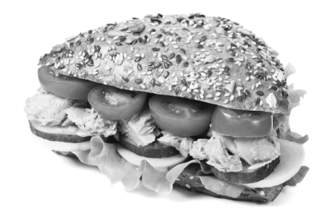
2. Does she like tuna sandwiches?

3. What is Jane’s favourite fruit?

4. Does she like orange juice?

5. Are there any biscuits in her lunch box today?

II – Vocabulary
A. Label the pictures.
 | 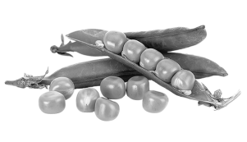 |  | 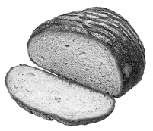 | 
1. ______________ | 2. ______________ | 3. ______________ | 4. ______________ | 5. ______________
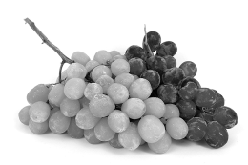 |  | 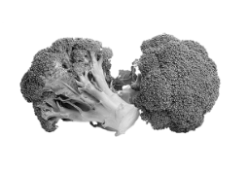 |  |   
6. ______________ | 7. ______________ | 8. ______________ | 9. ______________ | 10. ______________
III – Grammar
A. Complete with the verb to like.
1. I ________________________ vegetables but I ________________________ (not) peas.
2. Jane’s brother ________________________ ham sandwiches but he _______________________ (not) fish.
3. What food ______________________ you ______________________ for breakfast? We ______________________ cereal and yoghurt. We ______________________ (not) apple juice.
4. My parents ___________________ (not) pizza very much but they ____________________ pasta a lot.
5. ______________________ Sarah ______________________ soup? No, she ______________________.
B. Write sentences with the verb to like ( affirmative;✗negative; ? interrogative).
1. Jessie / cauliflower ✗
2. Robert / hot chocolate
3. your sisters / like / pancakes / ?
4. Kids / not like / fish / very much ✗
5. Melinda / like / cupcakes / ?

C. Complete with some or any.
1. There are ___________ bananas on the shelf.
2. There aren’t ___________ strawberries.
3. Are there ___________ apples? Yes, there are.
4. There is ___________ cheese but there isn’t ___________ coffee.
IV – Writing
A. This is Lydia, Jane’s sister. Write about the food and drinks Lydia likes and doesn’t like.
 |  |   
For breakfast | cereal / fruit / apple juice | coffee / bacon
For lunch | chicken / rice | hamburger
For lunch | To drink: water | coke (yucky!)
For lunch | For dessert: pears / bananas | cupcakes
For dinner | grilled fish / vegetables | pizza
For dinner | To drink: orange juice | lemonade
For dinner | For dessert: ice cream (yummy) | melon

Name No. Class Date
Date Mark Teacher
Unit 4 Progress Test
Food and drinks / Verb to like / Some and any
B
I – Reading
A. Read the text.
 | My lunch box
5  10 | My name is Jane Taylor and I’m 10 years old.  I like my school very much and I’m in year 5.  I take my lunch to school every day. In my lunch box I have sandwiches, fruit and vegetables (for example, carrot sticks – I love them!). I like cheese and ham sandwiches very much. They are delicious!  I don’t like fish and I don’t like tuna sandwiches. Apples and grapes are my favourite fruit. I don’t like strawberries. I usually have water, but I like orange juice too. I don’t like lemonade.  For dessert I have some biscuits or a chocolate bar. Today there aren’t any biscuits in my lunch box but there is a chocolate muffin. It’s yummy!
B. Complete the table.
1. name |  |  | 6. fruit she likes
2. surname |  |  | 7. fruit she doesn’t like
3. age |  |  | 8. drinks she likes
4. year at school |  |  | 9. drinks she doesn’t like
5. sandwiches she likes |  |  | 10. dessert for today
C. True (T) or False (F)?
 | T | F
1. Jane takes her lunch to school in a bag.
2. There are sandwiches in her lunch box. |  | 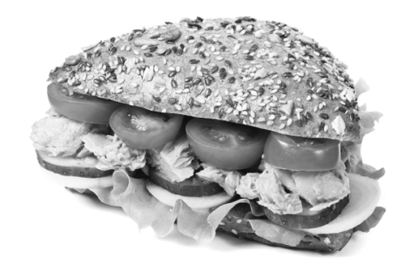
3. Tuna sandwiches are delicious.
4. She doesn’t like strawberries.
5. There’s a chocolate bar in her lunch box.

II – Vocabulary
A. Label the pictures with the words in the box.
pineapple wine bread broccoli carrots coffee grapes eggs water peas
1. ______________ | 2. ______________ | 3. ______________ | 4. ______________ | 5. ______________
6. ______________ | 7. ______________ | 8. ______________ | 9. ______________ | 10. ______________
III – Grammar
A. Circle the correct option.
1. I like / likes vegetables but I don’t / doesn’t like peas.
2. Jane’s brother like / likes ham sandwiches but he don’t / doesn’t like fish.
3. What food do / does you like / likes for breakfast?
4. My parents don’t / doesn’t like pizza very much but they like / likes pasta a lot.
5. Do / Does Sarah like / likes soup? No, she don’t / doesn’t.
B. Write sentences with the verb to like.
1. Jessie / not like / cauliflower / .
2. Robert / like / hot chocolate / .
3. your sisters / like / pancakes / ?
4. Kids / not like / fish / very much / .
5. Melinda / like / cupcakes / ?

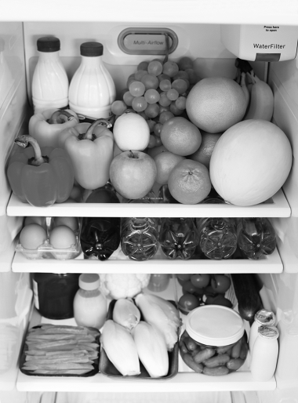
C. True (T) or False (F)?
 | T | F
1. There are some grapes.
2. There aren’t any strawberries.
3. There aren’t any apples.
4. There isn’t any chicken.
5. There are some eggs.

IV – Writing
This is Lydia, Jane’s sister. Write about the food and drinks Lydia likes and doesn’t like.
 |  | 
For breakfast | cereal / fruit / apple juice | coffee / bacon
For lunch | chicken / rice | hamburger
For lunch | To drink: water | coke (yucky!)
For lunch | For dessert: pears / bananas | cupcakes
For dinner | grilled fish / vegetables | pizza
For dinner | To drink: orange juice | lemonade
For dinner | For dessert: ice cream (yummy) | melon
For breakfast Lydia likes (1)_______________________, fruit and (2)_______________________. She (3)_______________________ coffee or bacon.
For lunch she likes (4)_______________________ and (5)_______________________ but she doesn’t like (6)_______________________. To drink she likes (7)_______________________ but she (8)_______________________ coke because it’s (9)_______________________. For dessert she (10)______________________ pears or (11)___________________________ but she doesn’t like (12)_____________________.
For dinner she (13)_______________________ grilled fish and (14)_______________________ but she (15)_______________________ pizza. To drink she likes (16)_______________________ but she doesn’t like (17)_______________________. For dessert she (18)_______________________ ice cream because it’s (19)_______________________ but she (20)_______________________ melon.

Unit 4 – Listening Test
Instrumento de Avaliação – Compreensão oral
Objetivos | Domínio Intercultural | Estrutura | Cotações | Critérios  de Correção
• Compreender discursos simples, articulados  de forma clara  e pausada | Conhecer o seu meio e o dos outros para compreender  a diversidade: identificar diferentes tipos de alimentos | A. Seleção  de informação  B. Seleção  de informação  C. Completamento de espaços | 10 x 5 = 50  5 x 5 = 25  5 x 5 = 25 | Certo / Errado  Certo / Errado  Certo / Errado
 |  |  | Total: 100 | Certo / Errado  Certo / Errado  Certo / Errado
Unit 4 – Progress Test A
Instrumento de Avaliação – Leitura, léxico, gramática e escrita
Objetivos | Domínio Intercultural | Estrutura | Cotações | Critérios  de Correção
• Compreender textos breves e simples: reconhecer informação que lhe é familiar | Conhecer o seu meio e o dos outros para compreender  a diversidade: identificar diferentes tipos de alimentos | I  B. Verdadeiro /  falso (com correção  das afirmações falsas)  C. Responder  a perguntas sobre o texto | Afirmações verdadeiras e sem referência: 2 x 1 = 2  (B. 2; B. 4)  Afirmações falsas  3 x 2 = 6  (B. 1; B. 3; B. 5)  5 x 3 = 15 | Certo / Errado  Certo / Parcialmente certo / Errado  (Conteúdo certo: 4 pontos  Conteúdo parcialmente certo: 1 a 3  Conteúdo errado: 0)
- Aplicar itens lexicais relacionados com as áreas temáticas previstas no Domínio Intercultural (diferentes tipos  de alimentos) |  | II  Legendagem de imagens | 10 x 2 = 20 | Certo / Errado
- Aplicar estruturas elementares  do funcionamento  da língua nas áreas temáticas previstas no Domínio Intercultural (to like; some and any) |  | III  A. Completamento de espaços  B. Construção  de frases  C. Completamento de espaços | 11 x 2 = 22  5 x 2 = 10  5 x 1 = 5 | Certo / Errado  Certo / Errado  Certo / Errado
- Produzir um texto simples (a partir  de informação dada) |  | IV  Produção de texto | 20 | Competência pragmática: 12 Competência linguística: 8  (ver níveis  de desempenho  na página 314)
- Produzir um texto simples (a partir  de informação dada) |  | IV  Produção de texto | Total: 100

Unit 4 – Progress Test B
Instrumento de Avaliação – Leitura, léxico, gramática e escrita
Objetivos | Domínio Intercultural | Estrutura | Cotações | Critérios  de Correção
• Compreender textos breves  e simples: reconhecer informação  que lhe é familiar | Conhecer o seu meio e o dos outros para compreender a diversidade: identificar diferentes tipos de alimentos | I  A. Preenchimento  de tabela  B. Verdadeiro /  falso | 10 x 1 = 10  5 x 2 = 10 | Certo / Errado  Certo / Errado
- Aplicar itens lexicais relacionados com as áreas temáticas previstas no Domínio Intercultural (diferentes tipos de alimentos) |  | II  Legendagem  de imagens | 10 x 2 = 20 | Certo / Errado
- Aplicar estruturas elementares  do funcionamento  da língua nas áreas temáticas previstas no Domínio Intercultural (to like; some and any) |  | III  A. Seleção  de informação  B. Construção  de frases  C. Verdadeiro / falso | 10 x 2 = 20  5 x 2 = 10  5 x 2 = 10 | Certo / Errado  Certo / Errado  Certo / Errado
- Produzir um texto simples (a partir  de informação dada) |  | IV  Produção de texto | 20 | Competência pragmática: 12 Competência linguística: 8  (ver níveis  de desempenho  na página 314)
- Produzir um texto simples (a partir  de informação dada) |  | IV  Produção de texto | Total: 100

Name No. Class Date
Date Mark Teacher
Unit 5 Listening Test

A. Part 1. Listen to Jake and tick () the correct answer. CD 3 Track 23
1. Jake gets up at
a. half past seven.

b. quarter to eight.

c. quarter past seven.

2. His lessons begin at
a. quarter to seven.

b. quarter to eight.

c. quarter past eight.

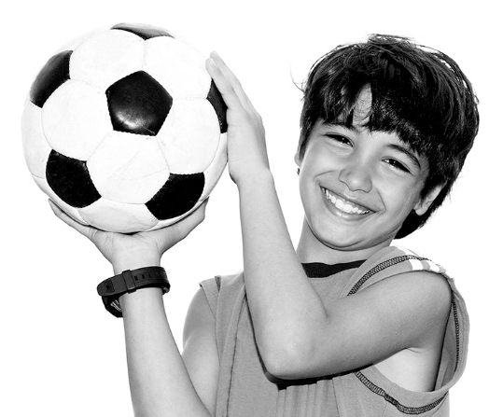
3. He has lunch at
a. home.

b. school.

c. the restaurant.

B. Part 1. Listen again. Fill in the table with Jake's daily routine.
CD 3 Track 23
In the morning | In the afternoon | In the evening
get up……………………………………………..………….…………  have lessons………………….…………………..…………… | go to football practice………………..…………  go back home…………………………………..…………… | have dinner……………….……………………...……………
C. Part 2. Listen and fill in the blanks. CD 3 Track 24

a
Jason (1)_______________________ sports very much. In his (2)_______________________ time he plays volleyball and he (3)_______________________ gymnastics. On (4)_______________________ and (5)_______________________ he goes (6)11111111111111111111111111111111. His best friend, Ryan, likes (7)_______________________ to music. He has piano lessons because he likes music very much.
At the weekend they (8)_______________________ go to concerts.

Name No. Class Date
Date Mark Teacher
Unit 5 My routine
Daily routine / Present Simple / Adverbs of frequency / Connectors /
Personal pronouns (object)
A

I – Reading
A. Read the text.
 | Ryan’s routine
5  10  15 |   Ryan Burton is ten years old and he is a rugby player.  He gets up at half past seven every day. He has a shower, gets dressed and makes his bed. Then he has breakfast with his brother, Tom, and his parents. After breakfast Ryan and Tom go to school. Their lessons start at twenty past eight. They have four lessons in the morning. At one o’clock they go back home to have lunch.  In the afternoon Tom has swimming lessons and Ryan goes to rugby practice. He plays on Tuesdays, Thursdays and Fridays.  Before dinner he does his homework and he walks his dog. Ryan and Tom go to bed at quarter to ten.  On Saturday he always has a rugby match. After the match he usually visits his best friend, George. They play video games or watch a film.
B. Are the sentences True (T) or False (F)? Correct the false ones.
 | T | F
1. Ryan doesn’t play any sport.
2. Before going to school, he makes his bed.
3. He has breakfast with his family.
4. He has lunch in the school canteen.
5. He plays rugby every day.
C. Answer the questions.
1. How old is Ryan?

2. What time does he get up?

3. How many lessons do Ryan and Tom have in the morning?

4. Does Ryan play rugby on Mondays?

5. When does he do his homework?

6. What does he do after the rugby match?

II – Vocabulary
A. What are these daily activities?
 |  |  | 
1. ________________ | 2. ________________ | 3. ________________ | 4. ________________
B. What time is it?
 | 1. __________________________ |  | 2. __________________________
III – Grammar
A. Ask questions for the words in bold.
1. ___________________________________________________________? ? Yes, he does. Ryan plays rugby.
2. _______________________________ _____________________________? ? Their lessons start at 8.20.
3. ____________________________________________________? ? He goes to rugby practice in the afternoon.

B. Put the verbs in brackets in the Present Simple.
1. Ryan _______________ (not play) rugby on Saturdays.
2. What time _______________ Ryan’s parents _______________ (get up)? At 7 o’clock.
3. Ryan and Tom _______________ (not go) to school in the afternoon.
4. _______________ he usually _______________ (do) his homework after dinner?
No, he _______________.
C. Write the words in the correct order.
1. Ryan and Tom / at the park / their / walk / sometimes / dog / .

2. always / Ryan / has / at home / lunch / .

3. is / at home / usually / Mrs Burton / at 6 o’clock / .

D. Complete with the correct connector: but, so, because or or. There are two extra.
1. In the afternoon Tom watches TV ___________ plays with his dog.
2. On Saturday morning Ryan doesn’t study ___________ he has rugby matches.
E. Complete with the correct personal pronoun (object).
1. Ryan plays rugby with his friends. He plays with _______________.
2. We go surfing. Come with _______________!
3. Their dog is very friendly. Look at _______________!
IV – Writing
A. Write about your daily routine.
My day
.I get up………………………………………………………………….………………………..…..………………………………………….

Unit 5 My routine
Daily routine / Present Simple / Adverbs of frequency / Connectors / Personal pronouns (object)
Name No. Class Date
Date Mark Teacher
B
I – Reading
A. Read the text.
 | Ryan’s routine
5  10  15 | Ryan Burton is ten years old and he is a rugby player.  He gets up at half past seven every day. He has a shower, gets dressed and makes his bed. Then he has breakfast with his brother, Tom, and his parents. After breakfast Ryan and Tom go to school. Their lessons start at twenty past eight. They have four lessons in the morning. At one o’clock they go back home to have lunch.  In the afternoon Tom has swimming lessons and Ryan goes to rugby practice. He plays on Tuesdays, Thursdays and Fridays.  Before dinner he does his homework and he walks his dog. Ryan and Tom go to bed at quarter to ten.  On Saturday he always has a rugby match. After the match he usually visits his best friend, George. They play video games or watch a film.
B. Match the two columns to make true sentences.
1. Ryan plays |  |  | a) a pet.
2. Before breakfast |  |  | b) at home.
3. He has breakfast |  |  | c) 3 times a week.
4. He goes to school |  |  | d) rugby.
5. He has lunch |  |  | e) Ryan’s best friend.
6. He has rugby practice |  |  | f) with his family.
7. He has got |  |  | g) Ryan makes his bed.
8. George is |  |  | h) with his brother

C. Answer the questions.
1. What time does he get up?
He __________ up at .
2. How many lessons do Ryan and Tom have in the morning?
They lessons in the morning.
3. Does Ryan play rugby on Mondays?
_______, he _____________. He .
4. When does he do his homework?
He __________ his homework .
5. What does he do after the rugby match?
He __________ his friend George and they .
II – Vocabulary
A. What are these daily activities?
 |  |  | 
1. br_____ t _______ | 2. li_____ to m ______ | 3. g_____ to ________ | 4. d_____ h_________
B. What time is it?
 | 1. It’s_____________________ |  | 2. It’s_____________________
III – Grammar
A. Ask questions for the words in bold.
1. ? (Ryan /play / rugby)
Yes, he does. Ryan plays rugby.
2. ? (What time / lessons / start)
Their lessons start at twenty past eight.
3. ? (When / go / rugby practice )
He goes to rugby practice in the afternoon.
B. Put the verbs in brackets in the Present Simple.
1. Ryan _______________ (not play) rugby on Saturdays.
2. What time _______________ Ryan’s parents _______________ (get up)? At 7 o’clock.
3. Ryan and Tom _______________ (not go) to school in the afternoon.
4. _______________ he usually _______________ (do) his homework after dinner?
No, he _______________.
C. Insert the adverbs of frequency in the correct place.
1. Ryan and Tom walk their dog at the park. (sometimes)

2. Ryan has lunch at home. (always)

3. Mrs Burton is at home at 6 o´clock. (usually)

D. Choose the correct option.
1. In the afternoon Tom watches TV but / or plays with his dog.
2. On Saturday morning Ryan doesn’t study because / and he has rugby matches.
E. Complete with the correct personal pronoun (object): us, them, it.
1. Ryan plays rugby with his friends. He plays with _______________.
2. We go surfing. Come with _______________!
3. Their dog is very friendly. Look at _______________!
IV – Writing
Write about your daily routine. Choose the actions in the box.
get up have a shower get dressed have breakfast got to school
have lunch do homework have dinner go to bed
My day
.I get up………………..………………………………………………………………………………………………………………….…………..

Listening Test Unit 5
Instrumento de Avaliação – Compreensão oral
Objetivos | Domínio Intercultural | Estrutura | Cotações | Critérios  de Correção
• Compreender discursos simples, articulados  de forma clara  e pausada | Conhecer o seu meio e o dos outros para compreender  a diversidade: identificar rotinas diárias e atividades de tempos livres | A. Seleção  de informação  B. Preenchimento  de tabela  C. Seleção  de informação | 3 x 6 = 18  6 x 7 = 42  8 x 5 = 40 | Certo / Errado  Certo / Errado  Certo / Errado
 |  |  | Total: 100 | Certo / Errado  Certo / Errado  Certo / Errado
Unit 5 – Progress Test A
Instrumento de Avaliação – Leitura, léxico, gramática e escrita
Objetivos | Domínio Intercultural | Estrutura | Cotações | Critérios  de Correção
• Compreender textos breves  e simples: reconhecer informação que lhe é familiar | Conhecer o seu meio e o dos outros para compreender  a diversidade: identificar rotinas diárias  e atividades  de tempos livres | I  B. Verdadeiro / falso  (com correção das afirmações falsas)  C. Respostas  a perguntas  sobre o texto | Afirmações verdadeiras  e sem referência  2 x 2 = 4  (B. 2; B. 3)  Afirmações falsas  3 x 4 = 12  (B. 1; B. 4; B. 5)  6 x 3 = 18 | Certo / Errado  Certo / Parcialmente  Certo / Errado  (Conteúdo certo: 3 pontos  Conteúdo parcialmente certo: 1 a 2  Conteúdo errado: 0)
- Aplicar itens lexicais relacionados com as áreas temáticas previstas no Domínio Intercultural (rotinas diárias e atividades  de tempos livres) |  | II  A. Legendagem de imagens  B. Resposta  a perguntas | 4 x 2 = 8  2 x 2 = 4 | Certo / Errado  Certo / Errado
- Aplicar estruturas elementares do funcionamento da língua nas áreas temáticas previstas no Domínio Intercultural (Present Simple; adverbs of frequency; connectors; personal pronouns – object) |  | III  A. Completamento de frases  B. Preenchimento  de espaços  C. Ordenação  de palavras  D. Preenchimento  de espaços  E. Preenchimento  de espaços | 3 x 3 = 9  5 x 2 = 10  3 x 1 = 3  2 x 3 = 6  3 x 2 = 6 | Certo / Errado  Certo / Errado  Certo / Errado  Certo / Errado  Certo / Errado
- Produzir um texto simples (Descrever uma imagem) |  | IV  Produção de texto | 20 | Competência pragmática: 12 Competência linguística: 8 (ver níveis  de desempenho  na página 314)
- Produzir um texto simples (Descrever uma imagem) |  | IV  Produção de texto | Total: 100
Unit 5 – Progress Test B
Instrumento de Avaliação – Leitura, léxico, gramática e escrita
Objetivos | Domínio Intercultural | Estrutura | Cotações | Critérios  de Correção
• Compreender textos breves e simples: reconhecer informação que lhe é familiar | Conhecer o seu meio e o dos outros para compreender  a diversidade: identificar rotinas diárias  e atividades  de tempos livres | I  A. Correspondência  B. Respostas  a perguntas  sobre o texto | 8 x 2 = 16  5 x 4 = 20 | Certo / Errado  Certo / Parcialmente certo / Errado  (Conteúdo certo: 3 pontos  Conteúdo parcialmente certo: 1 a 2  Conteúdo errado: 0)
- Aplicar itens lexicais relacionados com  as áreas temáticas previstas no Domínio Intercultural (rotinas diárias e atividades de tempos livres) |  | II  B. Legendagem  de imagens  C. Resposta  a perguntas | 4 x 2 = 8  2 x 1 = 2 | Certo / Errado  Certo / Errado
- Aplicar estruturas elementares  do funcionamento  da língua nas áreas temáticas previstas no Domínio Intercultural (Present Simple; adverbs of frequency; connectors; personal pronouns – object) |  | III  A. Completamento de frases  B. Preenchimento  de espaços  C. Completamento de frases  D. Seleção  E. Preenchimento  de espaços | 3 x 3 = 9  5 x 2 = 10  3 x 1 = 3  2 x 3 = 6  3 x 2 = 6 | Certo / Errado  Certo / Errado  Certo / Errado  Certo / Errado  Certo / Errado
- Produzir um texto simples (Descrever uma imagem) |  | IV  Produção de texto | 20 | Competência pragmática: 12 Competência linguística: 8  (ver níveis  de desempenho  na página 314)
- Produzir um texto simples (Descrever uma imagem) |  | IV  Produção de texto | Total: 100

