PROGRESS TEST | 1

Name |  | No. | Class
Date | Mark | Teacher

LISTENING


1. Listen and complete the table in note form.

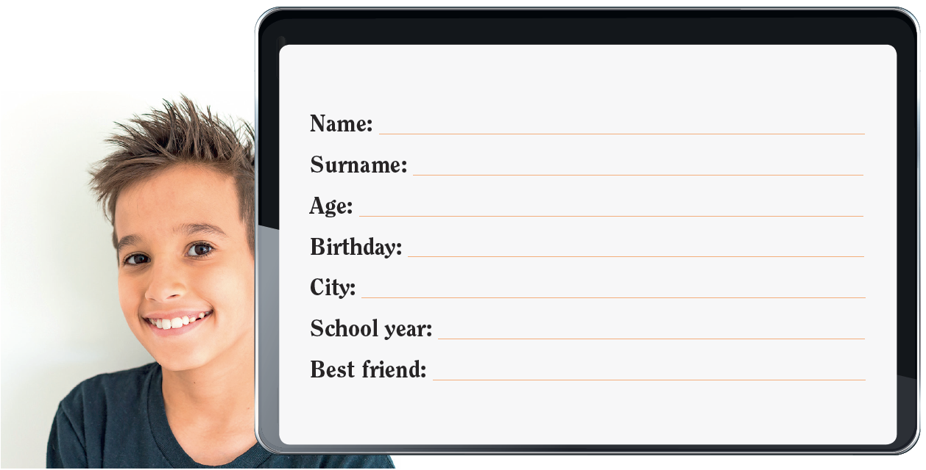

2. Listen again and circle the right answer.

1. What’s his telephone number?  a) 78625448  b) 78652448  c) 78562448 | 2. He has got…  a) a brother and a sister.  b) a brother.  c) a sister.

3. What’s his favourite sport?





a) b) c)

READING, GRAMMAR AND WRITING | A

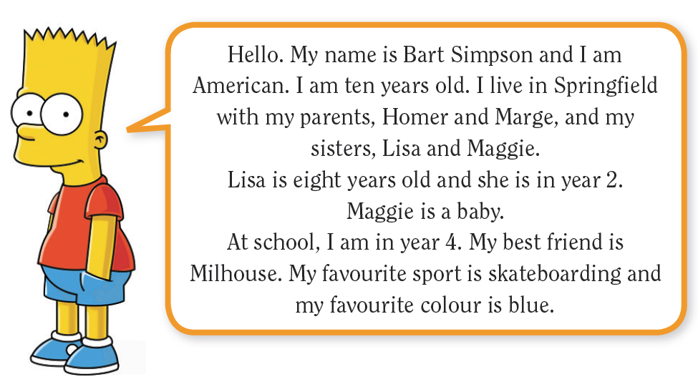
PART 1

Read the text.

1. Fill in the table.

Name
Age
Nationality
Year at school
Best friend
Favourite sport

2. Circle the right answer.

1. Bart ________ an American boy.

a) is b) isn’t

2. He lives with ___________ .
a) his parents b) his parents and sisters

3. His sister Lisa is ___________ years old.
a) 10 b) 8

4. Bart likes ___________ .
a) skating b) skateboarding

5. Blue is his favourite ___________ .
a) colour b) friend

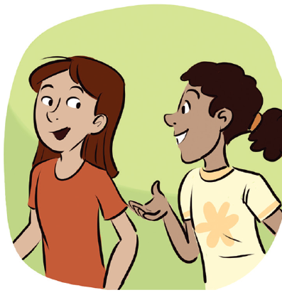
PART 2

1. Replace the words in bold by personal pronouns.
a) The girls are at school. ________________________________
b) Bart is 10 years old. ________________________________
c) Their school is next to the park. ___________________________
d) Bart and I are good friends. _______________________________

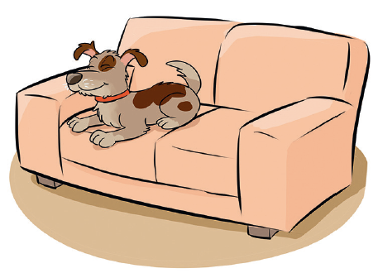
2. Circle the correct form of the verb to be.
a) Bart is / are a student.
b) I am / are ten years old.
c) The students isn’t / aren’t in the playground.
d) The dog am / is on the sofa.
e) Is / Are you American?

3. Match.
1. 4th a) fortieth

2. 12th b) twentieth

3. 14th c) fourteenth

4. 20th d) fourth

5. 40th e) twelfth

4. Complete the sentences with the possessive determiners.
a) John loves ____________ family. b) I love ____________ country.
c) We like ____________ school. d) They love ____________ parents.

PART 3

Write six sentences about yourself.
Name: ________________________________________________________________________
Age: _________________________________________________________________________
Birthday: ______________________________________________________________________
Address: ______________________________________________________________________
Phone number: _________________________________________________________________
Best friend: ____________________________________________________________________

READING, GRAMMAR AND WRITING | B


PART 1

Read the text.

Susan: Hi, Jim! How are you?  Jim: I’m fine, thanks. And you?  Susan: I’m fine, too. This is my friend Mary. She is American.  Jim: Really? Where are you from, Mary?  Mary: I’m from New York.  Jim: Wow! How old are you?  Mary: I’m ten. And you?  Jim: I’m eleven. I’m in year 6. | Susan: Mary is in year 5, just like me.  Jim: Mary, what’s your favourite country?  Mary: Well. I love Portugal, but my favourite country is the USA.  Jim: What’s your phone number? Can I call you?  Mary: Of course. My phone number is 54678891. Bye!  Jim: Bye! See you later.

1. Read and match.
1. Susan and Mary a) from the USA.

2. Mary is b) in year 5.

3. Jim is c) are friends.

4. Susan is d) is 54678891.

5. Mary loves e) 11 years old.

6. Mary’s phone number f) Portugal.

2. Mark the sentences right () or wrong (×). Correct the wrong information.
a) Susan is American.

______________________________________________________________________
b) Mary is from New York.

______________________________________________________________________
c) The two girls are in year 5.

______________________________________________________________________
d) Mary’s favourite country is Portugal.

______________________________________________________________________
e) Jim can call Mary.

______________________________________________________________________

PART 2

1. Complete the sentences with the correct form of the verb to be.
a) She ______ a teacher. She ______ (not) a student.
b) We ______ (not) at home. We ______ in the park.
c) My house ______ next to the gym. It ______ (not) near the school.
d) When ______ your birthday? My birthday ______ on 14th March.
e) ________ you Mark Smith? No , I______ .

2. Write in full.
a) 3rd – ___________________________________________________________________
b) 13th – ___________________________________________________________________
c) 26th – ___________________________________________________________________
d) 48th – ___________________________________________________________________
e) 100th – ___________________________________________________________________
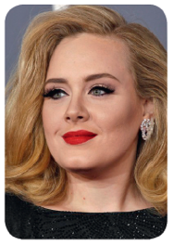
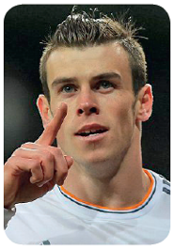

3. Write the nationalities.

a) I’m from Portugal. I’m ____________________.
b) I’m from Wales. I’m ______________________.
c) She’s from England. She’s ________________.


d) He’s from Scotland. He’s _________________.
e) He’s from Australia. He’s _________________.

4. Choose the right possessive determiner in each pair.
a) Mary has got many brothers and sisters.
Her / His family is big.
b) This is a nice park. His / Its name is Swan Park.
c) Peter and Tom are from Canada. Their / His mother is American.
d) I have got many friends. This is my / your friend Paul.

PART 3

Imagine a dialogue with a new schoolmate. Write about 30 words.

A: Ask your new schoolmate personal questions (name, age, birthday, address…)

You: Answer the questions.

PROGRESS TEST | 1

SCRIPT

CD2 Track 50
Hi! My name is Mark White. I am ten years old and my birthday is on 22nd April. I am English and I live in London with my parents and my sister Jane. My telephone number is 78652448. I am a student in year 5 and I like my school very much. My best friend is Robert. He is in my class. We love playing tennis.

ANSWERS

LISTENING  1 Name: Mark  Surname: White  Age: 10  Birthday: 22nd April  City: London  School year: 5  Best friend: Robert  2. 1. b); 2. c)  3. a) | READING, GRAMMAR AND WRITING – A  PART 1  1. Name: Bart Simpson  Age: 10  Nationality: American  Year at school: 4  Best friend: Milhouse  Favourite sport: skateboarding  2. 1. a); 2. b); 3. b); 4. b); 5. a)  PART 2  1. a) They; b) He; c) It; d) We  2. a) is; b) am; c) aren’t; d) is;  e) Are  3. 1. d); 2. e); 3. c); 4. b); 5. a)  4. a) his; b) my; c) our; d) their  PART 3  Personal answer. | READING, GRAMMAR AND WRITING – B  PART 1  1. 1. c); 2. a); 3. e); 4. b); 5. f); 6. d)  2. a) Wrong. Mary is American.  b) Right.  c) Right.  d) Wrong. Mary’s favourite country is the USA.  e) Right.  PART 2  1. a) is / isn’t  b) aren’t / are  c) is / isn’t  d) is / is  e) Are / am not  2. a) third; b) thirteenth; c) twenty-sixth; d) forty-eighth; e) a hundredth  3. a) Portuguese; b) Welsh; c) English; d) Scottish; e) Australian  4. a) Her; b) Its; c) Their; d) my  PART 3  Personal answer.

SPEAKING TEST | 1

PART 1


PART 2
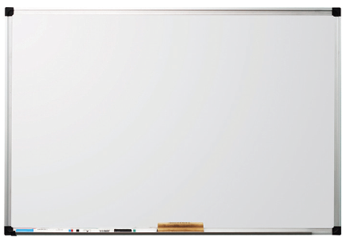

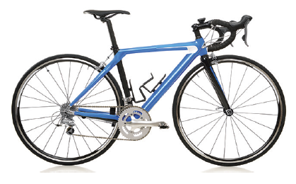

1. 2. 3.
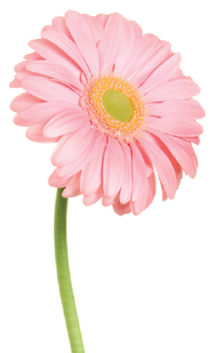
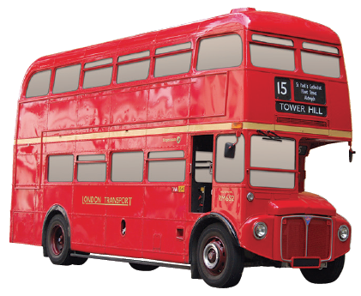



4. 5. 6.

SPEAKING TEST | 1

PROCEDURES

Part 1

The teacher greets the learner and checks his/her name.
A. The teacher shows the learner a picture and asks the learner to point to the items: Where is a boy?
Where is a girl? Where is a tree? Where is the school? Where is a schoolbag?
B. The teacher asks questions about the picture: How many children can you see? Are they teachers?
Where are they? What’s their school address? What’s the weather like?

Part 2
The teacher shows the learner some smaller pictures and asks: What’s this? What colour(s) is it?

Part 3
The teacher asks the learner some personal questions related to the topic: How old are you? When is your birthday? What’s your phone number? What’s your address? What’s your favourite colour? Who is your best friend?

SUGGESTED ANSWERS

Part 1
B. I can see nine children. / No, they aren’t. They are students/pupils. / They are at school/in the playground. / It’s Main Street. / It’s hot.

Part 2
1. It’s a dog. It’s brown. / 2. It’s a bicycle. It’s blue. / 3. It’s a board. It’s white. / 4. It’s a bus. It’s red. /
5. It’s a ball. It’s green, yellow and white. / 6. It’s a flower. It’s pink.

Part 3

Personal answers.

