PROGRESS TEST | 3

Name |  | No. | Class
Date | Mark | Teacher

LISTENING



1. Listen and tick () the right answer.

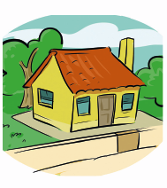
1. Where does Carol live?
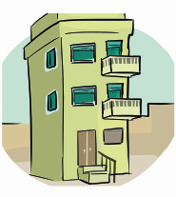
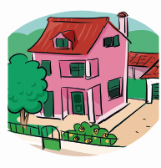

a) b) c)

2. Which is Carol’s favourite room?
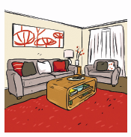
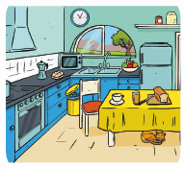
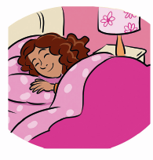

a) b) c)

2. Listen and mark the sentences true (T) or false (F).
a) Carol lives in a small house.

b) Her favourite room is her bedroom.

c) Her bedroom is very comfortable.

d) It is painted white.

e) In Carol’s bedroom there is a small window.

f) She usually studies at her desk.

g) There isn’t a TV set in her bedroom.

READING, GRAMMAR AND WRITING | A

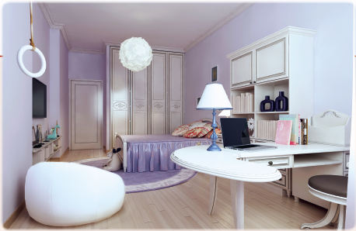
PART 1

Read the text.

Maggie’s bedroom
Maggie: Hello, Sue! Come in. Welcome to my bedroom.
Sue: Thank you. Well, your bedroom is big!
Maggie: Yes, it is… and full of light.
Sue: I love the colour. It’s light violet.
Maggie: It’s my favourite colour. Do you like my bed?
Sue: Of course. It’s big and comfortable. All your furniture is white! I like it. And you’ve got a TV set and a laptop.
Maggie: I spend a lot of time in my room. I study here, but I also relax…
Sue: On this modern sofa… What a wonderful room!
Maggie: I’m happy you like it, too. Let’s do homework and then play.
Sue: OK.

1. Fill in the table about Maggie’s bedroom.

Bedroom
Colour
Bed
Furniture
Sofa

2. Match to make sentences.
1. Sue is visiting a) love the colour of the room.

2. Maggie’s bedroom b) Maggie’s room for the first time.

3. The two girls c) a TV set and a laptop.

4. In Maggie’s bedroom d) is big and bright.

5. There is e) in her bedroom.

6. Maggie spends a lot of time f) all the furniture is white.

PART 2

1. Complete the sentences with there is (), there are (), there isn’t (×) or there aren’t (×).
a) In my house, ___________ a garden. ()
b) In his bedroom, ___________ many books. (×)
c) In her bedroom, ___________ a big TV set. (×)
d) In my living room, ___________ two sofas. ()

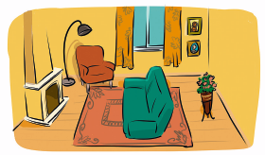
2. Look at the picture. Circle the right preposition.
a) There is a carpet on / in the floor.
b) The sofa is behind / opposite the fireplace.
c) There is a lamp over / under the armchair.
d) There are two pictures next to / opposite the window.
e) The vase of flowers is behind / below the sofa.

3. Write the plural of the words in brackets.
a) There are twenty ________________ in the room. (child)
b) They are playing ________________ . (game)
c) ________________ usually like cheese. (mouse)
d) There are four ________________ at the bus stop. (man)

PART 3

Complete this text describing your bedroom.
I ______________ my bedroom. It is ________________ and _______________.
Its colour is ________________. There is ______________ and _______________.
There are _________________ and _________________. I usually ____________________ in my bedroom.
READING, GRAMMAR AND WRITING | B

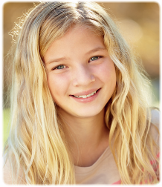
PART 1

Read the text.

My home
My name is Sue. I live in a flat with my parents and my brother. It’s on the second floor.
When you enter the flat, there is a hall. On the right, there is a kitchen. Opposite the entrance door, there is a living room and on the left there is a corridor to the bedrooms and the bathroom.
The kitchen is small, but it’s OK for us. In the kitchen, there is a cooker and a washing machine. There is also a fridge and a sink. In the middle, there is a table and four chairs.
The living room has a big window. There is a lot of light! There is a table and six chairs. There is a sofa and two armchairs. Opposite the sofa is the TV set, where we watch our favourite programmes. It’s my favourite room.
The first room is my parents’. There is a big bed and two bedside tables. There is a bookcase with a lot of books and a desk with a personal computer. There are many family photos on the walls.
The next room is my bedroom. I share it with my brother. There are two beds, a wardrobe and a long mirror. There is a bookcase with books and CDs.
Opposite my bedroom, there is a bathroom. Its walls are brown and I don’t like it. So, I use orange towels!
My home is not big, but I like it.

1. Fill in the table with the names of the rooms and the furniture.

SUE’S FLAT

2. Complete the sentences.
a) Sue’s flat is on _______________________________________________________________.
b) When you enter her flat, you see _________________________________________________.
c) Her favourite room is __________________________________________________________.
d) She doesn’t like ______________________________________________________________.
e) Sue likes ____________________________________________________________________.

PART 2

1. Complete the dialogue between Sue and her friend Laura. Use there + to be.

Laura: So, Sue, (a) ______________ an attic in your house?
Sue: No, (b) _____________ . It’s a flat on the second floor…
Laura: Oh, I see. How many rooms (c) _____________?
Sue: (d) _____________ five rooms, including the bathroom.
Laura: (e) ______________ a bedroom for yourself?
Sue: Well, no, I share it with my brother.

2. Look at the picture. Complete the sentences with: on, opposite, next to, in front of.
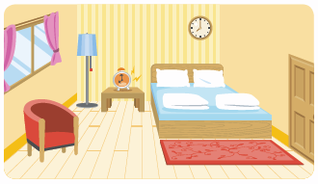
a) There is a window ___________ the door.
b) There is a rug ___________ the floor.
c) There is a bedside table ___________ the bed.
d) The alarm clock is ___________ the bedside table.
e) The armchair is ___________ the window.

3. Write the plural of the words.
All (a) ____________ (person) love birthday (b) _____________ (party). There are usually (c) _____________ (cake) and (d) _____________ (candy) and (e) ____________ (child), (f) ____________ (man) and (g) ____________ (woman) have fun.

PART 3

In about 30 words, write a dialogue with a friend inviting him/her to your birthday party.

PROGRESS TEST | 3

SCRIPT

CD2 Track 52
Hello! I’m Carol. I live in a big flat with my family. I like all the rooms, but my favourite one is my bedroom. My bedroom is on the second floor. It is sunny and comfortable. Its colour is pink. In the middle of the room there is a bed and two bedside tables. There is a sofa in front of my bed, where I like to sit on and relax. There’s a big window with a wonderful view of the park. Under the window there is a desk and chair. That’s where I usually do my homework and study. I like my bedroom because it is the only place where I can be alone. Sometimes I read a book or watch TV. I love my room very much.

ANSWERS

LISTENING  1. 1. b); 2. a)  2. a) False; b) True; c) True; d) False; e) False; f) True; g) False | READING, GRAMMAR AND WRITING – A  PART 1  1. Bedroom: big, full of light  Colour: light violet  Bed: big and comfortable  Furniture: white  Sofa: modern  2. 1. b); 2. d); 3. a); 4. f); 5. c);  6. e)  PART 2  1. a) there is  b) there aren’t  c) there isn’t  d) there are  2. a) on; b) opposite; c) over; d) next to; e) behind  3. a) children; b) games; c) Mice; d) men  PART 3  Personal answer. | READING, GRAMMAR AND WRITING – B  PART 1  1. Kitchen: cooker, washing machine, fridge, sink, table, four chairs.  Living room: table, six chairs, sofa, two armchairs.  Parents’ room: bed, two bedside tables, bookcase, desk.  Sue’s room: two beds, wardrobe, mirror, bookcase.  2. a) the second floor.  b) a hall.  c) the living room.  d) the bathroom walls.  e) her home.  PART 2  1. a) is there  b) there isn’t  c) are there  d) There are  e) Is there  2. a) opposite; b) on; c) next to; d) on; e) in front of  3. a) people; b) parties; c) cakes; d) candies; e) children; f) men; g) women  PART 3  Personal answer.

SPEAKING TEST | 3

PART 1
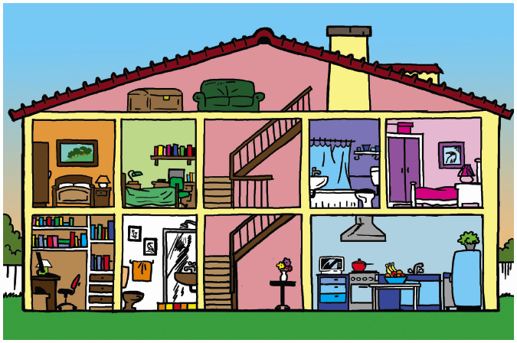

PART 2
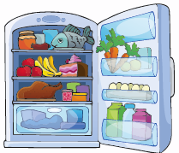
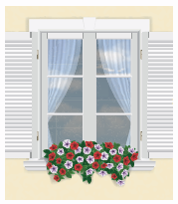

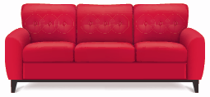

1. 2. 3.

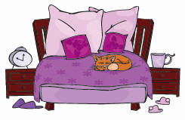

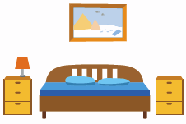
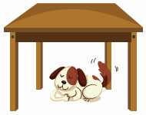

4. 5. 6.

SPEAKING TEST | 3

PROCEDURES

Part 1

The teacher greets the learner and checks his/her name.
A. The teacher shows the learner a picture and asks the learner to point to the items: Where is the kitchen? Where is the bathroom? Where is the bedroom? Where is the study? Where are the stairs?
B. The teacher asks questions about the picture: Is this a house or a flat? How many bedrooms are there?
And how many bathrooms? Is there a garage? / Is there a garden?

Part 2
The teacher shows the learner some smaller pictures and asks: 1. What’s this? 2. What’s this? 3. And this?
4. Where is the cat? 5. Where is the dog? 6. Where is the painting?

Part 3
The teacher asks the learner some personal questions related to the topic: Where do you live? Is your home a house or a flat? How many rooms are there? What’s your favourite room? What furniture is there?
Why do you like it?

SUGGESTED ANSWERS

Part 1
B. This is a house. / There are three bedrooms. / There are two bathrooms. / No, there isn’t a garage. /
Yes, there is a garden.

Part 2
1. This is a sofa. / 2. This is a window. / 3. This is a fridge. / 4. The cat is on the bed. / 5. The dog is under
the table. / 6. The painting is above the bed.

Part 3

Personal answers.

