PROGRESS TEST | 4

Name |  | No. | Class
Date | Mark | Teacher

LISTENING


1. Listen to the dialogue and number the pictures (1–4) in the right order.

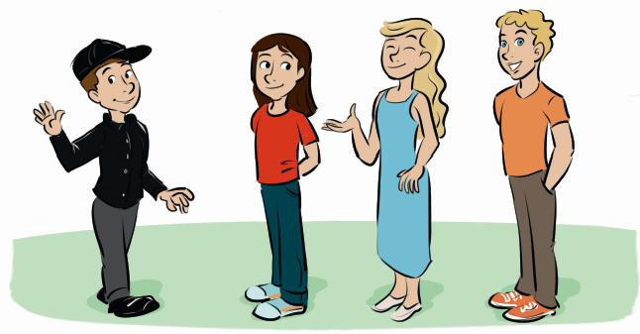

a) b) c) d)

2. Listen again and complete the sentences with one or two words.
a) Alice has got a brother, a sister and ____________________________ .
b) Alice’s brother is ____________________________ .
c) Jane is her ____________________________ .
d) Jane is wearing ____________________________.
e) _________________________ Susan is wearing jeans and a T-shirt.
f) Susan has got ____________________________ hair.
g) Mike is wearing a black cap and a _________________________.
h) Mike is Alice’s ____________________________ cousin.

READING, GRAMMAR AND WRITING | A

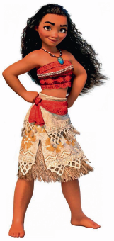
PART 1

Read the text.
This is Moana, the new Disney princess. She is a beautiful Polynesian teenager and she is the chief’s daughter. Her name means ‘ocean’ in many Polynesian languages. She is medium-height and slim. She has got dark skin and long, curly, dark hair. Her eyes are dark brown and her mouth and nose are small. She’s wearing an orange top and a flowery skirt.

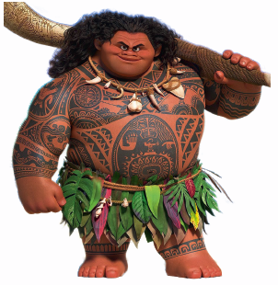

This is Maui, Moana’s friend. He is a demigod. He is very tall and strong. He has got many tattoos. He has got curly hair and dark skin, like Moana. His brown eyes are small, but his nose and his mouth are big. He is not very good-looking. He isn’t wearing any clothes, except a skirt made of leaves.

1. Fill in the table about Moana and Maui.

 | Moana | Maui
General appearance
Height
Weight
Hair
Eyes

2. Read and match.
1. Moana is a) a skirt and a top.

2. Her father is b) many tattoos.

3. She’s wearing c) a chief.

4. Maui is d) a Polynesian princess.

5. He has got e) a demigod.

PART 2

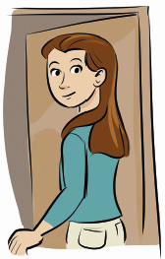
1. Write the words in the correct order.
a) girl / she / a / beautiful / is
__________________________________________________
b) has / he / brown / got / hair / short
__________________________________________________
c) her / blue / eyes / are
__________________________________________________
d) I / new / have / dress / a / got
__________________________________________________

2. Match the questions and the answers.
1. How old are you? a) He is 1.70 metres tall.


2. How tall is he? b) They’re mine.

3. How big is your house? c) I’m 10 years old.

4. Whose umbrella is this? d) It’s hers.

5. Whose glasses are these? e) It’s small.

3. Complete the sentences with the present continuous of the verbs in brackets.
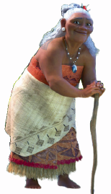
a) He __________________ (write) a new book.
b) Carol __________________ (not / study) Arts.
c) I __________________ (wear) a suit.
d) __________________ you __________________ (enjoy) yourself?
e) The students __________________ (not / pay) attention.
f) My friend and I __________________ (chat) on the Internet.

PART 3

Follow the text as a model and describe Moana’s grandmother, Tala.
READING, GRAMMAR AND WRITING | B
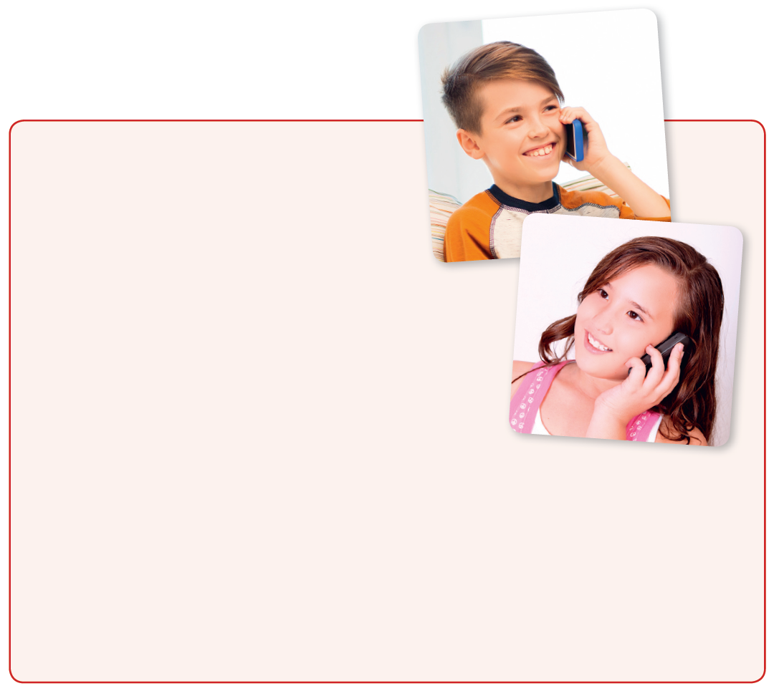

PART 1

Read the text.

Telephone conversation
Ben: Hi, Janet. How are you?
Janet: I’m fine, thanks. And you?
Ben: Well, I’m feeling a bit bored.
Janet: Why? What’s the problem?
Ben: I’m alone at home. My parents are at work and
my brother is having a guitar lesson.
Janet: What are you doing?
Ben: Nothing. That’s the problem.
Janet: What about homework?
Ben: I don’t have any homework. There’s nothing good on TV and it’s raining. I can’t go outside.
Janet: Well, my mother and I are cooking. We are baking a cake for tea time. Come
over and we’ll have tea together. Then, we can play a game.
Ben: OK. Thank you so much. I’ll be there in ten minutes. Bye!
Janet: Bye!

1. Mark the sentences right () or wrong (×). Correct the wrong information.
a) Janet is phoning Ben. ______________________________________________

b) Ben’s parents are not at home. ______________________________________

c) Ben is feeling happy. ______________________________________________

d) Janet invites him for tea. ___________________________________________

2. Answer the questions.
a) Why is Ben feeling bored? ____________________________________________________
b) What is his brother doing? ____________________________________________________
c) What are Janet and her mother doing?
____________________________________________________________________________
d) What can Janet and Ben do after tea?
____________________________________________________________________________

PART 2

1. Complete the sentences with the words in brackets.
a) She has got __________________________. (eyes / green / round)
b) She’s wearing a __________________________. (long / dress / white)
c) She has got ________________________ (hair / blonde) and ________________ (skin / fair).

2. Complete the questions with how tall, how old, how big.
a) _______________________ is this boy? – He’s nine.
b) _______________________ is your school bag? – It’s small.
c) _______________________ is this girl? – She’s 1.60 m.

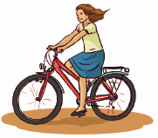
3. Fill in the gaps with possessive pronouns.
a) I’m riding my bike. The bike is ________________ .
b) We have a computer. The computer is ________________ .
c) She has got a cat. The cat is ________________ .
d) The children have got many toys. The toys are ______________ .
e) You are reading a book. The book is ________________ .

4. Complete these short dialogues. Use the present continuous.
A: What ________ you _________________ (wear)?

B: I _________________ (wear) a dress.
C: ___________ he _____________ (study)?
D: No, he ____________. He ____________ (play) online.
E: What ____________ they _____________ (do)?
F: They _____________________ (garden).

PART 3

Ben and Janet are talking on the phone.

Write six sentences about what you, your family and your friends are doing now.

PROGRESS TEST | 4

SCRIPT

CD2 Track 53
Vera: Who are those people, Alice?
Alice: They are my brother, my sister and my two cousins.
Vera: Really? Who is that tall boy with blonde hair and blue eyes?
Alice: He is my brother James. And the girl next to him, with long wavy hair, is my sister Jane.
Vera: She's beautiful and I like her dress.
Alice: The other girl with straight hair, wearing jeans and a T-shirt, is my cousin Susan.
Vera: So, the boy with the black shirt and black cap is your cousin, right?
Alice: Yes. His name is Mike and he is my favourite cousin. Don’t tell Susan!
Vera: OK.

ANSWERS

LISTENING  1. a) 4; b) 3; c) 2; d) 1  2. a) two cousins  b) tall  c) sister  d) a dress  e) Her cousin  f) straight  g) black shirt  h) favourite | READING, GRAMMAR AND WRITING – A  PART 1  1.  2. 1. d); 2. c); 3. a); 4. e); 5. b)  PART 2  1. a) She is a beautiful girl.  b) He has got short brown hair.  c) Her eyes are blue.  d) I have got a new dress.  2. 1. c); 2. a); 3. e); 4. d); 5. b)  3. a) is writing  b) isn’t studying  c) am wearing  d) Are… enjoying  e) aren’t paying  f) are chatting  PART 3  This is Tala, Moana’s grandmother. She is old and short. She has got dark skin and long white hair. Her eyes are brown and her nose and mouth are big. She is wearing an orange dress and a white skirt. | READING, GRAMMAR AND WRITING – B  PART 1  1. a) Wrong. Ben is calling Janet.  b) Right.  c) Wrong. He is feeling bored.  d) Right.  2. a) Ben is feeling bored because he’s alone at home.  b) He is having a guitar lesson.  c) They are cooking. They are baking a cake.  d) They can play a game.  PART 2  1. a) round green eyes  b) long white dress  c) blonde hair / fair skin  2. a) How old; b) How big;  c) How tall  3. a) mine; b) ours; c) hers; d) theirs; e) yours  4. A: are… wearing  B: am wearing  C: Is… studying  D: isn’t / is playing  E: are… doing  F: are gardening  PART 3  Personal answer.
  Moana | Maui
  beautiful | not very  good-looking
  medium-height | very tall
  slim | strong
  curly dark | curly
  dark brown | small

SPEAKING TEST | 4

PART 1

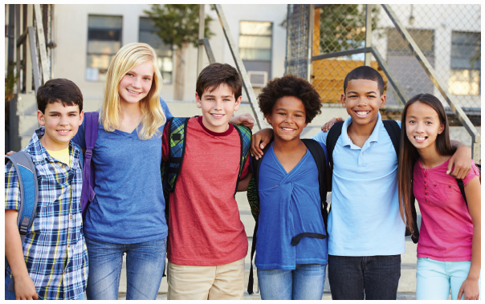

Michael Laura Peter Kate Phil Jessica

PART 2

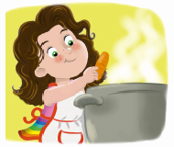



1. 2. 3.


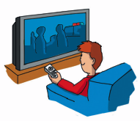


4. 5. 6.

SPEAKING TEST | 4

PROCEDURES

Part 1

The teacher greets the learner and checks his/her name.
A. The teacher shows the learner a picture and asks the learner to point to the people: Who’s tall? Who’s short and slim? Who has got curly hair? Who has got blonde hair? Who has got blue eyes?
B. The teacher asks questions about the picture: How many people can you see? What does Phil look like? What is Michael wearing? What is Jessica wearing?

Part 2

The teacher shows the learner some smaller pictures and asks: What is he / she doing?

Part 3
The teacher asks the learner some personal questions related to the topic: Are you tall or short?
Are you young or old? What colour are your eyes? Have you got straight hair? What are you wearing today? Are these your favourite clothes?

SUGGESTED ANSWERS

Part 1
A. Laura is tall. / Jessica and Michael are short and slim. / Kate has got curly hair. / Laura has got blonde hair. / Peter has got blue eyes.
B. I can see six people. / He’s tall and has got very short, dark hair. / He’s wearing a yellow T-shirt, a shirt and probably jeans. / She’s wearing a pink T-shirt and light blue jeans.

Part 2
1. He is dancing. / 2. She is gardening. / 3. She is cooking. / 4. She is listening to music. / 5. She is reading. / 6. He is watching TV.

Part 3
Personal answers.

