PROGRESS TEST | 6

Name |  | No. | Class
Date | Mark | Teacher

LISTENING


1. Listen and tick () the correct answer – a, b or c.
1. Where is Jim spending his holiday?
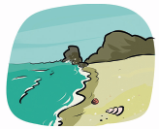

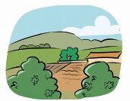

a) b) c)

2. Which is Jim’s family?




a) b) c)

3. What is the weather like?




a) b) c)

2. Listen again and complete the table about Jim’s holiday.

Place
Weather
Food
Children’s activities
Parents’ activities
Jim’s new friend
Favourite sports

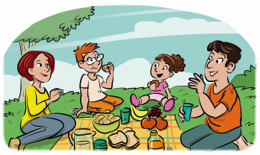
READING, GRAMMAR AND WRITING | A

PART 1

Read the text.

Free time
Hello! My name is Martin. I am eleven years old. I am going to tell you about my free time activities.
I don’t have much free time on school days, but I go to the swimming pool three times a week after school. I also have some time before sleep, so I usually read a book.
I have more free time at weekends, after I do my homework. There are many things that I like doing in my free time. When I am with my friends, we usually play computer games and watch films. We also like roller-skating and riding our bikes in the park.
I also love spending time with the family. We play games and go for long walks with our dog. In the evening, we watch TV together. In summer, we have picnics and barbecues. In winter, we prefer going to the cinema.
I don’t have enough time for everything that I like doing. I’d like to have more free time.

1. Fill in the table in note form.

Name
Age
Activities on school days
Activities with friends
Activities with family

2. Complete the sentences.
a) Martin doesn’t have __________________________________________________________.
b) He goes to the swimming pool _________________________________________________.
c) On Saturdays and Sundays, ___________________________________________________.
d) In the evening, Martin and his family _____________________________________________.
e) They go to the cinema _______________________________________________________.

PART 2
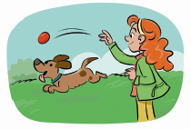
1. Complete the sentences with the correct form of the verbs.
a) Paul likes ______________ (ride) his bike.
b) She loves ______________ (walk) her dog.
c) Her friend John doesn’t like ______________ (watch) TV.
d) We love ______________ (play) table games.
2. Complete with the right pronoun.
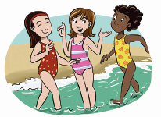
a) Do you like this book? Do you like ______________?
b) Maria and Sue are my friends. I really like ______________.
c) She has a problem. Can you help ______________?
d) Please, mum, buy ______________ this video game.
e) This is my brother Jack. Talk to ______________ .

3. Circle the right word.

a) Jane has many presents on her birthday, so / but she is happy.
b) They are going to the beach and / because it’s sunny.
c) The children are playing or / and having fun.
d) My brother likes basketball, but / so he doesn’t like football.
e) We can go to the beach or / so to the mountain.

PART 3

Complete this postcard about your holiday to send to a friend.
Hello, dear friend!
I’m on holiday in _____________. I am with ____________ and we are ____________ . The weather is _____________ and the place is ______________. My free time activities are ____________________________________.
How is your holiday? Write soon and tell me.
Love, ______________

READING, GRAMMAR AND WRITING | B

PART 1

Read the text.


Postcard from London
Hi, Ann!
I’m on holiday with my parents in London. We’re having a fantastic time here. There are lots of things to see and do. The weather isn’t very sunny but there’s no rain, so we can explore the city. It is wonderful. I love the traditional black taxis and the red buses. British people are very friendly and polite. There are people from all over the world. I also like the museums and the monuments like Tower Bridge, Buckingham Palace and the famous Big Ben. The parks are also nice because there are many birds and animals, like ducks and squirrels. I want to see some musicals like my favourite, ‘The Lion King’. The only bad thing is the food. We eat a lot of fast food.
See you next week!
Love,
Carol
Vocabulary help polite – educadas ducks and squirrels – patos e esquilos

1. Fill in the table in note form.

Place
Weather
People
Monuments
Food

2. Answer the questions.
a) Who is writing the postcard? __________________________________________________
b) Where is she? _____________________________________________________________
c) Is she having a good holiday? _________________________________________________
d) What’s the weather like? _____________________________________________________
e) Why does she like the parks? __________________________________________________
f) What’s her favourite musical? __________________________________________________

PART 2
1. Complete the sentences with the correct form of the verbs.
swim • watch TV • play computer games • read books • cook • listen to music




a) He likes __________. b) They love ___________. c) She hates ___________.

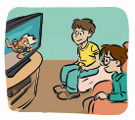
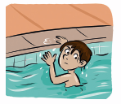

d) We enjoy __________. e) I like ____________. f) He doesn’t like __________.
2. Fill in the gaps with object pronouns.
a) I like this film. I like __________________.
b) They are my grandparents. I love __________________.
c) That is my book. Give it to __________________.
d) Mary loves flowers. This rose is for __________________.
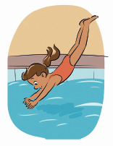
3. Fill in the gaps with: and, but, so, because.
a) Our house is old ______________ it is comfortable.
b) It is snowing, ______________ we are going skiing.
c) I like swimming ______________ fishing.
d) She is going to the supermarket ______________ there isn’t any milk.
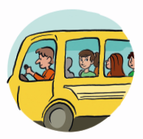
4. Look at the pictures and complete the sentences
with the right prepositions of movement.
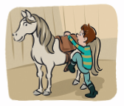
a) Ann is going ______________ school.
b) Peter is getting ______________ a horse.
c) Cathy is diving ______________ the water.

PART 3

Write an email to a new friend telling him/her about
your favourite free time activities.
PROGRESS TEST | 6

SCRIPT

CD2 Track 55
Hello, Robert! Here I am, spending a wonderful holiday in the Algarve. I really love summer and this is the ideal place to enjoy it. The weather is hot, the beaches are beautiful and the food is delicious. All the family is relaxing and having fun. On the beach, I swim and surf, my little brother makes sand castles and my parents take long walks and read their favourite books. We visit some interesting places and meet very nice people. My new friend is André and he is Portuguese. We love sports, so we play beach volleyball and football with other friends. I hope you’re having a good holiday too. See you soon! Jim

ANSWERS

LISTENING  1. 1. c); 2. a); 3. b)  2. Place: Algarve  Weather: hot  Food: delicious  Children’s activities: swimming, surfing, making sand castles  Parents’ activities: taking long walks, reading  Jim’s new friend: André  Favourite sports: beach volleyball and football | READING, GRAMMAR AND WRITING – A  PART 1  1. Name: Martin  Age: 11  Activities on school days: swimming and reading  Activities with friends: playing computer games, watching films, roller-skating, riding their bikes  Activities with family: games, long walks, watching TV, picnics, barbecues, going to the cinema  2. a) much free time.  b) three times a week after school.  c) he has more free time.  d) watch TV together.  e) in winter.  PART 2  1. a) riding; b) walking; c) watching; d) playing  2. a) it; b) them; c) her; d) me; e) him  3. a) so; b) because; c) and; d) but; e) or  PART 3  Personal answer. | READING, GRAMMAR AND WRITING – B  PART 1  1. Place: London  Weather: not sunny but no rain  People: friendly and polite  Monuments: Big Ben, Tower Bridge, Buckingham Palace  Food: bad  2. a) It’s Carol.  b) She is in London.  c) Yes, she is.  d) The weather isn’t very sunny but there is no rain.  e) There are many birds and animals, like ducks and squirrels.  f) Her favourite musical is ‘The Lion King’.  PART 2  1. a) reading books  b) playing computer games  c) cooking  d) watching TV  e) listening to music  f) swimming  2. a) it; b) them; c) me; d) her  3. a) but; b) so; c) and; d) because  4. a) to; b) onto; c) into  PART 3  Personal answer.

SPEAKING TEST | 6

PART 1
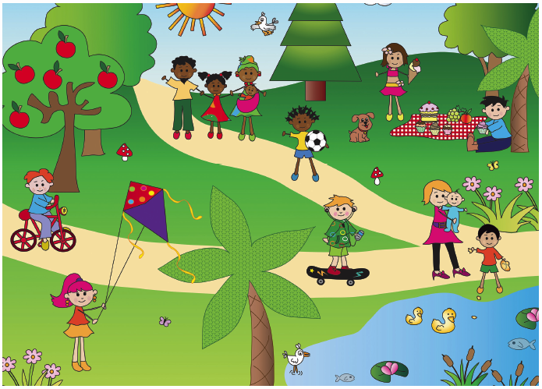

PART 2

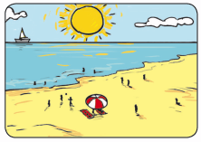
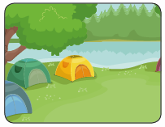
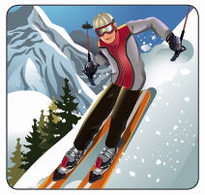

1. 2. 3.


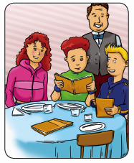
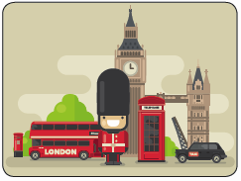

4. 5. 6.

SPEAKING TEST | 6

PROCEDURES

Part 1

The teacher greets the learner and checks his/her name.
A. The teacher shows the learner a picture and asks the learner to point to the people: Who is having a picnic? Who is playing with a ball? Who likes cycling? Who loves skateboarding? Who prefers feeding the ducks?
B. The teacher asks questions about the picture: Is it summer or winter? What is the weather like? Where are these people? (The teacher points to a boy on the left and a girl on the right). What is he riding? What is she eating?

Part 2
The teacher shows the learner some smaller pictures and asks: (Pictures 1, 2 and 3) What kind of holiday is it? (Pictures 4, 5 and 6) What can you do on holiday?

Part 3
The teacher asks the learner some personal questions related to the topic: What are your favourite free time activities in winter? And in summer? What do you hate doing? Do you usually go on holiday? What kind of holiday do you prefer? Why?

SUGGESTED ANSWERS

Part 1
B. It’s summer. / It’s hot, sunny. / They are in a park. / He is riding a bike. / She is eating an ice cream.

Part 2
1. It’s a beach holiday. / 2. It’s a camping holiday. / 3. It’s a skiing holiday. / 4. I can visit monuments. /
5. I can go shopping. / 6. I can have lunch / dinner in a restaurant.

Part 3

Personal answers.

