PROGRESS TEST | 2

Name |  | No. | Class
Date | Mark | Teacher

LISTENING


1. Listen to the text and label the pictures with the names:
Anne
Daniel
Jim
Rita
Tom
Mary








a) _________ b) _________ c) _________ d) _________ e) _________ f) _________

2. Listen again and circle the right answer.

1. Rita’s mother is a _____________ .
a) doctor b) cook c) nurse

2. Rita’s mother is ________________ .
a) 38 years old b) 39 years old c) 48 years old

3. Rita’s father is a ________________ .
a) nurse b) teacher c) cook

4. Rita’s father works in a ________________ .
a) restaurant b) hotel c) school

5. Daniel is Rita’s ________________ .
a) father b) grandfather c) brother

6. Daniel is ________________ .
a) 3 years old b) 13 years old c) 30 years old

7. Rita’s grandparents are ________________ .
a) horrible b) fine c) friendly

READING, GRAMMAR AND WRITING | A

PART 1

Read the text.

My family

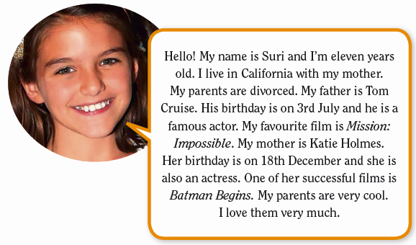
My family

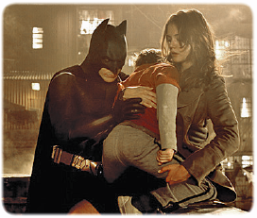
1. True (T) or false (F)?
a) Suri is 11 years old.

b) She lives with her parents.

c) Tom and Katie are actors.

d) Katie’s birthday is in July.

e) Suri doesn’t like her parents.

2. Complete the sentences.
a) Suri lives in ________________.
b) Her father’s name ________________.
c) Her mother is an ________________.
d) Katie is in the film ________________.
e) Suri loves ________________.

PART 2

1. Are these sentences right () or wrong (×)? Correct the wrong ones.

a) Jane’s mother is a teacher.

_______________________________
b) The girls’s brother is in year 5.

_______________________________
c) I like John’s family.

_______________________________
d) London is the capital of England’s.

_______________________________

2. Underline the right answer.
a) I have / has got many comic books.
b) Has / Have Mary got any pets?
c) My grandparents haven’t / hasn’t got a car.
d) Have / Has you got any brothers or sisters?

3. Complete the sentences with a, an, the or X (no article).
a) My father is ___________ engineer and my mother is ___________ secretary.

b) Today ___________ sun is shining.
c) I have got ___________ dog and ___________ horse.
d) ___________ football is my favourite sport.

PART 3

Complete this dialogue about your family.

Friend: Hello. How are you?
You: _________________________________________________________________________
Friend: What are your parents’ names?
You: _________________________________________________________________________
Friend: How old are they?
You: _________________________________________________________________________
Friend: Have you got any brothers or sisters?
You: _________________________________________________________________________

READING, GRAMMAR AND WRITING | B

PART 1

Read the text.

My family
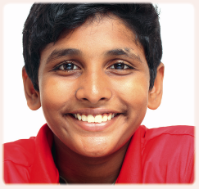
My name is Vikash and I am 11. I live in India. There are nine people in my family.
My grandfather is 72 and he is very kind. My grandmother is 65 and she is very sweet. They like telling us stories and we love them very much.
My father is a nurse. He is nice and generous. He works a lot, but he also likes gardening. He sometimes takes us to the cinema. My mother is a housewife and she is cool.
I have got a brother and three sisters. My younger brother, Bablu, is 4 years old. He is very noisy, but we all love him. He likes talking and playing outdoor games.
My three sisters are Ruchi, Rukmini and Madhu. My sister Ruchi is 13 and she likes painting. Rukmini is 8 and she is very calm. Madhu is 10 and she is a good student. She is always the first in her class.
We are a happy family.
http://www.importantindia.com/7603/short-essay-on-my-family
(abridged and adapted)

1. Circle the right answer.

1. Vikash is a(n) ________ boy.
a) British b) Indian c) Portuguese

2. He has got a ________ family.
a) small b) rich c) large

3. His ________ is very sweet.
a) mum b) grandpa c) grandma

4. Vikash’s mother is a ________.
a) nurse b) housewife c) teacher

5. He has got ________ brothers and sisters.
a) four b) three c) two

2. Answer the questions.
a) How old is Vikash? _________________________________________________________.
b) How many people are there in his family? _______________________________________.
c) What’s his father’s job? _____________________________________________________.
d) Who is the good student in the family? _________________________________________.

PART 2

1. Complete the sentences with possessive forms (’s, ’ or of).
a) The ___________ parents are Indian. (boys)
b) The ___________ house is big and comfortable. (family)
c) The ___________ this story is very sad. (end)
d) The ___________ Ireland is Dublin. (capital)

2. Complete the sentences. Follow the example.
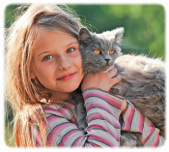
Has she got a dog? No, she has got a cat.
a) _____ he _____ a sister? No, _______ a brother.
b) _____they _____ cars? No, _______ bicycles.
c) _____ Sue _____ a computer? No, _______ a mobile phone.

3. Complete this text with a, an, the or X (no article).

Hello. I’m James. I live in (a) _____ London, (b) _____ capital of (c) _____ United Kingdom, with my parents and my younger brother. My father is (d) _____ doctor and my mother is (e) _____ architect. My brother is (f) _____ student.



PART 3
In about 30 words, write an email to a new friend and tell him/her about your family.

PROGRESS TEST | 2

SCRIPT

CD2 Track 51
Hello! I am Rita. Let me tell you about my family. I live with my parents, my brother and my grandparents. My mum’s name is Mary and she is a nurse. She is 38 years old. She is short and slim. She’s got long brown hair and blue eyes. My dad’s name is Jim. He’s 39 years old. He’s tall and has got short black hair and brown eyes. He works as a cook in a restaurant. My brother Daniel is 13 years old. He is in year 8. He’s tall and slim and he’s got short black hair and blue eyes. My grandparents’ names are Tom and Anne. They aren’t young, but they are very nice!

ANSWERS

LISTENING  1. a) Mary; b) Tom; c) Daniel  d) Jim; e) Rita; f) Anne  2. 1. c); 2. a); 3. c); 4. a); 5. c);  6. b); 7. c) | READING, GRAMMAR AND WRITING – A  PART 1  1. a) True; b) False; c) True; d) False; e) False  2. a) California  b) is Tom Cruise  c) actress  d) Batman Begins  e) her parents  PART 2  1. a) Right.  b) Wrong. The girls’ brother  c) Right.  d) Wrong. … the capital of England  2. a) have; b) Has; c) haven’t; d) Have  3. a) an / a  b) the  c) a / a  d) X  PART 3  Personal answer. | READING, GRAMMAR AND WRITING – B  PART 1  1. 1. b); 2. c); 3. c); 4. b); 5. a)  2. a) He is eleven years old.  b) There are nine people in his family.  c) His father is a nurse.  d) The good student in the family is his sister Madhu.  PART 2  1. a) boys’  b) family’s  c) end of  d) capital of  2. a) Has… got / … he has got  b) Have… got / … they have got  c) Has… got / … she has got  3. a) X; b) the; c) the; d) a; e) an; f) a  PART 3  Personal answer.

SPEAKING TEST | 2

PART 1

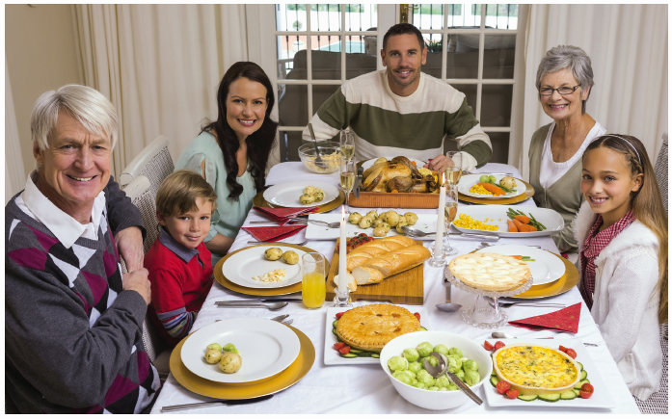

PART 2




1. 2. 3.



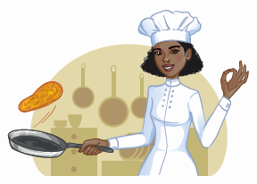


4. 5. 6.

SPEAKING TEST | 2

PROCEDURES

Part 1

The teacher greets the learner and checks his/her name.
A. The teacher shows the learner a picture and asks the learner to point to the items: Who is the son?
Who is the daughter? Who is the father? Who is the mother? Who are the grandparents?
B. The teacher asks questions about the picture: How many people are there in this family? Where are they? Are they happy? (The teacher points to the juice / a chair.) What’s this? What colour is it?

Part 2
The teacher shows the learner some smaller pictures and asks: 1. What’s this? 2. What are the family’s pets?
3. What’s their favourite food? 4. What’s his favourite thing? 5. What’s his job? 6. What’s her job?

Part 3
The teacher asks the learner some personal questions related to the topic: Is your family big or small? What are your parents’ names? How old is your father? And your mother? Have you got any brothers or sisters? Have you got any pet?

SUGGESTED ANSWERS

Part 1
B. There are six. / They are in the dining room. / Yes, they are (happy). / This is (orange) juice. It’s orange. / This is a chair. It’s white.

Part 2
1. This is a family tree. / 2. They are a cat and a dog. / 3. Their favourite food is pizza. / 4. His favourite thing is a book. / 5. He is a doctor. / 6. She is a cook.

Part 3

Personal answers.

