PROGRESS TEST 5

Name_________________________________________________ No. ______ Class_______
Date _____ / _____ / _____ Mark______________________ Teacher______________________


LISTENING
1. Listen and draw the time. What time does Tom…
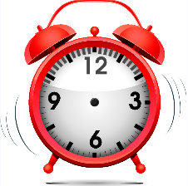
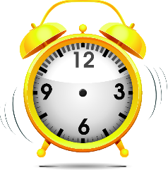
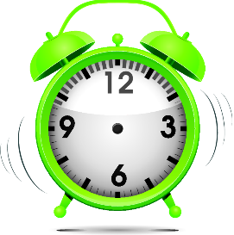

a) …get up? b) …leave for school? c) …begin lessons?
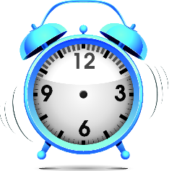
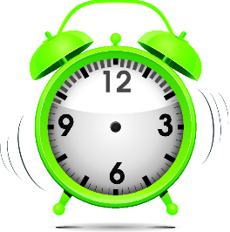

d) …go home? e) …has dinner with f) …go to bed?
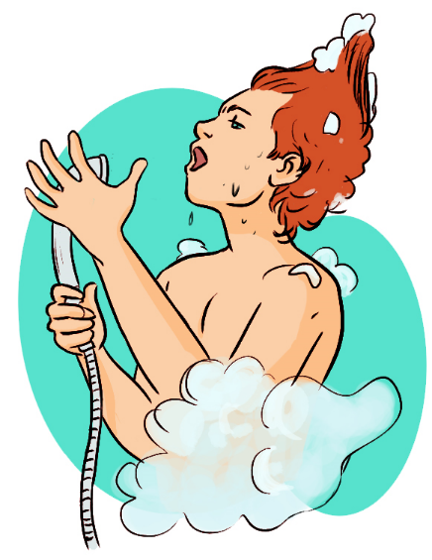
2. Listen again and circle the right answer.
1. Tom is ______________________________.
a) English b) American
2. He is a ______________________________.
a) teacher b) student
3. In the morning he has ______________________________.
a) a bath b) a shower
4. At breakfast the family has ___________________________.
a) coffee b) milk
5. He has lessons ______________________________.
a) in the morning b) in the morning and in the afternoon
6. After doing homework, he ______________________________ with his brother.

a) studies b) plays
7. Before going to bed, he ______________________________.
a) brushes his teeth b) watches TV


PART 1
A
READING, GRAMMAR AND WRITING
Read the text.

My name is Adam. I am ten years old and I am a
student. I live with my parents and my sister. I like
school and my schoolmates but I prefer weekends.
On Saturdays, I usually sleep until ten o´clock. Then
I have a shower and I have breakfast with the family.
We have more time, so my mum usually makes
pancakes and orange juice. After breakfast, I usually
do my homework.
At one o’clock, we have lunch and then I have some time to play football with
my friends. Football is my favourite sport. I am a good player and my dream is to
be a professional.
At eight o’clock, the family has dinner and we watch TV. I go to bed at eleven
o’clock.
On Sundays, we always drive to my grandparents’ house for lunch. I love them.
They are very nice and friendly. In the afternoon we come back home and I play
computer games with my sister. On Sundays, I go to bed at ten o’clock.

My weekends

1. Read and match.
1. Adam is a) playing football with his friends.
2. He prefers b) he has lunch at his grandparents’ house.
3. On Saturdays c) ten years old.
4. He loves d) weekends to weekdays.
5. On Sundays e) he gets up at 10 o’clock.
2. Complete the sentences.
a) Adam lives _________________________________________________________________.
b) At weekends, he gets up ______________________________________________________.
c) Breakfast is _________________________________________________________________.
d) Adam’s favourite sport _______________________________________________________.
e) On Sunday afternoon, he usually _______________________________________________.
PART 2
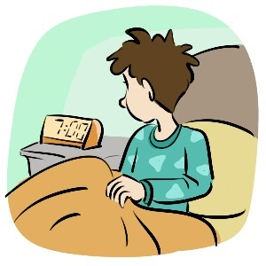
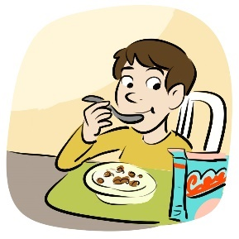
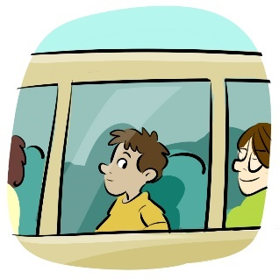
1. Complete the sentences about Adam’s school days.

a) He ___________________ b) He _______________ c) He _________________
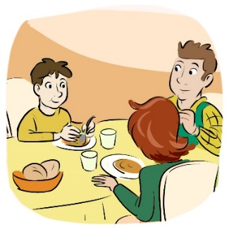
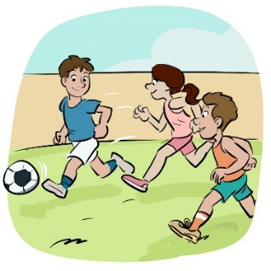
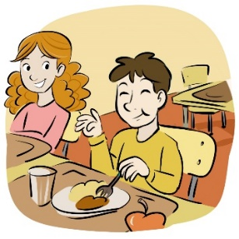
at 7 o’clock. at half past seven. at 8 o’clock.

d) He ___________________ e) In the afternoon he f) He _________________
at one o’clock. ___________________. at eight o’clock.

2. Order the words.
a) usually / she / TV / watches / after / dinner / .
_________________________________________________________________________________________
b) are / never / late / school / for / they / .
_________________________________________________________________________________________
c) eats / vegetables / rarely / he / and / fruit / .
_________________________________________________________________________________________

3. Circle the right word in each pair.
a) There aren’t some / any yogurts in the fridge.
b) It’s hot. I want any / some water.
c) How many / any sandwiches are there?
PART 3
Answer the questions about your daily routine on school days.
What time do you get up? What do you do after school?
How do you go to school? What time do you have dinner?
Where do you have lunch? What time do you go to bed?

PART 1
B
READING, GRAMMAR AND WRITING
Read the text.

Cristiano Ronaldo is a famous Portuguese
football player. At the moment he plays in Real
Madrid, Spain.
He gets up at 8 o’clock and he has breakfast.
He usually has fried eggs, sliced ham, fruit and
coffee or bread with cheese or jam and orange
juice. In the morning Cristiano trains in the
gym for about three hours.
He has lunch with his teammates at one o’clock. After lunch, they like playing
computer games. At four o’clock, all the team trains in Real Madrid training
camp. Then they watch some games with their coach to review the strategies.
Cristiano gets home at half past seven. He has dinner with his family and plays
with his son. He usually goes to bed at ten o’clock to have a good night’s sleep.
It’s a busy day, but Cristiano loves what he does.

Cristiano Ronaldo’s daily routine

1. Circle the right answer.
1. Cristiano Ronaldo is a ________________________________ football player.
a) Spanish b) Portuguese c) British

2. At breakfast he sometimes drinks ___________________________.
a) coffee b) milk c) tea

3. He has lunch with _____________________________________________.
a) his teammates b) his family c) his coach

4. Before going to bed, he _____________________________.
a) goes to sleep b) plays with his son c) has dinner

2. Answer the questions.
a) What is Cristiano Ronaldo’s job?
________________________________________________________________________________________
b) What does he do after breakfast?
________________________________________________________________________________________
c) Where is he at four o’clock?
________________________________________________________________________________________
d) What time does he go to bed?
________________________________________________________________________________________

PART 2
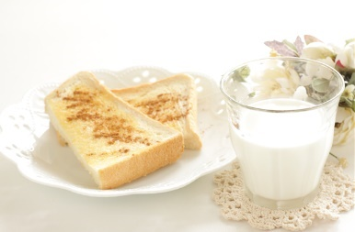
1. Complete the dialogues with the present simple.
A: What __________ you __________ (have) for breakfast?
B: I usually _______________ (eat) toasts and _______________ (drink) milk.
C: What time __________ Alex __________ (get up)?
D: He _________________ (get up) at half past seven.
E: How ___________ the students ___________ (go) to school?
F: They _______________ (not / walk) to school. They _____________ (go) by bus.

2. Ask questions.
a) _________________________________________________________________________?
I go to school at 8 o’clock.
b) _________________________________________________________________________?
We have lunch at the school canteen.
c) _________________________________________________________________________?
She does her homework after dinner.

3. Insert the adverb in the right place.
a) We go to the cinema. (sometimes)
_________________________________________________________________________
b) I listen to music in the bus. (usually)
_________________________________________________________________________
c) John is late for school. (never)
_________________________________________________________________________
PART 3
7.30 – wake up 4 – go home
8 – breakfast 5 – do homework
9 – lessons 7.30 – dinner
12.30 – lunch 9 – watch TV
2 – lessons 10 – go to bed


Write Jane’s daily routine
according to the notes.

SCRIPT
PROGRESS TEST 5

Hi! I’m Tom and I’m ten years old. I live in London. This my daily routine on school days. I get up at seven o’clock and have a shower. I get dressed and have breakfast with the family. We usually have milk and toast, but sometimes I eat yogurt and cereal. At a quarter to eight I leave home for school. I usually go on foot, but when it’s raining I catch the bus. Lessons begin at half past eight. I have lunch in the school canteen. I have some more lessons in the afternoon and at four o’clock I go home. I do my homework and then I play with my brother. We like playing football and computer games. At eight o’clock the family has dinner together. Then we watch TV. At about ten o’clock I brush my teeth and go to bed. Tomorrow is another day!

ANSWERS
LISTENING

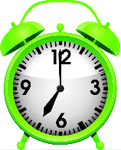
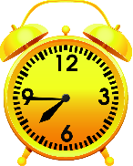
1.
a) b)

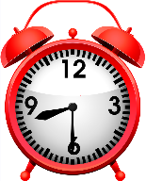
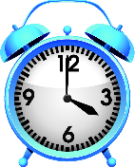
c) d)

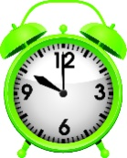

e) f)

2.
1. a); 2. b); 3. b); 4. b); 5. b); 6. b); 7. a)
READING, GRAMMAR AND WRITING – A
READING, GRAMMAR AND WRITING – A
PART 1
1.
1. c); 2. d); 3. e); 4. a); 5. b)

2.
a) with his parents and his sister.
b) at 10 o’clock.
c) pancakes and orange juice.
d) is football.
e) plays computer games with his sister.

PART 2

1.
a) wakes up / gets up
b) has breakfast
c) goes to school
d) has lunch
e) plays football
f) has dinner

2.
a) She usually watches TV after dinner.
b) They are never late for school.
c) He rarely eats fruit and vegetables. / He rarely eats vegetables and fruit.

3.
a) any; b) some; c) How many

PART 3

Personal answer.

READING, GRAMMAR AND WRITING – B
READING, GRAMMAR AND WRITING – B
PART 1
1.
1. b); 2. a); 3. a); 4. b)

2.
a) He is a football player.
b) After breakfast, he trains in the gym.
c) At four o’clock, he is in Real Madrid training camp.
d) He goes to bed at ten o’clock.

PART 2

1.
A: do… have
B: eat / drink
C: does … get up
D: gets up
E: do… go
F: don’t walk / go

2.
a) What time do you go to school?
b) Where do you have lunch?
c) When does she do her homework?

3.
a) We sometimes go to the cinema.
b) I usually listen to music in the bus.
c) John is never late for school.

PART 3
Jane wakes up at half past seven and has breakfast at eight o’clock. Her lessons begin at nine o’clock. At half past twelve, she has lunch. In the afternoon, lessons begin at two o’clock and finish at four o’clock. Jane goes home and, at five o’clock, she does her homework. At half past seven, she has dinner with the family. At nine o’clock, she watches TV and at ten o’clock she goes to bed.

SPEAKING TEST 5

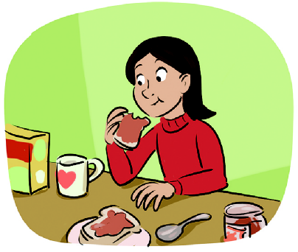

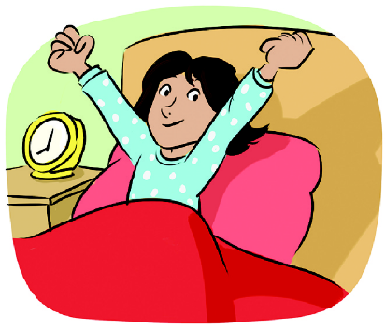
PART 1
1. 2. 3.

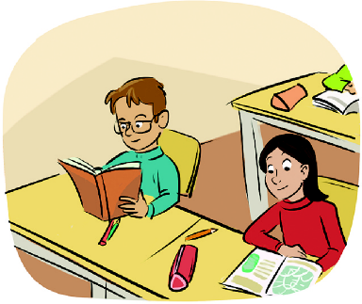
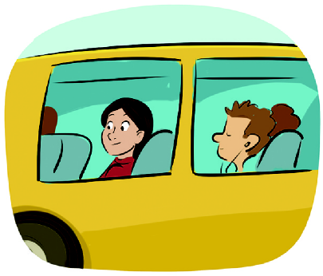
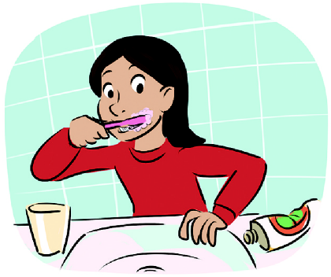
4. 5. 6.

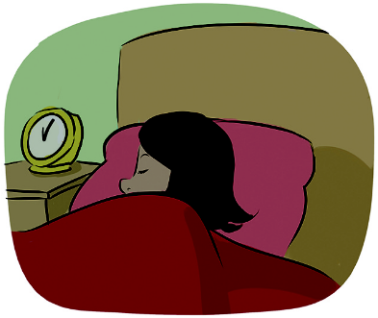
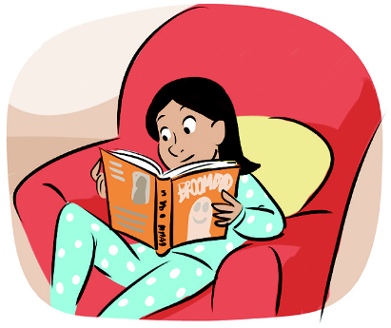
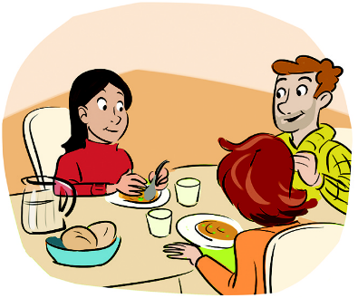
7. 8. 9.

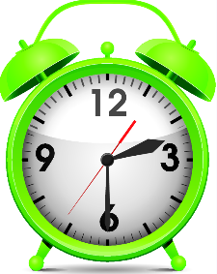
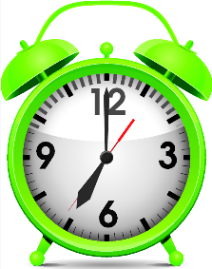
PART 2
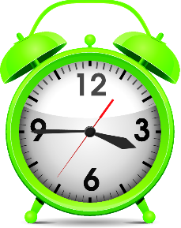

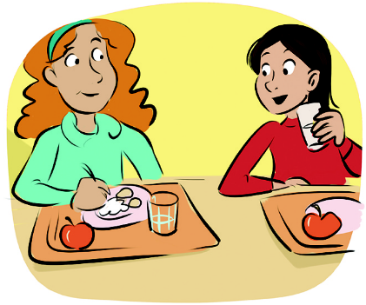
1. 2. 3.
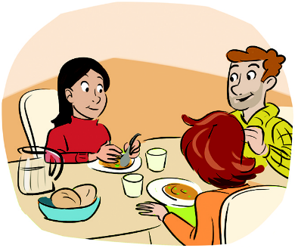

4. 8 a.m. 5. 1 p.m. 6. 7.30 p.m.
PROCEDURES

Part 1
The teacher greets the learner and checks his/her name.
- The teacher shows the learner a picture and asks the learner to point to the items: The girl wakes up. She brushes her teeth. She is at school. She reads (a book). They have dinner.
- The teacher asks questions about pictures 2, 3, 5, 8 and 9: What does she usually do on school days?

Part 2
The teacher shows the learner some smaller pictures and asks: (Pictures 1, 2 and 3) What time is it? (Pictures 4, 5 and 6) Look at the pictures and the time and identify the meal.

Part 3
The teacher asks the learner some personal questions related to the topic: What time do you usually wake up on school days? What do you have for breakfast? Where do you have lunch? When do you do your homework? What time do you go to bed? What do you prefer doing at the weekend?

SUGGESTED ANSWERS

Part 1
- Pictures 1, 4, 6, 8, 7
- She has a shower. / She has breakfast. / She takes the bus / goes to school. / She reads a book. / She goes to bed.

Part 2
- It’s seven o’clock. / 2. It’s half past two. / 3. It’s a quarter to four. / 4. It’s breakfast. / It’s lunch. / 6. It’s dinner.

Part 3
Personal answers.

