FICHA DE TRABALHO 24
Adição e subtração de frações e de numerais mistos

NOME: ______________________________________N.º: ______ TURMA: _________ DATA: ____________

- Completa as igualdades seguintes.
- $\frac{\text{4}}{\text{5}} \text{+} \frac{\boxed{}}{\text{5}} \text{=} \frac{\text{6}}{\text{5}}$ e) $\frac{\boxed{}}{\text{15}} \text{+} \frac{\text{4}}{\text{15}} \text{=} \frac{\text{17}}{\text{15}}$ i) $\frac{\text{8}}{\text{9}} \text{-} \frac{\boxed{}}{\text{9}} \text{=} \frac{\text{1}}{\text{9}}$
- $\frac{\text{4}}{\text{5}} \text{+} \frac{\boxed{}}{\text{5}} \text{=} \frac{\text{10}}{\text{5}}$ f) $\frac{\text{4}}{\text{5}} \text{+} \frac{\boxed{}}{\text{5}} \text{=} \frac{\text{31}}{\text{13}}$ j) $\frac{\boxed{}}{\text{12}} \text{-} \frac{\text{20}}{\text{12}} \text{=} \text{1}$
- $\frac{\boxed{}}{\text{8}} \text{+} \frac{\text{3}}{\text{8}} \text{=} \frac{\text{9}}{\text{8}}$ g) $\frac{\boxed{}}{\text{4}} \text{-} \frac{\text{7}}{\text{4}} \text{=} \frac{\text{5}}{\text{4}}$ k) $\frac{\boxed{}}{\text{10}} \text{-} \frac{\text{3}}{\text{10}} \text{=} \frac{\text{1}}{\text{10}}$
- $\frac{\boxed{}}{\text{9}} \text{+} \frac{\text{7}}{\text{9}} \text{=} \frac{\text{21}}{\text{9}}$ h) $\frac{\text{14}}{\text{4}} \text{-} \frac{\boxed{}}{\text{4}} \text{=} \text{3}$ l) $\frac{\boxed{}}{\text{9}} \text{-} \frac{\text{7}}{\text{9}} \text{=} \text{1}\frac{\text{2}}{\text{9}}$
- Completa as igualdades seguintes.
- $\frac{\text{4}}{\text{5}} \text{+} \boxed{} \text{=} \frac{\text{17}}{\text{10}}$ c) $\frac{\text{7}}{\text{4}} \text{-} \boxed{} \text{=} \frac{\text{9}}{\text{8}}$ e) $\boxed{} \text{+} \frac{\text{4}}{\text{5}} \text{=} \frac{\text{31}}{\text{20}}$
- $\frac{\text{5}}{\text{3}} \text{-} \boxed{} \text{= }\frac{\text{5}}{\text{6}}$ d) $\frac{\text{1}}{\text{3}} \text{+} \boxed{} \text{=} \frac{\text{7}}{\text{12}}$ f) $\boxed{} \text{-} \frac{\text{5}}{\text{12}} \text{=} \frac{\text{17}}{\text{12}}$
- Determina, na forma de fração irredutível, o valor de:
- $\frac{\text{2}}{\text{3}} \text{+} \frac{\text{5}}{\text{6}}$ f) $\text{5} \frac{\text{1}}{\text{2}} \text{+} \text{3} \frac{\text{1}}{\text{4}}$ k) $\frac{\text{2}}{\text{3}} \text{-} \frac{\text{5}}{\text{12}} \text{+} \frac{\text{5}}{\text{24}}$
- $\frac{\text{5}}{\text{8}} \text{-} \frac{\text{7}}{\text{24}}$ g)$\text{10} \frac{\text{1}}{\text{7}}\text{+} \text{3} \frac{\text{2}}{\text{5}}$ l) $\frac{\text{4}}{\text{5}} \text{-} \frac{\text{7}}{\text{10}} \text{+ }\frac{\text{5}}{\text{6}}$
- $\frac{\text{4}}{\text{5}} \text{+} \frac{\text{15}}{\text{20}}$ h) $\text{2} \frac{\text{12}}{\text{15}} \text{-} \text{1} \frac{\text{5}}{\text{6}}$ m) $\frac{\text{4}}{\text{5}} \text{+ }\frac{\text{7}}{\text{10}} \text{- }\frac{\text{8}}{\text{15}}$
- $\frac{\text{19}}{\text{36}} \text{-} \frac{\text{4}}{\text{9}}$ i) $\text{3} \frac{\text{3}}{\text{5}} \text{-} \text{2} \frac{\text{3}}{\text{4}}$ n) $\frac{\text{11}}{\text{16}} \text{- }\frac{\text{5}}{\text{12}} \text{+ }\frac{\text{1}}{\text{3}}$
- $\frac{\text{4}}{\text{9}} \text{+} \frac{\text{1}}{\text{3}}$ j) $\text{4} \frac{\text{9}}{\text{15}} \text{-} \text{3} \frac{\text{1}}{\text{2}}$
- Calcula o valor das expressões seguintes.
a)    $$\text{1 }\frac{\text{1}}{\text{8}} \text{+ }\frac{\text{3}}{\text{4}} \text{+} \text{2 }\frac{\text{1}}{\text{2}} \text{=}$$  $$\text{= }\frac{\text{9}}{\text{8}} \text{+ }\frac{\text{3}}{\text{4}} \text{+ }\frac{\text{5}}{\text{2}}=$$  = | b)  $$\text{2} \frac{\text{1}}{\text{6}} - \frac{\text{7}}{\text{12}} +\text{1 }\frac{\text{1}}{\text{3}} =$$  = | c)  $$\text{3 }\frac{\text{1}}{\text{10}} \text{+ }\frac{\text{3}}{\text{2}} \text{-} \text{2 }\frac{\text{3}}{\text{5}} \text{=}$$  =

- Determina o peso do saco em cada uma das balanças da figura abaixo.
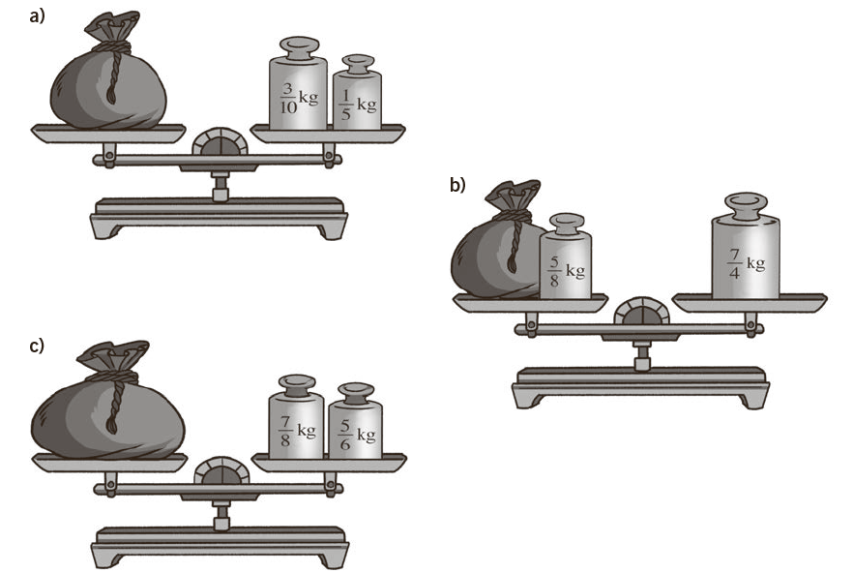
- Determina o peso de cada saco em cada uma das balanças.
