TEST 1 UNIT 1 Friends and Family
Name __________________________________________________ No. _______ Class ______
Date _____/_____/_____ Mark _________________ Teacher ____________________________
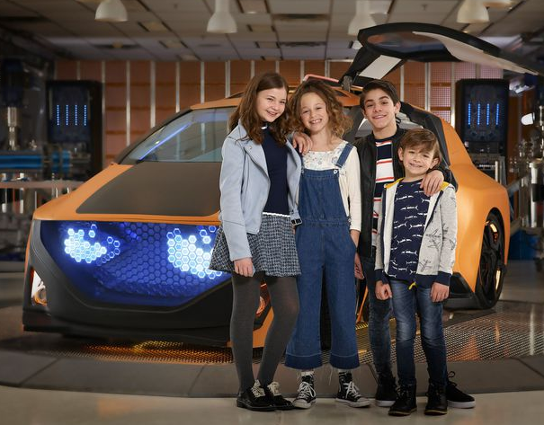
LISTENING

The Actors and Actresses
that Star in Fast Layne

©Disney Channel/Ed Herrera
A. Match the sentence halves according to what you hear. (4 x 2 = 8 points)
1. Sophie Pollono stars as Layne Reed, a 12-year-old active girl ____  2. Sofia Rosinsky stars as Zora Morris, Layne’s funny neighbor ____  3. Brandon Rossel stars as Layne’s friend Cody Castillo, ____  4. Winslow Fegley stars as Mel, ____ |  | a. a smart, charming boy with a talent for fixing cars.  b. Layne’s nosy younger cousin.  c. whose life changes completely when she befriends a smart talking car named “VIN.”  d. who teams up with Layne in her adventures.

B. Listen again and circle the correct option. (12 x 1 = 12 points)
Sophie lives in Los Angeles with her ¹parents / sisters, her brother Jack, a turtle and three ²cats / dogs. She enjoys spending time with her ³friends / family and shopping for clothes.

Sofia is 12 years old and she likes painting, ⁴singing / dancing and playing the ⁵piano / drums. She also supports several charities including those which help ⁶animals / artists.

Brandon loves ⁷cars / bikes, hanging out with his ⁸cousins / friends and playing soccer. He also likes volunteering with special needs kids and older ⁹children / people.

Winslow belongs to a ¹⁰film / family of actors. His ¹¹grandparents / parents, sister and brother are all actors. He is 10 years old. He enjoys playing the ¹²piano / guitar, going to the theater and museums.
https://www.wdtvpress.com/disneychannel/shows/fast-layne/bios/ (AmE; abridged and adapted)

TEST 1 UNIT 1 Friends and Family
Name __________________________________________________ No. _______ Class ______
Date _____/_____/_____ Mark _________________ Teacher ____________________________

READING AND GRAMMAR

A. Read the text carefully.
Fast Layne

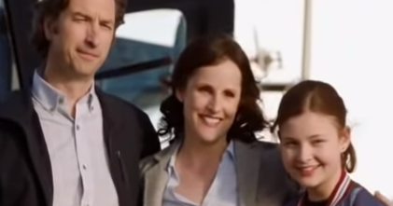
Fast Layne is an American television series created for Disney Channel. It tells the adventures of Layne, Zora, Cody and Mel, and VIN, a smart talking car.
The four friends live in the town of Cedarville. Layne Reed is a smart and an active girl. She is only 12 years old, but she is Cedarville Middle School president. Zora Morris is Layne's neighbor and best friend. Cody Castillo is a boy from school with a talent for fixing cars; he is Layne's love interest. Mel is Layne's younger cousin. He is nosy and he is always trying to discover what Layne and Zora are doing.
Layne’s parents are two brilliant scientists who create VIN, the intelligent car. Cheryl is her mother. She is tall and slim. She has got wavy, brown hair and brown eyes. She is very intelligent and hard-working. Rob is her father. He is tall and slim, too, and he has got short, brown hair. He is very smart and patient. Betty is Layne’s aunt and Mel’s mother. She’s friendly and kind.
Layne’s adventures are dangerous, but she has lots of fun with her friends and family! And with VIN, of course!
https://en.wikipedia.org/wiki/Fast_Layne (AmE; abridged and adapted)

B. Choose the correct option. (5 x 1 = 5 points)
1. Fast Layne is an American... | a. channel. | b. TV series. | c. film.
2. Layne, Zora, Cody and Mel are... | a. cousins. | b. neighbours. | c. friends.
3. VIN is a… | a. smart boy. | b. robot. | c. talking car.
4. Betty is… | a. Zora’s aunt. | b. Zora’s mother. | c. Layne’s aunt.
5. Layne’s adventures… | a. are exciting. | b. are boring. | c. aren’t dangerous.

C. Answer the questions about the text. (5 x 3 = 15 points)
1. Where does Layne live? ______________________________________________________
2. What is Layne like? __________________________________________________________
3. How old is Layne? ___________________________________________________________
4. Who is Layne’s best friend? ___________________________________________________
5. What do Layne’s parents do? __________________________________________________

D. Complete the table with information from the text. (4 x 2 = 8 points)
CHERYL |  | ROB
1. Personality: |  | 3. Personality:
2. Appearance: |  | 4. Appearance:

E. Choose the correct option. (7 x 1 = 7 points)
1. Layne lives in Cedarville. Its / It’s an imaginary town.
2. Layne is a smart girl. She / Her is also very active.
3. Zora is Layne’s neighbour. She is also his / her best friend.
4. Cody is a boy from school. Fixing cars is their / his passion.
5. Mel is Layne’s cousin. He’s / His a very nosy boy.
6. Layne’s parents are scientists. They / Their job is to develop important scientific projects.
7. VIN is a car created by Layne’s parents. Its / It’s an intelligent car.

F. Complete the paragraph with the correct form of to be or to have got. (10 x 1 = 10 points)
 | Who ¹_______________ Betty George?  Betty George ²_______________ Layne’s aunt and Mel’s mother. She ³_______________ curly, blonde hair; her hair ⁴_______________ wavy and light brown. Her eyes ⁵_______________ green; they are blue. Betty and Mel ⁶_______________ unfriendly; they ⁷_______________ friendly and kind. ⁸_______________ Aunt Betty nosy? No, she ⁹_______________, but Mel ¹⁰_______________!

G. Write sentences in the present continuous. (5 x 3 = 15 points)
1. Layne / drive / VIN / ? ________________________________________________________
2. Cody / fix / a car / . __________________________________________________________
3. Rob and Cheryl / not work/ . ___________________________________________________
4. Zora / study / ? _____________________________________________________________
5. Aunt Betty and Mel / shop / . ___________________________________________________

WRITING

H. Write a short text about YOU (mention the topics in the box). Write about 25-35 words. (20 points)
Name Age Birthday
Occupation
Physical features Personality
Sports and hobbies

__________________________________________________________________________
__________________________________________________________________________
__________________________________________________________________________
__________________________________________________________________________
__________________________________________________________________________
__________________________________________________________________________
__________________________________________________________________________

Good work!

