FAST WORKSHEET 1 VOCABULARY |  | Nationalities
Name |  |  | No. | Class
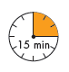

A. Match the pairs and write their nationalities.

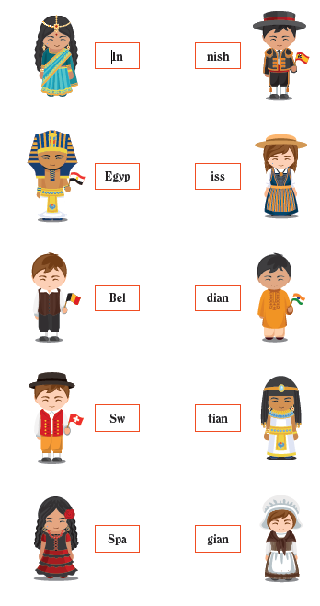
(1) ___________________________

(2) ___________________________

(3) ___________________________

(4) __________________________

(5) __________________________

B. Complete the sentences with the right nationalities.

1. They are from Portugal. They are____________________________.
2. We are from the USA. We are_____________________________.
3. He is from Angola. He is_______________________________.
4. She is from Scotland. She is______________________________.
5. They are from Wales. They are_____________________________.
6. He is from Italy. He is _______________________________.
7. They are from Ireland. They are____________________________.
8. She is from Japan. She is______________________________.
9. We are from England. We are_____________________________.
10. I am from France. I am_______________________________.
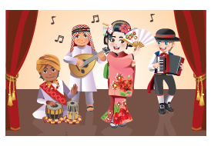

C. Look at the picture. Unscramble the letters in the box and complete
the sentences.
Abianra nepase nalitioties andi manr

1. There are four people in this band.
They have four different na____________________________.
2. Georg is Ge________________________________________.
3. Aika is Ja__________________________________________.
4. Omar is Saudi- _____________________________________.
5. Rahul is in_________________________________________.

Answers
A. Match the pairs and write their nationalities.

(1) Indian

(2) Egyptian

(3) Belgian

(4) Swiss

(5) Spanish

B. Complete the sentences with the right nationalities.
1. They are from Portugal. They are Portuguese
2. We are from the USA. We are American
3. He is from Angola. He is Angolan
4. She is from Scotland. She is Scottish
5. They are from Wales. They are Welsh
6. He is from Italy. He is Italian
7. They are from Ireland. They are Irish
8. She is from Japan. She is Japanese
9. We are from England. We are English
10. I am from France. I am French

C. Look at the picture. Unscramble the letters in the box and complete
the sentences.
Abianra nepase nalitioties andi manr

1. There are four people in this band.
They have four different nationalities
2. Georg is German
3. Aika is Japanese
4. Omar is Saudi-Arabian
5. Rahul is Indian

