FAST WORKSHEET GRAMMAR 10 | Adverbs of frequency
Name |  | No. | Class
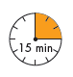

A. Insert the adverb of frequency in the correct place.
1. Martha plays tennis. (rarely)_______________________________________________.
2. Martha and her parents cook dinner together. (often)___________________________.
3. They go shopping. (once a week) __________________________________________.
4. Her father misses a football match on TV. (hardly ever) _________________________.
5. Her mother listens to music while she works. (usually)__________________________.

B. Complete the sentences with always, usually, sometimes,
twice a week or never and the right form of the verbs in brackets
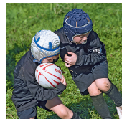
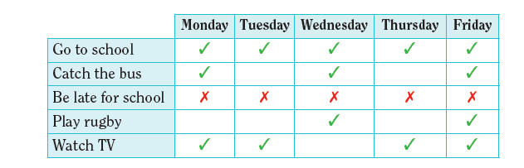

1. Michael_________________ (go) to school in the morning.
2. He_____________________ (catch) the bus.
3. He_____________________ (be) late for school.
4. He_____________________ (play) rugby.
5. He_____________________ (watch) TV.

C. Find one mistake in each sentence and correct it.

1. We never are late for school. ______________________________________________
2. He makes always his bed. ________________________________________________
3. She does rarely the ironing. _______________________________________________
4. They cook often their meals. ______________________________________________

5. I wake up early hardly ever on Sundays. ____________________________________

ANSWERS
A. Insert the adverb of frequency in the correct place.
1. Martha plays tennis. (rarely) Martha rarely plays tennis.
2. Martha and her parents cook dinner together. (often) Martha and her parents often cook dinner together.
3. They go shopping. (once a week) They go shopping once a week.
4. Her father misses a football match on TV. (hardly ever) Her father hardly ever misses a football match on TV.
5. Her mother listens to music while she works. (usually) Her mother
usually listens to music while she works.

B. Complete the sentences with always, usually, sometimes,
twice a week or never and the right form of the verbs in brackets
1. Michael always goes (go) to school in the morning.
2. He sometimes catches (catch) the bus.
3. He is never (be) late for school.
4. He plays rugby twice a week (play) rugby.
5. He usually watches (watch) TV.

C. Find one mistake in each sentence and correct it.

1. We never are late for school. We are never late for school.
2. He makes always his bed. He always makes his bed.
3. She does rarely the ironing. She rarely does the ironing.
4. They cook often their meals. They often cook their meals.
5. I wake up early hardly ever on Sundays. I hardly ever wake up early on Sundays.

