FAST WORKSHEET 14 VOCABULARY | School rooms/places
Name |  | No. | Class

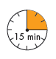
A. Read and match the words.

1. girls’ / boys’ a. area
2. sports b. shop
3. reception c. bar
4. school d. room
5. headteacher’s e. field
6. coffee f. toilet
7. computer g. office
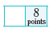
B. Read and complete the crossword.
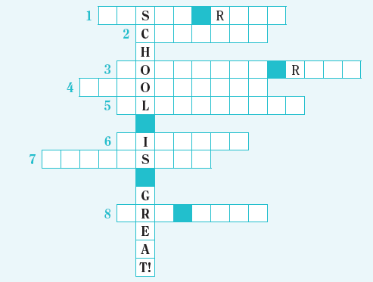

1. You learn to play musical instruments in this room.
2. You can have lunch there.
3. You can learn a lot about Information and Communication Technology in this room.
4. You can do a lot of experiments in this room.
5. You have fun with your friends there.
6. You can read a lot of books with fantastic adventures in this room.
7. This is a room equipped for gymnastics, games, and other physical exercise.
8. This is a room where you can draw and paint

ANSWERS
A. Read and match the words.
1. girls’ / boys’ a. area
2. sports b. shop
3. reception c. bar
4. school d. room
5. headteacher’s e. field
6. coffee f. toilet
7. computer g. office

B. Read and complete the crossword.

1. music room
2. canteen
3. computer room
4. laboratory

5. playground
6. library
7. gymnasium
8. art room

