FAST WORKSHEET 15 GRAMMAR | Adverbs of manner
Name |  | No. | Class

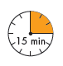
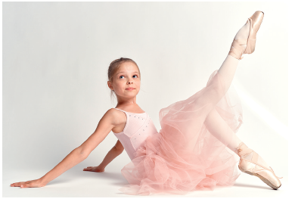
A. Read and match.

1. Constance dances ballet
2. Her parents like walking
3. Her friends at school always play
4. Her music teacher is singing
5. Her baby brother is sleeping
a. noisily during break.
b. quietly in his room.
c. slowly in the park.
d. gracefully.
e. loudly.

B. Circle the right option.
1. ‘Wait for me! You are walking too quickly / slowly.
2. He is building a Lego castle very carefully / terribly.
3. The children are running terribly / rapidly after their dog.
4. ‘Look! The children are singing and dancing quietly / happily.’
5. ‘I can do my English homework beautifully / easily.’
C. Complete the sentences with an adverb.
1. The concert is a success. The fans are clapping their hands_____________________
(excited).
2. It’s a very bad game. The boys are playing_______________________ (terrible).
3. They play the piano_______________________ (beautiful).
4. The students are preparing their Arts project very______________________ (careful).
5. They are in the park, sitting__________________ (quiet) under a tree.

ANSWERS

A. Read and match.

1. Constance dances ballet
2. Her parents like walking
3. Her friends at school always play
4. Her music teacher is singing
5. Her baby brother is sleeping
a. noisily during break.
b. quietly in his room.
c. slowly in the park.
d. gracefully.
e. loudly.

B. Circle the right option.
1. ‘Wait for me! You are walking too quickly / slowly.
2. He is building a Lego castle very carefully / terribly.
3. The children are running terribly / rapidly after their dog.
4. ‘Look! The children are singing and dancing quietly / happily.’
5. ‘I can do my English homework beautifully / easily.’

C. Complete the sentences with an adverb.

1. The concert is a success. The fans are clapping their hands excitedly (excited).
2. It’s a very bad game. The boys are playing terribly (terrible).
3. They play the piano beautifully (beautiful).
4. The students are preparing their Arts project very carefully (careful).
5. They are in the park, sitting quietly (quiet) under a tree.

