FAST WORKSHEET 18 VOCABULARY | After-school activities
Name |  | No. | Class

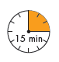
- Complete the names of these school clubs.
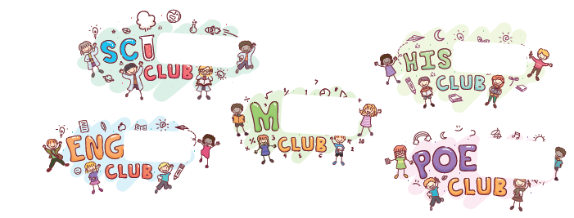
- What clubs are they in?

1. Mary and James like foreign languages. They’re in the_____________________
2. John likes doing sports. He’s in the_____________________________________
3. Helen and Peter like taking photographs. They’re in the_____________________
4. Constance likes singing. She’s in the____________________________________
5. William likes drawing and painting. He’s in the_____________________________

C. What do they do after school?
Complete the sentences with the missing words.
Drama Dance Computer Eco Science

1. Constance loves dancing.

She’s in the________________ club.
2. John likes editing videos and pictures.
He’s in the_________________ club.
3. Sophia and Bernard like theatre and acting.
They’re in the_______________ club.
4. William and Claire like doing experiments.
They’re in the_______________ club.
5. Paul likes to protect the environment.
He’s in the_________________-club.

ANSWERS

A. Complete the names of these school clubs.
try

ence

tory
aths

lish

B. What clubs are they in?

1. Mary and James like foreign languages. They’re in the Languages Club.
2. John likes doing sports. He’s in the Sports Club.
3. Helen and Peter like taking photographs. They’re in the Photo Club.
4. Constance likes singing. She’s in the School choir.
5. William likes drawing and painting. He’s in the Art Club.

C. What do they do after school?
Complete the sentences with the missing words.
Drama Dance Computer Eco Science

1. Constance loves dancing.
She’s in the Dance club.
2. John likes editing videos and pictures.
He’s in the Computer club.
3. Sophia and Bernard like theatre and acting.
They’re in the Drama club.
4. William and Claire like doing experiments.
They’re in the Science club.
5. Paul likes to protect the environment.
He’s in the Eco-club.

