FAST WORKSHEET 20 GRAMMAR | There + to be (past simple)
Name |  | No. | Class

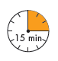
A. Nancy went to the clothes shop near her school.
Find out the things she saw at the shop. Read and match.

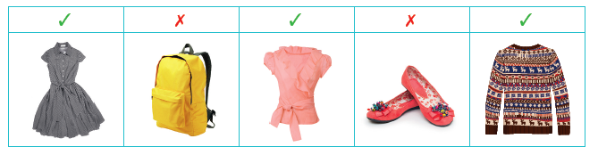

1. Were there any dresses?
2. Were there any schoolbags?
3. Was there a blouse?
4. Was there any pair of shoes?
5. Were there any sweaters?
a. Yes, there was.
b. No, there wasn’t.
c. Yes, there were.
d. Yes, there were.
e. No, there weren’t.

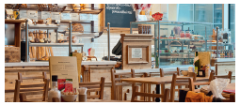
B. Nancy went to a new bakery,
too. Nancy and James are talking
about it. Write what they are
saying in the past simple.

1. There are delicious cakes. ____________________________________________
2. Are there any croissants? _____________________________________________
3. Is there mango juice? ________________________________________________
4. No, there isn’t any Christmas cake. _____________________________________
5. No, there aren’t any pancakes. _________________________________________

C. Complete the sentences with the right form of there + to be.
1. ______________a bookshop in the shopping centre? – No, there wasn’t.
2.________________________ a bakery? – Yes, there was.
3. Were there any supermarkets? – No, ________________________.
4. Was there a shoe shop? – Yes, ______________________________.
5._____________________________ any restaurants? – Yes, there were.

ANSWERS

A. Nancy went to the clothes shop near her school.
Find out the things she saw at the shop. Read and match.

1. Were there any dresses?
2. Were there any schoolbags?
3. Was there a blouse?
4. Was there any pair of shoes?
5. Were there any sweaters?
a. Yes, there was.
b. No, there wasn’t.
c. Yes, there were. (or 1)
d. Yes, there were. (or 5)
e. No, there weren’t.

B. Nancy went to a new bakery,
too. Nancy and James are talking
about it. Write what they are
saying in the past simple.

1. There are delicious cakes. There were delicious cakes.
2. Are there any croissants? Were there any croissants?
3. Is there mango juice? Was there mango juice?
4. No, there isn’t any Christmas cake. No, there wasn’t any Christmas cake.
5. No, there aren’t any pancakes. No, there weren’t any pancakes.

C. Complete the sentences with the right form of there + to be.
1. Was there a bookshop in the shopping centre? – No, there wasn’t.
2. Was there a bakery? – Yes, there was.
3. Were there any supermarkets? – No, there weren’t.
4. Was there a shoe shop? – Yes, there was.
5. Were there any restaurants? – Yes, there were.

