FAST WORKSHEET 22 VOCABULARY | Types of homes
Name |  | No. | Class
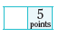
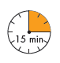

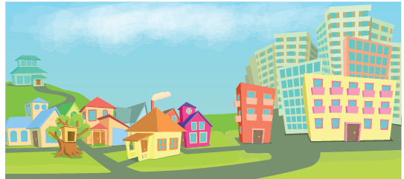

A. Complete the types of homes with the missing letters.
1. b__ o__ k of f__ a__ s
2. d__ t__ c__ e__ h__ u__ e
3. m__ n__ i__ n
4. t__ e__ h__ u__ e
5. s__ m__ -d__ t__ c__ e __ h__ u__ e



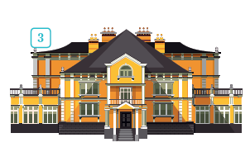
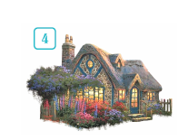
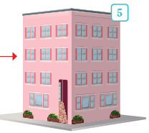
B. Unscramble the letters and find 5 types of homes.
1. acelst______________________
2. abglnouw___________________
3. aimnnos____________________
4. acegott_____________________
5. aflt________________________

ANSWERS

A. Complete the types of homes with the missing letters.
1. b l o c k of f l a t s
2. d e t a c h e d h o u s e
3. m a n s i o n
4. t r e e h o u s e
5. s e m i-d e t a c h e d h o u s e

B. Unscramble the letters and find 5 types of homes.
1. acelst castle
2. abglnouw bungalow
3. aimnnos mansion
4. acegott cottage
5. aflt flat

