FAST WORKSHEET 23 VOCABULARY | Furniture
Name |  | No. | Class
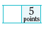
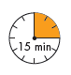
A. Complete the paragraph with the words in the box.
coffee table windows vase sofa living room

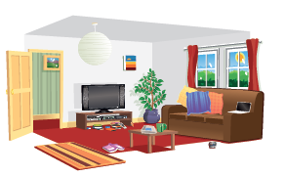
This is Janet’s (1) _______________. It’s very
comfortable. The walls are grey and it has got
two big sunny (2) _______________on the right.
There is a brown (3) ___________, where Janet
and her family sit together watching TV in the
evening. There is a (4) _____________________
in front of the sofa. There is a (5) ______________

with a beautiful plant next to the TV.
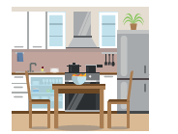
B. This is Janet’s kitchen. Choose the correct option.
1. This kichten / kitchen is very modern / old-fashioned.
2. There is a cook / cooker and an oven / ouven.
3. There is a frigde / fridge and many cubords / cupboards.
4. There are many shelves / shelfes and pans / pins.
5. There is a dining table / coffee table and two chairs / stools.
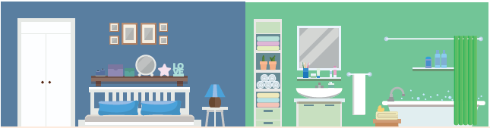
C. Look at the picture and complete the text.
Janet’s favourite room is her (1) b_______________. It has got a large and comfortable
bed. Next to the bed there is a (2) b__________________with a blue (3) l____________
on it. There is a white (4) w__________________where Janet keeps all her nice clothes.
There are many (5) p_____________on the wall. She has got her own (6) b__________,
which is next to the bedroom. It got some (7) s___________for the (8) t_____________,
a (9) w____________, where she washes her face and hands and brushes her teeth,
and a (10) b__________________ for her bubble baths.

ANSWERS

A. Complete the paragraph with the words in the box.
coffee table windows vase sofa living room

This is Janet’s (1) living room. It’s very
comfortable. The walls are grey and it has got
two big sunny (2) windows. on the right.
There is a brown (3) sofa, where Janet.
and her family sit together watching TV in the
evening. There is a (4) coffee table.
in front of the sofa. There is a (5) vase.
with a beautiful plant next to the TV.
B. This is Janet’s kitchen. Choose the correct option.
1. This kichten / kitchen is very modern / old-fashioned.
2. There is a cook / cooker and an oven / ouven.
3. There is a frigde / fridge and many cubords / cupboards.
4. There are many shelves / shelfes and pans / pins.
5. There is a dining table / coffee table and two chairs / stools.
C. Look at the picture and complete the text.
Janet’s favourite room is her (1) bedroom. It has got a large and comfortable
bed. Next to the bed there is a (2) bedside table with a blue (3) lamp on it.
There is a white (4) wardrobe where Janet keeps all her nice clothes.
There are many (5) pictures on the wall. She has got her own (6) bathroom, which is
next to the bedroom. It got some (7) shelves for the (8) towels, a (9) washbasin
where she washes her face and hands and brushes her teeth, and a (10) bath for her bubble baths.

