FAST WORKSHEET 24 GRAMMAR | Past simple (irregular verbs)
Name |  | No. | Class

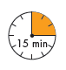
- What did Sam do yesterday? Circle the correct form of the verbs.

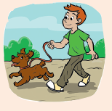
Sam got up when he (1) heared / heard the alarm clock.
He had a shower and (2) got / getted dressed.
He (3) eated / ate cornflakes for breakfast.
He (4) drank / drinked milk, too. After having breakfast,
he (5) goed / went outside to enjoy the sunny day.

B. Complete the sentences with the verbs on the right in the past simple.
do
see
take
go
make
1. Tracy____________ a film at the cinema.
2. Claire and Simon____________ shopping.
3. Martha________________ the ironing.
4. Peter_________________ his bed.
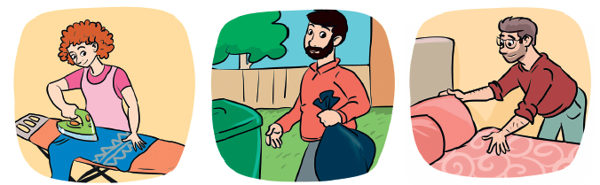
5. Charles____________ out the rubbish.
C. Put the words in order and write sentences in the past simple.
1. Sam / at the back of the classroom / sit /? ________________________________.
2. buy / Martha / a beautiful dress /. _______________________________________.
3. at the café / his friends / Andrew / meet /. _________________________________.
4. William / music lessons / have /. ________________________________________.
5. not go / yesterday / Peter / to school /. ___________________________________.

ANSWERS

- What did Sam do yesterday? Circle the correct form of the verbs.

Sam got up when he (1) heared / heard the alarm clock.
He had a shower and (2) got / getted dressed.
He (3) eated / ate cornflakes for breakfast.
He (4) drank / drinked milk, too. After having breakfast,
he (5) goed / went outside to enjoy the sunny day.

B. Complete the sentences with the verbs on the right in the past simple.
do
see
take
go
make
1. Tracy saw a film at the cinema.
2. Claire and Simon went shopping.
3. Martha did the ironing.
4. Peter made his bed.
5. Charles took out the rubbish.
C. Put the words in order and write sentences in the past simple.
1. Sam / at the back of the classroom / sit /? Did Sam sit at the back of
the classroom?
2. buy / Martha / a beautiful dress /. Martha bought a beautiful dress.
3. at the café / his friends / Andrew / meet /. Andrew met his friends at the café.
4. William / music lessons / have /. William had music lessons.
5. not go / yesterday / Peter / to school /. Yesterday Peter didn’t go to school/
Peter didn’t go to school yesterday.

