FAST WORKSHEET 26 VOCABULARY | Travelling/Summer/activities/Holidays
Name |  | No. | Class
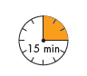
A. What can these teenagers do at the Summer Camp?
Circle the words, complete the activities and find out.


campingpicnicshikinggamessing

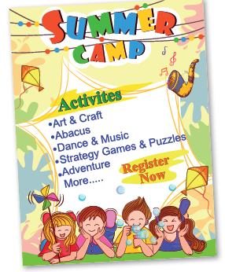

1. have ______________________
2. go__________________________
3. dance and__________________________
4. go__________________________
5. play________________________

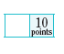
B. What are Rose and Simon going to do on holiday?
Complete their holiday plans.


1. go to the b__ __ c__
2. go to the m__ u__ __ __ i__ s
3. go si__ __ __ s e__ __ __ g
4. take p__ __ t__ s
5. write p__ __ __ c__ __ __ s
6. visit important p__ __ c__ __
7. go s__ __ __ m__ __ g
8. go s__ __ f__ __ g
9. visit a theme p__ __ __
10. c__ c__ e

Answers

A. What can these teenagers do at the Summer Camp?
Circle the words, complete the activities and find out.

campingpicnicshikinggamessing

1. have picnics
2. go camping
3. dance and sing
4. go hiking
5. play games

B. What are Rose and Simon going to do on holiday?
Complete their holiday plans.

1. go to the be a c h
2. go to the m o u n t a i n s
3. go si g h t s e e i n g
4. take p h o t o s
5. write p o s t ca r d s

6. visit important p l a c e s
7. go s w i m mi n g
8. go s u r f i n g
9. visit a theme p a r k
10. c y c l e

