FAST WORKSHEET 28 VOCABULARY | Means of transport
Name |  | No. | Class
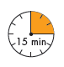

A. Complete the crossword with the missing letters.

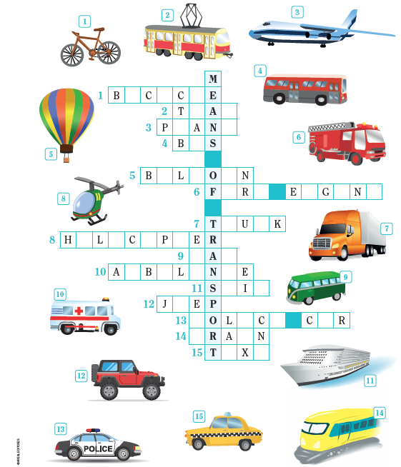

ANSWERS

1. Bicycle
2. Tram
3. Plane
4. Bus
5. Balloon
6. Fire engine
7. Truck

9. Van
10. Ambulance
11. Ship
12. Jeep
13. Police car
14. Train
15. Taxi
8. Helicopter

