FAST WORKSHEET 3 GRAMMAR | To be (present simple)
Name |  | No. | Class
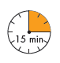

- Circle the correct option.
1. Rob and Helen______twelve years old.
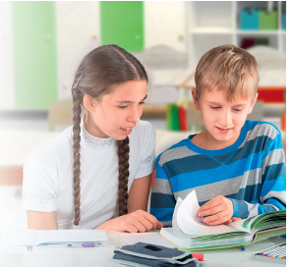
a. am b. are c. isn’t
2. No, Rob isn’t English. He______American.
a. is b. aren’t c. isn’t
3. ______Helen from England?
a. Am b. Are c. Is
4. They______ very good students.
a. am b. are c. isn’t
5. No, I______ English. I’m Portuguese.
a. am not b. aren’t c. isn’t
B. Complete the sentences with the right form of the verb to be.
1. Helen________ (be) a nice teenager. She________ (be) from England.
2. She_________ (not be) shy, she_________ (be) very talkative.
3. Her hair is brown, but her eyes________ (not be) brown, they________ (be) blue.
4. Her parents________ (not be) English. They________ (be) Irish.
5. Where________ (be) you from? – We________ (be) from Portugal.
C. Complete the dialogue with the right form of the verb to be.

Helen: Hi, Rob! What class (1) ________ (be) you in?
Rob: I (2) ________ (be) in class 6A.
Helen: Great! You (3) ________ (not be) in class 6B. We (4) ________ (be) in the same class!
Rob: Your favourite subject (5) ________ (be) English, isn’t it?
Helen: Yes…
Rob: Well, we can do our English homework together…

Answers

- Circle the correct option.
1. Rob and Helen are twelve years old.
a. am b. are c. isn’t
2. No, Rob isn’t English. He is American.
a. is b. aren’t c. isn’t
3. Is Helen from England?
a. Am b. Are c. Is
4. They are very good students.
a. am b. are c. isn’t
5. No, I am not English. I’m Portuguese.
a. am not b. aren’t c. isn’t
B. Complete the sentences with the right form of the verb to be.
1. Helen is (be) a nice teenager. She is (be) from England.
2. She isn’t (not be) shy, she is (be) very talkative.
3. Her hair is brown, but her eyes aren’t (not be) brown, they are (be) blue.
4. Her parents aren’t (not be) English. They are (be) Irish.
5. Where are (be) you from? – We are (be) from Portugal.

C. Complete the dialogue with the right form of the verb to be.

Helen: Hi, Rob! What class (1) are (be) you in?
Rob: I (2) am (be) in class 6A.
Helen: Great! You (3) aren’t (not be) in class 6B. We (4) are (be) in the same class!
Rob: Your favourite subject (5) is (be) English, isn’t it?
Helen: Yes…
Rob: Well, we can do our English homework together.

