FAST WORKSHEET 9 VOCABULARY | Household chores
Name |  | No. | Class
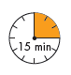

A. What are they doing in their houses? Circle the words/expressions
in the box and write them on the lines below.
feedthedogvacuumwatertheplantssweepthefloortidyuparoom

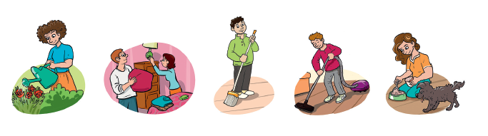
1.___________ 2. ___________ 3. ___________ 4. ___________ 5. ___________
____________ ____________ ____________ ____________ ____________

B. Read and match the phrases.

1. mop
2. make
3. put
4. feed
5. do

a. toys away
b. the dog
c. the kitchen floor
d. the washing up
e. the bed

C. Find one mistake in each sentence and correct it.

1. My sister looks out a young child. __________________________________________.
2. Peter, will you take off the rubbish, please? __________________________________.
3. Tom always makes the dog for a walk. ______________________________________.
4. I often cook the table. ___________________________________________________.
5. Tidy your room and do the toys away. ______________________________________.

ANSWERS

A. What are they doing in their houses? Circle the words/expressions
in the box and write them on the lines below.
feedthedogvacuumwatertheplantssweepthefloortidyuparoom

1. water the plants 2. tidy up a room 3. sweep the floor 4. vacuum 5. feed the dog

B. Read and match the phrases.

1. mop
2. make
3. put
4. feed
5. do

a. toys away
b. the dog
c. the kitchen floor
d. the washing up
e. the bed

C. Find one mistake in each sentence and correct it.

1. My sister looks out a young child. My sister looks after a young child.
2. Peter, will you take off the rubbish, please? Peter, will you take out the rubbish, please?
3. Tom always makes the dog for a walk. Tom always takes the dog for a walk.
4. I often cook the table. I often set the table / cook lunch.
5. Tidy your room and do the toys away. Tidy your room and put the toys away.

