PROGRESS TEST 1

Name_________________________________________________ No. ______ Class_______
Date _____ / _____ / _____ Mark______________________ Teacher______________________

LISTENING
A

1. Listen to the first text and circle the correct option.

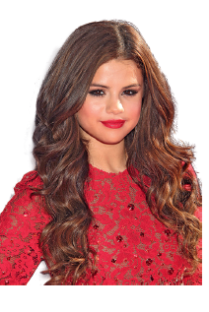
1. Selena’s birthday is on_________________.
a) 20th June b) 21st July c) 22nd July
2. She is_________________.
a) American b) Mexican c) British
3. Her favourite colour is _________________.
a) green b) pink c) grey
4. She is_________________.
a) slim b) fat c) thin
5. Her hobbies are_________________.
a) skateboarding and playing football
b) skateboarding and surfing
c) skateboarding and watching TV

2. Listen to the second text and mark true (T) or false (F).


a) Zayn has got two sisters.
b) He’s a pop singer.
c) His favourite food is chicken.
d) He is tall.
e) Zayn is not shy.

LISTENING
B

1. Listen to the first text and complete the table in note form.

Birthday:
Jobs:
Number of sisters:
Height:
Weight:
Favourite colour:
Favourite food:



2. What sports does Selena like? Tick (✓) the boxes.
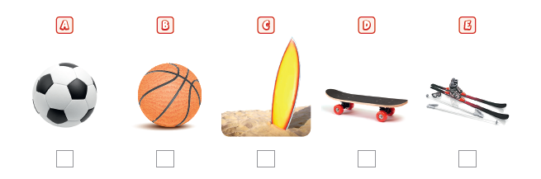

3. Listen to the second text and complete the sentences.

a) Zayn’s birthday is on__________________________.
b) He is from__________________________.
c) He has got __________________________ sisters.
d) His eyes are__________________________.
e) Zayn is a__________________________ person.

A
READING, GRAMMAR AND WRITING B
READING, GRAMMAR AND WRITING B


PART 1
Dear Yoko,
Let me write about my family. I live with my mum, my dad and my brother in Lisbon. My dad’s name is Kazuki and he is Japanese, like you! He speaks Japanese and Portuguese. He’s a little fat! He works in a supermarket. My mum’s name is Carla and she’s a hairdresser. She’s tall and slim, she’s got short, blonde hair and green eyes. My brother is very tall and he loves playing tennis. His name is Pedro. He’s a little bit boring, but I love him. I like playing with him. We have got a dog and his name is Alf. He is brown and very friendly. Write me back and tell me about your family!
Love,
Maria

- Complete the table about Maria and her family.
City:
Father’s nationality:
Mum’s job:
Brother’s personality:
Dog’s colour:


2. Write T (true) or F (false). Correct the false sentences.
a) Maria has got a sister. _______________________________________
b) She lives in Portugal. ________________________________________
c) Maria’s father speaks two languages. ___________________________
d) Her mother is short. _________________________________________
e) They have got a cat. _________________________________________

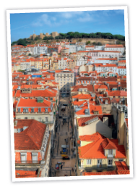
PART 2
1. Circle the correct personal pronoun.
a) Her name is Maria. She / They lives in Lisbon.
b) Kazuki is her dad. He / We is a bit fat.
c) We / I are a cool family.
d) They / He have got a dog called Alf.
e) Can you / I tell me about your family too?

2. Underline the correct possessive determiner.
a) Look, that’s Maria! Her / His dad is Japanese.
b) They live in Scotland. Our / Their country is amazing!
c) We are in the same class. My / Our class is really nice.
d) Mr Jones is my history teacher. His / Her car is over there.
e) Look, that’s my classroom! Your / Its walls are blue.

3. Complete the sentences with the correct form of the verb to be from the box.
are (3 x) is aren’t

a) Her mum________________________ a hairdresser.
b) ________________________ they nice?
c) You ________________________so pretty!
d) Her mum and dad________________________ (not) from the UK.
e) ________________________you British? – No, I’m not.

4. Complete the sentences with the correct form of the verb to have got from the box.
haven’t got has got (2 x) have got

a) My mum and I________________________ green eyes and dark hair.
b) The cat________________________ a fluffy tail.
c) Alison and Jane________________________ (not) a pet.
d) ________________________he a________________________ big family?

5. Underline the present continuous in the text.
Tina is watching TV and her sister Maya is studying. Their mother always cooks
their favourite food on Saturdays: chips and burgers. She is making dessert right
now: strawberry cheesecake! Yummy! On Sundays they go for a walk in the park
with their dog Spock. Now they are playing with their dog. What a lovely weekend!


PART 3
• Write a short text (six sentences) about
Tom, using the information in the table.
Tom
Age: 11
Comes from: France
Physical description: tall, a bit fat,
black eyes, straight, brown hair
Personality: happy and intelligent

_______________________________________________________________________
_______________________________________________________________________
_______________________________________________________________________
_______________________________________________________________________
_______________________________________________________________________
_______________________________________________________________________
_______________________________________________________________________
_______________________________________________________________________
_______________________________________________________________________

READING, GRAMMAR AND WRITING B
B

PART 1
Dear Yoko,
Let me write about my family. I live with my mum, my dad and my brother in Lisbon. My dad’s name is Kazuki and he is Japanese, like you! He speaks Japanese and Portuguese. He’s a little fat! He works in a supermarket. My mum’s name is Carla and she’s a hairdresser. She’s tall and slim, she’s got short, blonde hair and green eyes. My brother is very tall and he loves playing tennis. His name is Pedro. He’s a little bit boring, but I love him. I like playing with him. We have got a dog and his name is Alf. He is brown and very friendly. Write me back and tell me about your family!
Love,
Maria

1. Correct the wrong information in these sentences.
a) There are five people in Maria’s family. _____________________________________
b) Maria’s dad is slim. _____________________________________
c) Her mother works in a supermarket. _____________________________________
d) Pedro is Maria’s cousin. _____________________________________
e) He loves playing football. _____________________________________

2. Complete the sentences according to the text.
a) Maria lives with her mum, ________________________________________ in Lisbon.
b) Her father speaks_____________________________________________________.
c) Her mother is ________________________________________________________.
d) The family pet is______________________________________________________.

PART 2

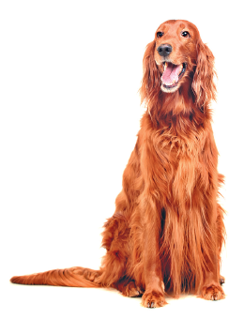
1. Complete the sentences with personal pronouns.
a) What colour is that dog? – _________________is brown.
b) That is George. What nationality is_________________?
c) Hello! _________________am Charlie.
d) My sister and I have blue eyes. _________________ are twins.

2. Fill in the gaps with a possessive determiner.
a) I am a student. _________________name is Danny.
b) Josh is 12. When is _________________birthday?
c) Hello, Barbara! What’s _________________address?
d) They are my grandparents. _________________ house is yellow.

3. Complete the sentences with the correct form of the verb to be.
a) _________________ he from Portugal? – Yes, he_________________.
b) They_________________ brother and sister.
c) Linda_________________ my favourite aunt.
d) My mother and my father _________________40 years old.

4. Fill in the gaps with the correct form of the verb to have got (affirmative, negative
or interrogative).
a) My parents_________________ brown eyes.
b) _________________she_________________ a dog?
c) You _________________ (not) a new pair of shoes.
d) Chloe and I_________________ new friends.

5. Complete the sentences. Use the present continuous of the verbs in brackets.
a) I__________________________________ (listen) to music.
b) _________________you_________________ (read) a new book?
c) They______________________________ (not/run) in the park.
d) We______________________________ (sing) a beautiful song.

PART 3

• Write a short text (25-35 words) about a friend or someone you like.
Here are some tips:
• Name
• Age
• Nationality
• Job/occupation
• Physical description
• Personality
• …

_______________________________________________________________________
_______________________________________________________________________
_______________________________________________________________________
_______________________________________________________________________
_______________________________________________________________________
_______________________________________________________________________
_______________________________________________________________________
_______________________________________________________________________
_______________________________________________________________________
_______________________________________________________________________
_______________________________________________________________________
_______________________________________________________________________
_______________________________________________________________________
_______________________________________________________________________

C
READING, GRAMMAR AND WRITING B

PART 1
Hello, everyone!
My name is Marie and I am from a small village in France. I am 12 years old.
I have got long, brown hair and brown eyes. I am not very tall and I am slim.
I love reading books and dancing! My father says I am intelligent and beautiful.
I also like animals. My father and I have got a dog called Max.
I live with my father and his name is
Pierre. He is 40 years old. I love my dad! He
is short and thin. He has got dark eyes,
brown hair and a beard. His favourite
colour is green. He is very calm and polite.
I have got some good friends, especially
Sonia, Sophie and Julianne. We have a
good time together!
Write me back and tell me about you!
Love,
Marie




1. Complete the table in note form.
 | Marie | Pierre
Age:
Hair:
Eyes:
Height:
Weight:
Personality:

2. Answer the questions.
a) How old is Marie? _______________________________________________
b) What does she look like? _________________________________________
c) What’s her father’s name? ________________________________________
d) Where are they from? ____________________________________________
e) Has Pierre got grey hair? _________________________________________


3. Match the words on the left with their opposites.

1. tall a) hate
2. love b) bad
3. calm c) short
4. polite d) nervous
5. good e) rude

PART 2

1. Replace the words in bold by a personal pronoun.
a) Marie and Sonia are friends. _______________________________
b) Marie is intelligent. _______________________________
c) The horse is brown. _______________________________
d) My father and I like animals. _______________________________
e) Are you and Marie friends? _______________________________

2. Fill in the gaps with a possessive determiner.
a) Is this__________________ dad? He’s so funny! (you)
b) What’s __________________name? (he)
c) This is__________________ home. (we)
d) Look! It’s __________________family! (I)
e) Is this __________________dog? (they)

3. Fill in the gaps with the correct form of the verb to be or to have got.
a) We__________________ not__________________ two bikes.
b) They__________________ (not) French. They are Canadian!
c) __________________she the new doctor?
d) __________________James and Sandra__________________ a new house?
e) Carrie __________________long, brown hair.
f) She __________________not __________________your new mobile number.
g) __________________ you 12 years old? – No, I __________________11.

4. Write sentences using the present continuous.
a) Marie / not / sleep
_______________________________________________________________
b) They / a horse / ride
_______________________________________________________________
c) Marie and her friends / tea / drink
_______________________________________________________________
d) I / a letter / not / write
_______________________________________________________________

PART 3
• In 25-35 words, write an email to Marie about yourself. Don’t forget to mention:
• Your name, age, nationality, occupation, physical description, personality…

_________________________________________________________________
_________________________________________________________________
_________________________________________________________________
_________________________________________________________________
_________________________________________________________________
_________________________________________________________________

SCRIPTS

LISTENING - A and B
LISTENING – A and B
Selena Gomez
Her name is Selena Gomez and her birthday is on 22nd July. She lives in Los Angeles,
but she was born in Dallas, Texas State. She is a singer and an actress.
Selena loves her family and she has got two younger sisters, Gracie and Tori.
She is short and thin. Her favourite colour is green and her favourite food is pizza.
She loves basketball and her hobbies are skateboarding and surfing.

Zayn Malik
Zayn Malik’s birthday is on 12th January and he is British. He was born in England
and now he lives in the United States of America. He has got three sisters.
Zayn is a pop singer. We all know him from One Direction!
He likes fast food and loves chicken. He has got brown hair; brown eyes and he is short.
Zayn is very nice and shy.

ANSWERS
LISTENING - A
LISTENING - B

1.
Birthday: 22nd July
Jobs: singer and actress
Number of sisters: two (2)
Height: short
Weight: thin
Favourite colour: green
Favourite food: pizza
2.
b) ✓; c) ✓; d) ✓
3.
a) 12th January
b) England
c) three (3)
d) brown
e) nice and shy

1.
1. c
2. a
3. a
4. c
5. b

2.
a) F
b) T
c) T
d) F
e) F

READING, GRAMMAR AND WRITING - A
2.
a) F. She’s got a brother.
b) T
c) T
d) F. She’s tall.
e) F. They’ve got a dog.

PART 1
1.
City: Lisbon
Father’s nationality: Japanese
Mum’s job: hairdresser
Brother’s personality: boring
Dog’s colour: brown

PART 2

1.
a) She
b) He
c) We
d) They
e) you
2.
a) Her
b) Their
c) Our
d) His
e) Its
3.
a) is
b) Are
c) are
d) aren’t
e) Are
4.
a) have got
b) has got
c) haven’t got
d) Has … got

5.
is watching; is studying; is making; are playing
PART 3
He is Tom.
He’s eleven years old.
He comes from France.
He’s tall and a bit fat.
He has got black eyes and straight, brown hair.
He’s happy and intelligent.
READING, GRAMMAR AND WRITING - B
PART 1

1.
a) There are four people in Maria’s family.
b) Maria’s dad is a little fat.
c) Her mother is a hairdresser.
d) Pedro is Maria’s brother.
e) He loves playing tennis.
2.
a) her dad and her brother
b) Japanese and Portuguese
c) a hairdresser / tall and slim
d) a dog

PART 2
4.
a) have got
b) Has … got
c) haven’t got / have not got
d) have got

5.
a) am listening
b) Are… reading
c) are not / aren’t running
d) are singing
1.
a) It
b) he
c) I
d) We
2.
a) My
b) his
c) your
d) Their
3.
a) Is / is
b) are
c) is
d) are

PART 3
Personal answer.
READING, GRAMMAR AND WRITING - C

PART 1

1.
 | Marie | Pierre
Age: | twelve (12) | forty (40)
Hair: | long, brown | brown
Eyes: | brown | dark
Height: | not very tall | short
Weight: | slim | thin
Personality: | intelligent | calm and polite

2.
a) Marie is twelve years old.
b) She is not very tall and she is slim. She has got long,
brown hair and brown eyes.
c) Her father’s name is Pierre.
d) They’re from a small village in France.
e) No, he hasn’t. He’s got brown hair.
3.
1. c
2. a
3. d
4. e
5. b

PART 2

1.  a) They  b) She  c) It  d) We  e) you  2.  a) your  b) his  c) our  d) my  e) their | 3.  a) have … got  b) aren’t / are not  c) Is  d) Have … got  e) has got  f) has … got  g) Are…am  4.  a) Marie is not sleeping.  b) They are riding a horse.  c) Marie and her friends are drinking tea.  d) I am not writing a letter.

PART 3
Personal answer.
SPEAKING

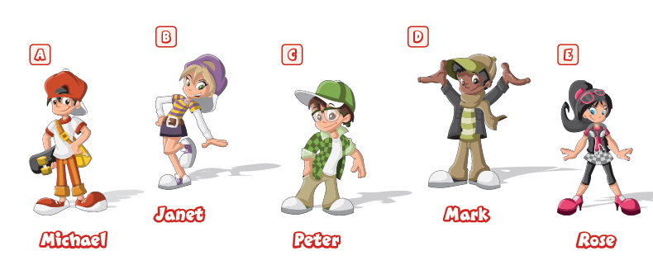
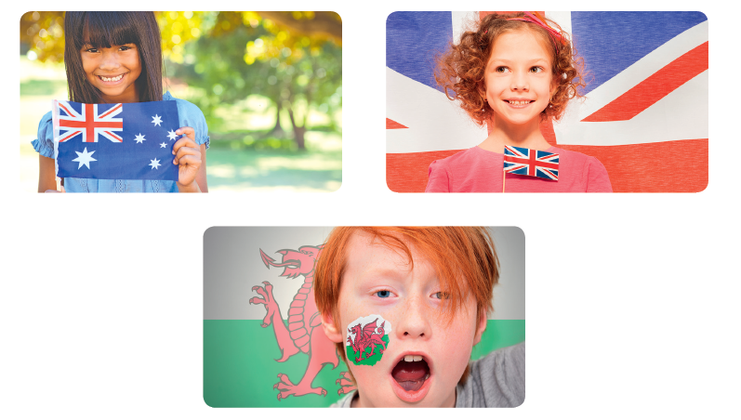

PART 1

PART 2

PROCEDURES
Part 1
The teacher greets the learner and checks his/her name.
A. The teacher shows the learner a picture and
asks the learner to point to the items:
a boy / a girl / a skateboard / a cap / sunglasses.
B. The teacher asks questions about the picture:
How many children can you see?
What is Michael wearing?
What is Janet wearing?
What colour is Peter’s hair?
What colour are Rose’s eyes?
Part 2
The teacher shows the learner some smaller pictures and asks:
What’s her/his/their nationality?
Part 3
The teacher asks the learner some personal questions related to the topic:
What’s your nationality?
Are you tall or short?
What colour are your eyes?
Have you got straight hair?
What are you wearing today
ANSWER KEY

Part 1 – B
I can see five children.
Michael is wearing a white and red T-shirt, orange jeans (trousers), a red cap and red trainers. Janet is wearing a striped T-shirt, a purple skirt, a violet hat and white trainers.
Peter’s hair is brown.
Rose’s eyes are blue.
Part 2
She is Australian.
She is British.
He is Welsh.
He is American.
They are English.
Part 3
Personal answers
.

