PROGRESS TEST 2

Name_________________________________________________ No. ______ Class_______
Date _____ / _____ / _____ Mark______________________ Teacher______________________

LISTENING
A


1. Listen to Ben, Tess and Jodie and complete the texts.
I am Ben.
I usually wake up at a) ________________o’clock.
I have a shower, comb my hair and
b) _____________________________ .
I don’t eat much for c) ________________. I only eat yoghurt with fruit and then I go to d) __________


Hey! Tess here!
I don’t go to school by e) ________________. I ride
my f) ________________.
My g) ____________begin at twenty h) _________
eight. I have lunch in the school i) ____________.

____________________.



My name is Jodie.
I go back j) _________________at half past four.
I have a k) _________________and then I do my
l) _______________. Sometimes I watch TV and some other times I m) ______________with my
n) __________________ outside.

2. Listen to what Ben does at weekends and order the sentences from 1 to 6.
a) Ben helps his dad with dinner. _____
b) They play games. _____
c) Ben and his dad go to the cinema. _____
d) He has lunch at the restaurant. _____
e) He goes swimming. _____
f) They go home. _____

LISTENING
B

1. Who says what? Write Ben, Tess or Jodie next to each sentence.


Who…
a) doesn’t go to school by car? __________________
b) wakes up at seven? __________________
c) does homework after having a snack? __________________
d) has lunch in the school canteen? __________________
e) eats a small breakfast? __________________
f) doesn’t watch TV every day? __________________

2. Listen to Ben talking about his weekends and mark true (T) or false (F).

a) Ben goes swimming with his mum. _____
b) They have lunch at home. _____
c) They usually watch a film in the afternoon. _____
d) Ben’s dad likes popcorn. _____
e) Ben and his dad have dinner at the restaurant. _____
f) They cook together. _____
g) Ben never helps his dad. _____
h) They have dinner and go to bed immediately. _____
LISTENING B
Ben Tess Jodie

A
READING, GRAMMAR AND WRITING B

READING, GRAMMAR AND WRITING B
PART 1


Hi guys!
Today I will tell you all about a typical school day!
I wake up at 7 o’clock every day. I walk my dog Dumbo and then
I have a shower at 7:30. After that, I have breakfast and I get
dressed. Around 8:15 I go to school on foot because I live nearby.
When I get to school, I have a chat with my friends and when the
bell rings, there we go! It’s time to learn new things!
I usually go home for lunch. At 14:00 I go back to school except
on Tuesdays and Thursdays because I have no lessons in the
afternoon. On those days I go to football training. My best friend
Tim plays in the same team, but he hardly ever shows up. He’s a
little bit lazy!
I usually have dinner at 8 o’clock, watch TV and at 9:30 it is time
to go to bed.
What about you? Make a post below and tell me about your day.

- Correct the wrong information according to the text.

a) Tom walks his dog after having a shower.
__________________________________________________________________
b) He goes to school by bus.
__________________________________________________________________
c) He has lunch in the canteen.
__________________________________________________________________
d) He doesn’t have a free afternoon.
__________________________________________________________________

2. Complete the sentences with information from the text.
a) Tom’s dog is called _______________________________________.
b) He has lunch at_________________________________________.
c) On Tuesdays and Thursdays afternoon he has got no ______________________.
d) Tom plays_____________________________________________.
e) Tom goes to bed________________________________________.

3. Match the pictures with the household chores on the right.
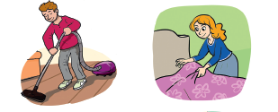

a) make the bed
b) vacuum
c) take out the rubbish
d) wash the clothes

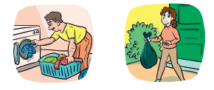
- 2.

3. 4. 1.____ 2. ____ 3. ____ 4. ____
PART 2
1. Complete the sentences with the correct adverb of frequency.
a) Tom____________________watches TV. ✔
never
sometimes
rarely
twice
b) He plays football __________________a week. ✔✔
c) He___________________ goes to bed late at night. ✘✘
d) Tom and Tim___________________ play together. ✘

2. Fill in the gaps using the present simple of the verbs in brackets.
On weekdays I always 1) __________________ (wake up) very early because of school,
but at the weekends I 2) __________________ (sleep) until late. In the afternoon my
sister and I 3) __________________ (ride) our bikes in the park.
Our mum 4) __________________ (not / like) when we come home late, but we
always 5) __________________ (tell) her: “Relax! It’s the weekend!”

3. Read the sentences and tick (✓) the correct verb tense: present simple or present
continuous.

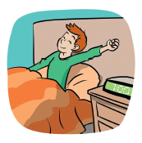
a) He___________________ to his parents at the moment.
is talking talks
b) I always___________________ up at 7 o’clock.
am getting get
c) They___________________ Minecraft now.
are playing play
d) You and Stella___________________ cartoons every day.
are watching watch

4. Fill in the gaps with while or when.
a) __________________do they go to the cinema?
b) She’s setting the table__________________ her dad is cooking.
c) I often bite my nails__________________ I’m nervous.
d) He does his homework__________________ she does the ironing.

PART 3

Write a short text about Peter’s daily routine. Use the information below and write
the time in full.

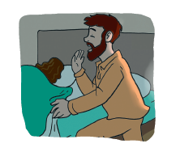
• Get up – 7:00
• Go to work – 8:00
• Have lunch with his colleagues – 12:30
• Go to the gym – 18:00
• Have dinner – 19:30
• Go to bed – 23:00

READING, GRAMMAR AND WRITING B
B

Part 1
Hi guys!
Today I will tell you all about a typical school day!
I wake up at 7 o’clock every day. I walk my dog Dumbo and then
I have a shower at 7:30. After that, I have breakfast and I get
dressed. Around 8:15 I go to school on foot because I live nearby.
When I get to school, I have a chat with my friends and when the
bell rings, there we go! It’s time to learn new things!
I usually go home for lunch. At 14:00 I go back to school except
on Tuesdays and Thursdays because I have no lessons in the
afternoon. On those days I go to football training. My best friend
Tim plays in the same team, but he hardly ever shows up. He’s a
little bit lazy!
I usually have dinner at 8 o’clock, watch TV and at 9:30 it is time
to go to bed.
What about you? Make a post below and tell me about your day.

1. Write T (true) or F (false). Correct the false sentences.
a) Tom has a shower after he walks Dumbo.
_______________________________________________________________________.
b) He walks to school.
_______________________________________________________________________.
c) He has three free afternoons.
_______________________________________________________________________.
d) Tom likes football.
_______________________________________________________________________.
e) Tom has dinner at 7.30.
_______________________________________________________________________.

2. Answer the questions about the text.
a) What time does Tom wake up?
______________________________________________________________________.
b) How does he go to school?
______________________________________________________________________.
c) Where does he usually have lunch?
______________________________________________________________________.
d) When does Tom go to football training?
______________________________________________________________________.
e) What does he do after dinner?
_______________________________________________________________________.
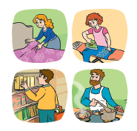
3. Look at the pictures and fill in the gaps.
a) Mrs Ford is_________________ the bed.
b) Donna is_________________ the clothes.
c) Ted is_________________ the shopping.
d) Will is_________________ dinner.

PART 2
1. Insert the adverbs of frequency in the correct position.
a) He listens to the radio. (often) _____________________________________________.
b) My English teacher gets angry. (sometimes) _________________________________.
c) She is so nice! (usually) __________________________________________________.
d) I sleep until late. (hardly ever) _____________________________________________.

2. Form sentences using the present simple.
a) a shower / Tom / always / in the morning / have
______________________________________________________________________.
b) We / school / sometimes / late / arrive / at
______________________________________________________________________.
c) not play / football / Mondays / on / I
______________________________________________________________________.
d) hardly ever / eat / dinner / for / fish / They
______________________________________________________________________.

3. Fill in the gaps with the present simple or present continuous of the verbs in
brackets.
a) Every Sunday we ______________________________ (visit) our grandparents.
b) I often ______________________________ (go) to the cinema.
c) She______________________________ (not / do) anything right now.
d) Look! ________________they__________________ (play) cards or Monopoly?

4. Match to make sentences.
1. When do you a) she’s really tired.
2. I have a shower while my mum b) usually clean the house?
3. She falls asleep when c) is preparing breakfast.
4. While I’m studying d) you can take out the rubbish.

PART 3
Imagine you are writing a post on Tom’s blog and tell him about your daily routine.
______________________________________________________________________

______________________________________________________________________

______________________________________________________________________

______________________________________________________________________

______________________________________________________________________

______________________________________________________________________

______________________________________________________________________

______________________________________________________________________

______________________________________________________________________

READING, GRAMMAR AND WRITING B
C

PART 1

Hello all!
I’m twenty years old and I’m a youtuber. My name
is BlueDavE. On my YouTube channel, you can see
my daily routine and everything that happens in
my life every day.

Now, let me tell you about my days.
I wake up around eight o’clock and get ready to start the day. I have a big
breakfast around quarter past eight. When I wake up, I am hungry! Then, I
think about fun things to do during the day. I am always thinking about my fans.
I sometimes go to the park to play tricks on other people. A friend of mine
films everything and later I post it online. It’s a lot of fun.
After that, I go home for lunch and in the afternoon, I answer my fans.
Sometimes I talk to them. It’s so cool!
At half past seven I have dinner with friends or family. I live alone, but my parents often come to have dinner with me.
I go to bed early and before that I read a little. I like Agatha Christie’s novels and books about technology.

1. Complete the table about BlueDavE in note form.
a) Age
b) Job/occupation
c) Time he wakes up
d) Places he goes to
e) People he meets
f) Books he reads

2. Answer the questions.
a) What does BlueDavE do at quarter past eight? ___________________________
b) Is he a student? ___________________________________________________
c) Where does he sometimes go in the morning? ___________________________
d) What does he do in the afternoon? ____________________________________
e) What books does he read? __________________________________________

3. Match the pictures with the household chores.



a) take out the rubbish
b) vacuum
c) make the bed
d) do the washing up

- 2.


3. 4. 1.____2. ____ 3. ____ 4. ____

PART 2
1. Form correct sentences.
a) often / I / Internet / surf / the /.
_______________________________________________________________________
b) go / bed / they / late / rarely / to /.
_______________________________________________________________________
c) she / hardly ever / her / rides / bike /.
_______________________________________________________________________
d) basketball / play / we / a / once / week /.
_______________________________________________________________________
e) Karen / swims / sea / in / the / often /.
_______________________________________________________________________

2. Fill in the gaps with the present simple of the verbs in brackets.
a) I never _____________________(watch) horror films!
b) He _____________________ (not / live) in Lisbon.
c) you_____________________ (work) eight hours a day?
d) My mum_____________________ (cook) dinner really fast.
e) Alex and Stephanie_____________________ (study) for two hours every day.
f) Your teacher_____________________ (know) a lot about history.

3. Complete the sentences with the present simple or present continuous of the verbs
in brackets.
a) Mr Johnson_____________________ (play) golf every week.
b) Annie_____________________ (do) her homework at the moment.
c) It smells good! What you _____________________ (eat)?
d) My parents never_____________________ (drive) me to school.

4. Fill in the gaps with when or while.
a) I can do this________________ you’re doing that.
b) _______________is your birthday?
c) Can I dance_______________ you are singing?
d) I always get nervous_______________ I have an
oral exam.

PART 3

Imagine you are a blogger or a youtuber and write a text about your daily routine
(25-35 words).
____________________________________________________________________

_______________________________________________________________________

_______________________________________________________________________

_______________________________________________________________________

_______________________________________________________________________

_______________________________________________________________________
_______________________________________________________________________

SCRIPTS
LISTENING - A

I am Ben.
I usually wake up at seven o’clock. I have a shower, comb my hair and get dressed.
I don’t eat much for breakfast. I only eat yoghurt with fruit and then I go to school.

Hey! Tess here!
I don’t go to school by car. I ride my bike. My lessons begin at twenty past eight.
I have lunch in the school canteen.

My name is Jodie.
I go back home at half past four. I have a snack and then I do my homework. Sometimes I watch TV and some other times I play with my friends outside.
LISTENING - B

It’s me again!
Let me tell you about my weekends.
At the weekends, I go to the swimming pool with my dad. Then, we have lunch in a nice restaurant.

In the afternoon, we usually go to the cinema and we eat popcorn.

At the end of the day, we go back home and I help my dad preparing dinner. We have a lot of fun in the kitchen! He is trying to teach me how to cook some simple meals.

After dinner, I wash the dishes and my dad takes out the garbage. We always split house chores. I like helping at home.

Before bed, we play cards or board games. It’s really fun!

ANSWERS
LISTENING - A
LISTENING - B

1.
a) Tess
b) Ben
c) Jodie
d) Tess
e) Ben
f) Jodie

2.
a) F
b) F
c) T
d) T
e) F
f) T
g) F
h) F
1.
a) seven
b) get dressed
c) breakfast
d) school
e) car
f) bike
g) lessons
h) past
i) canteen
j) home
k) snack
l) homework
m) play
n) friends

2.
a) 5
b) 6
c) 3
d) 2
e) 1
f) 4

READING, GRAMMAR AND WRITING - A

PART 1
1.
a) Tom walks his dog before he has a shower.
b) He goes to school on foot.
c) He has lunch at home.
d) He has two free afternoons.
2.
a) Dumbo
b) home
c) lessons / school
d) football
e) at 9:30.
3.
1. b; 2. a; 3. d; 4. c

PART 2

1.
a) sometimes
b) twice
c) never
d) rarely
2.
1. wake up
2. sleep
3. ride
4. doesn’t like
5. tell
3.
a) is talking
b) get
c) are playing
d) watch
4.
a) When
b) while
c) when
d) while

PART 3
Possible answer.
Peter gets up at seven o’clock. He goes to work at eight o’clock and he has lunch with his colleagues at half past twelve. He goes to the gym at six o’clock and he has dinner at half
past seven. Peter goes to bed at eleven o’clock.

READING, GRAMMAR AND WRITING - B
PART 1

1.
a) T.; b) T.
c) F. He has two free afternoons.
d) T.
e) F. He usually has dinner at 8 o’clock.
2.
a) Tom wakes up at seven o’clock.
b) He goes to school on foot.
c) He usually has lunch at home.
d) Tom goes to football training on Tuesdays and Thursdays.
e) He watches TV after dinner.
3.
a) making; b) ironing; c) doing; d) making/cooking

PART 2
1.
a) He often listens to the radio.
b) My English teacher sometimes gets angry.
c) She is usually so nice!
d) I hardly ever sleep until late.
2.
a) Tom always has a shower in the morning.
b) We sometimes arrive late at school.
c) I don’t play football on Mondays.
d) They hardly ever eat fish for dinner.
3.
a) visit; b) go; c) isn’t doing; d) Are … playing
4.
1. b); 2. c); 3. a); 4. d)

PART 3
Personal answer

READING, GRAMMAR AND WRITING - C

PART 1

1.
a) twenty
b) youtuber
c) eight o’clock
d) park, home
e) other people, a friend (of his), fans, friends, family, parents
f) Agatha Christie’s novels, technology books
2.
a) At quarter past eight he has a big breakfast.
b) No, he isn’t. He is a youtuber.
c) He sometimes goes to the park.
d) In the afternoon he answers his fans.
e) He reads Agatha Christie’s novels, and books about technology.
3.
1. c); 2. d); 3. b); 4. a

PART 2

1. 2.
a) I often surf the Internet.
b) They rarely go to bed late.
c) She hardly ever rides her bike.
d) We play basketball once a week.
e) Karen often swims in the sea.

a) watch
b) doesn’t live
c) Do … work
d) cooks
e) study
f) knows

3.
a) plays
b) is doing
c) are … eating
d) drive
4.
a) while
b) When
c) while
d) when

PART 3
Personal answer.

SPEAKING
PART 1
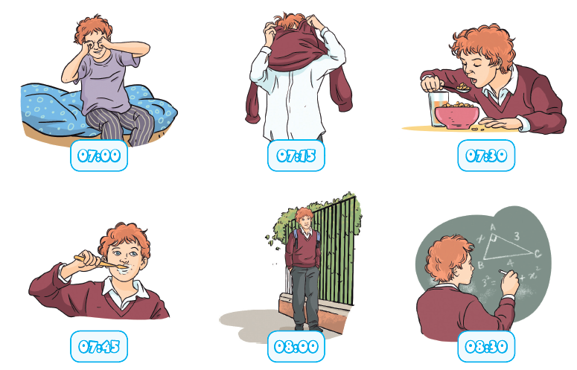
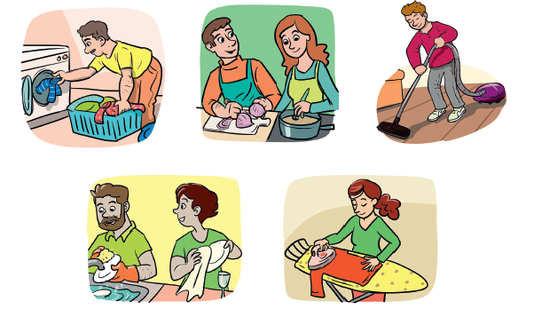

PART 2

PROCEDURES
Part 1
The teacher greets the learner and checks his/her name.
A. The teacher shows the learner a picture and asks the learner to point to the items:
The boy has breakfast.
He gets up.
He leaves for school.
He brushes his teeth.
He is in school.
B. The teacher asks questions about the picture:
Is it a weekday or a weekend? Why?
What time does he get up?
What time does he get dressed?
What time does he have breakfast?
What time does he go to school?
Part 2
The teacher shows the learner some smaller pictures and asks:
What are they / is she / is he doing?
Part 3
The teacher asks the learner some personal questions related to the topic:
Do you prefer weekdays or weekends?
What time do you get up on weekdays?
Do you help your parents with the chores?
What do you do?
What’s your favourite weekend activity?
ANSWER KEY

Part 1 – B Part 2

It’s a weekday. He goes to school.
The boy gets up at 7 o’clock.
He gets dressed at a quarter past seven.
He has breakfast at 7.30.
He goes to school at 8 o’clock.
He’s doing the washing.
They are cooking.
He is vacuuming the floor / using the vacuum cleaner.
They are washing the dishes. (They are doing the washing up.)
She’s ironing.

Part 3
Personal answers.

