PROGRESS TEST 3

Name_________________________________________________ No. ______ Class_______
Date _____ / _____ / _____ Mark______________________ Teacher______________________

LISTENING
A
1. Listen to a dialogue between Ally and a new student, Ed, and fill in the gaps.
Lessons class classroom library around canteen

Ally: Hello! Are you the new student in our a) __________________?
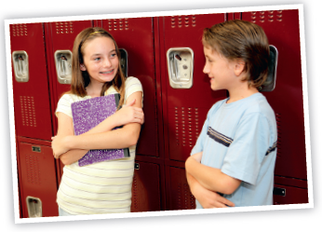
Ed: Yes, I am. My name’s Ed. And yours?
Ally: I’m Ally. Nice to meet you.
Ed: Nice to meet you too, Ally!
Ally: I will show you b) ________________. Our
school is really cool! You will like it!
Let’s start with our c) __________________.
This is where we have all our
d) ___________________ except for PE.
This is our e) _______________. The food is OK and on Fridays we can have
ice cream! When we go outside, we see the gym on the left and over there is
the f) ___________________.
Ed: You were right, this school seems really cool!
Ally: I’m glad you liked it!
2. Listen to Ally talking about Tuesdays and fill in what’s missing.
 | Monday | Tuesday | Wednesday | Thursday | Friday
8:00 – 9:30 |  |  | Maths
9:45 – 11:15 | Maths |  | Portuguese | Science | Portuguese
11:30 – 13:00 | English |  | English | Geography | History
 | Lunch break | Lunch break | Lunch break | Lunch break | Lunch break
14:00 – 15:30 | Art |  |  | Art
15:45 – 17:15 |  |  |  | PE

LISTENING
B

1. Listen to Ally talking to Ed and mark the sentences true (T) or false (F).
- Ed is an old student.
- Ally and Ed have all their
lessons in one classroom.
- They never have dessert
in the school canteen.
d) The library is outside.
e) Ed likes the school.
2. Listen to Ally talking about Tuesdays and order the sentences from 1 to 4.
a) History starts at 11:30 and ends at 13:00.
b) They have science.
c) They have PE.
d) They have a geography lesson.
3. Listen again and write the missing school subjects.

 | Monday | Tuesday | Wednesday | Thursday | Friday
8:00 – 9:30 |  |  | Maths
9:45 – 11:15 | Maths |  | Portuguese | Science | Portuguese
11:30 – 13:00 | English |  | English | Geography | History
 | Lunch break | Lunch break | Lunch break | Lunch break | Lunch break
14:00 – 15:30 | Art |  |  | Art
15:45 – 17:15 |  |  |  | PE

A
READING, GRAMMAR AND WRITING B
READING, GRAMMAR AND WRITING B
PART 1

I’m Jo. I am thirteen years old and my favourite school
subject is geography. My geography teacher is also
my favourite teacher. He always brings interesting
activities for us to do and he’s really funny! My friend
Beth prefers history because she likes learning about
other cultures and civilizations. In the future, I want
to be a geography teacher. I don’t like physical
education very much. I’m a bit lazy. I prefer sitting in
class to doing physical exercise.
Jo



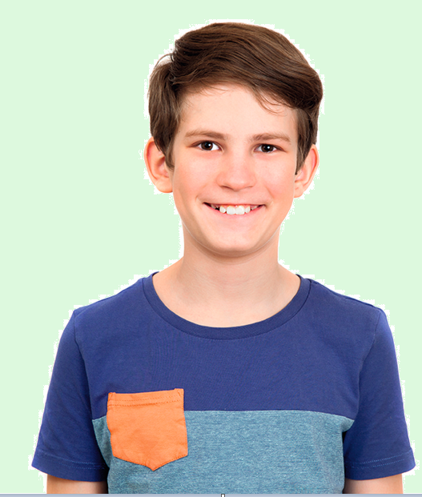

I am Ryan. I’m twelve and I am in year 6.
I love my school because all my friends are there.
My favourite school subjects are English and art and I
don’t like science. In English class, we always do role
plays and sometimes we act. Last Christmas, I was
the main actor in a school play. It was a modern
version of Romeo and Juliet and I played Romeo.
It was really fun! I want to be an actor.
Ryan

1. Complete the table.

 | Age | Favourite school  subject(s) | Future job | Dislikes
Jo
Ryan

2. Cross out (✗) the wrong option.
a) Jo likes / doesn’t like geography.
b) She is / isn’t an active person.
c) Ryan was / wasn’t Romeo in a school play.
d) He wants to be an actor / a teacher.

3. Complete the sentences with the words below.
canteen gymnasium library sports field school hall

a) We can read books at the___________________________________________.
b) Jo always has lunch in the school ____________________________________.
c) Romeo and Juliet starts at 6 o’clock in the______________________________.
d) Ryan and his friends play basketball in the _____________________________.
e) The students have PE lessons in the__________________________________.

PART 2
1. Tick (✓) the correct answer.
a) Beth is interested__________________ other civilizations.
at in
b) Ryan is good__________________ English.
of at
c) I am bad __________________doing sport.
at to
d) My school is famous__________________ its basketball team.
in for

2. Complete the sentences with the correct adverb of manner.
a) Please, don’t behave __________________ (bad) today!
b) Can you speak__________________ (slow), please?
c) I am writing this text__________________ (careful). I don’t want any mistakes.
d) The children are talking__________________ (loud) outside.

3. Replace the words in bold by a possessive pronoun.
a) These pencils are their pencils. ________________________________________
b) I think this is my schoolbag. Or is it your schoolbag? _______________________
c) Barbara’s school is big. Our school is small. ______________________________

4. Complete the sentences with was / were / wasn’t / weren’t.
a) Where________________ Barney last night?
b) My birthday________________ (not) last month.
c) The children_______________ (not) at school this morning. It’s Sunday, remember?
d) ________________your teachers at school yesterday?
e) ________________she a good student when she________________ a child?

PART 3
Write a text about Melissa and her school. Use the information below.
Name of school: | Educational school
  Favourite subjects: | Maths; Portuguese
  Dislikes: | History
  Likes: | Computer room; library
No lessons on: | Monday and Friday afternoon
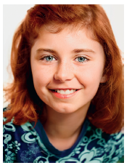

Hi! My name___________________________________________________________
_____________________________________________________________________
_____________________________________________________________________
_____________________________________________________________________
_____________________________________________________________________
_____________________________________________________________________
_____________________________________________________________________
_____________________________________________________________________
_____________________________________________________________________
_____________________________________________________________________
READING, GRAMMAR AND WRITING B
B

PART 1
Jo

I’m Jo. I am thirteen years old and my favourite school
subject is geography. My geography teacher is also
my favourite teacher. He always brings interesting
activities for us to do and he’s really funny! My friend
Beth prefers history because she likes learning about
other cultures and civilizations. In the future, I want
to be a geography teacher. I don’t like physical
education very much. I’m a bit lazy. I prefer sitting in
class to doing physical exercise.

I am Ryan. I’m twelve and I am in year 6.
I love my school because all my friends are there.
My favourite school subjects are English and art and I
don’t like science. In English class, we always do role
plays and sometimes we act. Last Christmas, I was
the main actor in a school play. It was a modern
version of Romeo and Juliet and I played Romeo.
It was really fun! I want to be an actor.
Ryan

1. Write T (true) or F (false). Correct the false sentences.
a) Tom has a shower after he walks Dumbo.

1. Complete the sentences.
a) Jo’s favourite subject is________________________________________.
b) She doesn’t like______________________________________ very much.
c) ____________________________________.is the subject Ryan doesn’t like.
d) Last Christmas, he was______________________________in a school play.
e) He wants to be_________________________________________________

2. Answer these questions about the text.
a) How old is Jo?
_________________________________________________________________
b) Who is Jo’s favourite teacher?
_________________________________________________________________
c) What does she want to be in the future?
_________________________________________________________________
d) Where do Ryan’s friends study?
_________________________________________________________________
e) What activities does he do in English?
_________________________________________________________________
3. Complete the sentences replacing the pictures by words.
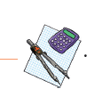

a) Jo likes________ a lot, but she doesn’t like ________.
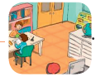
b) Quiet! We are in the ______________________
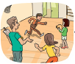
c) We have PE in the________________
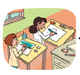
d) We draw and paint in the____________________

PART 2
1. Match the sentence halves.

1. I am terrible a) at English. She still speaks it well.
2. I am afraid b) for its football team.
3. My mum was good c) in acting.
4. They are interested d) of lab explosions.
5. My school is famous e) at science. I hate the lab!

2. Complete the sentences with an adverb of manner.
correctly badly quickly quietly

a) Jo is learning Russian very____________________.
b) Ryan is studying____________________ in his room.
c) Shhhh! Don’t behave____________________.
d) Please, try to answer the question ____________________.

3. Complete the sentences with the correct possessive pronoun.
a) John, is this__________________? – Yes, it is, thanks!
b) This is Jenny’s bag. It’s__________________.
c) These keys belong to my parents. They are__________________.

4. Fill in the gaps with the past simple of the verb to be.
a) How__________________ the maths lesson?
b) I __________________the best student in class last year.
c) We__________________ (not) happy with your marks last term.
d) __________________you in the gym yesterday?
e) Who__________________ your history teacher last year?

PART 3

Tell a friend about your ideal school in about 40 words. Write about: school
subjects, school places, rooms, teachers…
___________________________________________________________________
___________________________________________________________________
___________________________________________________________________
___________________________________________________________________
___________________________________________________________________
___________________________________________________________________
___________________________________________________________________
___________________________________________________________________
___________________________________________________________________

READING, GRAMMAR AND WRITING B
C

PART 1
My name is Gabrielle, but I prefer Gaby. I am 12 years old and I
go to a private school in London called St Jude’s School. I am in
year 6. Everyone has to wear a uniform there. Girls have to wear
a skirt, socks and a sweater. Boys also wear socks with shorts
and a sweater.
My school is not very big, but it’s really nice. Every class has a
classroom. We are responsible for cleaning it and keeping it tidy.
The library is my favourite place. There, I can read the books I
want! I love reading. My friends prefer the computer room or the
cinema club.
My favourite subjects are English and maths. I have maths four
times a week, but that’s OK for me. Our teacher is nice and we
do cool activities. The subject I don’t like is art. I’m terrible at it.
I have lunch in the school canteen four times a week. On Fridays
I have lunch at home because I have a free afternoon. In my
school we don’t usually have homework. We do all our work
after our lessons are finished with our study teachers.


1. Complete the table about Gaby’s school.
a) School’s name:
b) Location:
c) School year:
d) Most popular clubs/rooms:
e) Gaby’s favourite activity:
f) Gaby’s favourite subjects:

2. Answer the questions about the text.
a) How old is Gaby?
_______________________________________________________________
b) What do girls wear at St Jude’s school?
_______________________________________________________________
c) What’s her school like?
______________________________________________________________
d) What is the maths teacher like?
_______________________________________________________________
e) Where does she have lunch on Fridays?
_______________________________________________________________

3. Fill in the gaps with the school subjects.
a) In ______________________we learn interesting facts about the Earth.
b) In ______________________we learn about the past.

c) I like ______________________because I like numbers.
d) We do sports and physical exercise in ___________________.
e) We learn how to paint and draw in______________________.

PART 2

1. Complete the sentences with the correct prepositions.
a) I am good____________________ languages.
b) I think he’s bad____________________ art!
c) My classmates are always very nice____________________ me.
d) I am happy____________________ my school marks.

2. Complete the sentences by changing the adjectives in brackets into adverbs of manner.
a) You walk so____________________ (slow). We are already late! Hurry up!
b) Alan speaks____________________ (quiet). We can’t hear him.
c) Children, stop behaving ____________________ (bad)!
d) Hannah, don’t play music____________________ (loud).
e) Mr Bush is helping us ____________________ (patient).

3. Complete the sentences with possessive pronouns.
a) This is my desk. This is____________________ .
b) Is this her coat? Is this____________________?
c) Your pencil is broken. ____________________is broken.
d) Our computer is very modern. ____________________is very modern.
e) The cars belong to Frank and Harry. The cars are ____________________.

4. Complete the dialogue with the past simple of the verb to be.
Lenny: Hello, Dan! a) ____________Chloe and Kimberly at school this morning?
Dan: Hi, Lenny! No, they b) _____________ and they c) ____________ late for
school on Tuesday.
Lenny: And d) __________you in the English lesson on Monday? I didn’t see you.
Dan: No, I e) ______________ I f) __________________ill in bed.
Lenny: I hope it g) _________________(not) serious. Take care!

PART 3
Describe your school in about 40 words. Write about: your favourite places,
teachers, subjects, school day…

___________________________________________________________________
___________________________________________________________________
___________________________________________________________________
___________________________________________________________________
___________________________________________________________________
___________________________________________________________________
___________________________________________________________________
___________________________________________________________________
___________________________________________________________________
___________________________________________________________________ ___________________________________________________________________
__________________________________________________________________

SCRIPTS
LISTENING - A

Ally: Hello! Are you the new student in our class?
Ed: Yes, I am. My name’s Ed. And yours?
Ally: I’m Ally. Nice to meet you.
Ed: Nice to meet you too, Ally!
Ally: I will show you around. Our school is really cool! You will like it! Let’s start with our classroom. This is where we have all our lessons except for PE.
This is our canteen. The food is OK and on Fridays we can have ice cream! When we go outside, we see the gym on the left and over there is the library.
Ed: You were right, this school seems really cool!
Ally: I’m glad you liked it!
LISTENING - B

Ed, this is our timetable. Tuesday is my favourite day.
On Tuesdays we start the day with science and end it with PE. It starts at 15:45.
From 11:30 to 13:00 we have history.
Oh! I almost forgot! We have geography before that.

 | Monday | Tuesday | Wednesday | Thursday | Friday
8:00 – 9:30 |  | Science | Maths
9:45 – 11:15 | Maths | Geography | Portuguese | Science | Portuguese
11:30 – 13:00 | English | History | English | Geography | History
 | Lunch break | Lunch break | Lunch break | Lunch break | Lunch break
14:00 – 15:30 | Art |  |  | Art
15:45 – 17:15 |  | PE |  | PE

ANSWERS
LISTENING - A
LISTENING - B

1.
a) F; b) F; c) F; d) T; e) T
2.
a) 3
b) 1
c) 4
d) 2

3.
 | Tuesday
8:00 – 9:30 | Science
9:45 – 11:15 | Geography
11:30 – 13:00 | History
 | Lunch break
14:00 – 15:30
15:45 – 17:15 | PE

1.
a) class
b) around
c) classroom
d) lessons
e) canteen
f) library
2.
 | Tuesday
8:00 – 9:30 | Science
9:45 – 11:15 | Geography
11:30 – 13:00 | History
 | Lunch break
14:00 – 15:30
15:45 – 17:15 | PE
READING, GRAMMAR AND WRITING - A

PART 1

 | Age | Favourite school  subject(s) | Future job | Dislikes
Jo | 13 | Geography | Geography  teacher | Physical  Education
Ryan | 12 | English  and art | actor | Science

2. (Wrong options) 3.
a) doesn’t like
b) is
c) wasn’t
d) a teacher
a) library
b) canteen
c) school hall
d) sports field
e) gymnasium

PART 2

1.
a) in
b) at
c) at
d) for
2.
a) badly
b) slowly
c) carefully
d) loudly
3.
a) theirs
b) yours
c) Ours
4.
a) was
b) wasn’t
c) weren’t
d) Were
e) Was; was

PART 3
Hi! My name is Melissa. I go to the Educational school. My favourite subjects are maths and Portuguese. I don’t like history. My favourite places at school are the computer room and the library.I don’t have lessons on Monday and Friday afternoons
READING, GRAMMAR AND WRITING - B

PART 1

1. 2.
a) geography
b) physical education
c) Science
d) the main actor/Romeo
e) an actor

a) She is thirteen years old.
b) Jo’s favourite teacher is her geography teacher.
c) She wants to be a geography teacher.
d) Ryan’s friends study at his school.
e) He does role plays and sometimes he
even acts.
3.
a) geography … maths; b) library; c) gym/gymnasium; d) art room

PART 2

1.
1. e; 2. d; 3. a; 4. c; 5. b
2.
a) quickly; b) quietly; c) badly; d) correctly
3.
a) yours; b) hers; c) theirs
4.
a) was
b) was
c) weren’t
d) Were
e) was

PART 3
Personal answer
READING, GRAMMAR AND WRITING - C

PART 1

1.
a) St Jude’s School
b) London
c) 6
d) the computer room and the cinema club
e) reading
f) English and maths
2.
a) She is twelve years old.
b) At St Jude’s school girls wear a uniform – a skirt, socks and a sweater.
c) Her school is not very big, but it’s really nice.
d) The maths teacher is nice.
e) She has lunch at home.
3.
a) geography
b) history
c) maths
d) PE (physical education)
e) art

PART 2

1.
3.
a) mine; b) hers; c) Yours; d) Ours; e) theirs
4.
a) Were; b) weren’t; c) were; d) were;
e) wasn’t; f) was; g) wasn’t

a) at; b) at; c) to; d) with
2.
a) slowly; b) quietly; c) badly;
d) loudly; e) patiently

PART 3
Personal answer

SPEAKING
PART 1
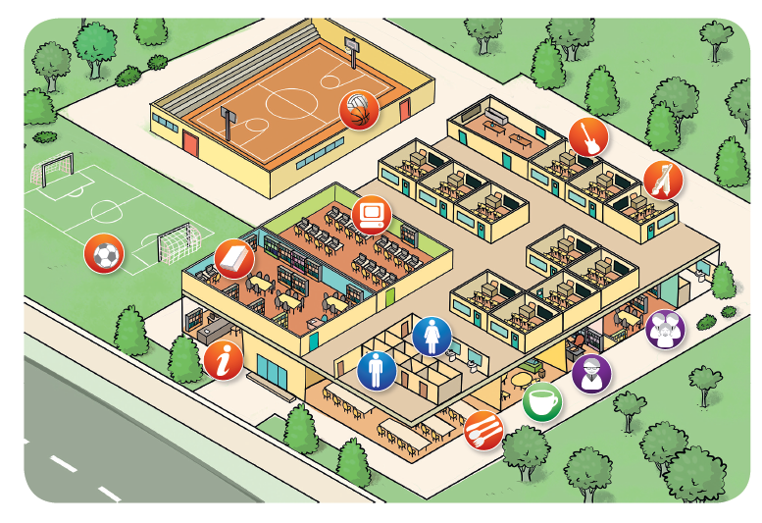

PART 2


PROCEDURES
Part 1
The teacher greets the learner and checks his/her name.
A. The teacher shows the learner a picture and
asks the learner to point to the rooms:
the library / the music room / the art room
the gym / the canteen.
B. The teacher asks questions about the picture:
Is this a big school?
Where do you practise sports?
Where do you learn music?
Where do you learn to paint and draw?
Where do you have lunch?
Part 2
The teacher shows the learner some smaller pictures
and asks:
(Points to the teacher.) Who’s she?
What lesson is it?
What are they doing?
What lesson is it?
What’s that on the board?
Part 3
The teacher asks the learner some personal
questions related to the topic:
What school subjects do you have?
What are your favourite school subjects?
Do you like your school? Why/Why not?
Are you a good student?
ANSWER KEY
Part 2

Part 1 – B
Yes, it is.
I (We) practise sports in the gym or in
the sports field.
I (We) learn music in the music room.
In the art room.
I have lunch in the canteen.

She’s a maths teacher.
It’s the PE (physical education) lesson.
They are drawing (painting) in the art lesson.
It’s the music lesson.
It’s a map in the geography lesson.

Part 3
Personal answers

