PROGRESS TEST 5

Name_________________________________________________ No. ______ Class_______
Date _____ / _____ / _____ Mark______________________ Teacher______________________

A
LISTENING

Keri is at a clothes shop and she is buying a new pair of jeans. Listen to the conversation between her and the shop assistant.

- Listen and choose the correct option.

1. Keri is shopping ______________________.
a) with her mum | b) with a friend | c) alone

2. The shop assistant shows her _______________________.
a) many colours | b) two colours | c) only blue jeans

3. Keri wants to buy ____________________ blue jeans.
a) basic | b) light | c) dark

4. She wants to try on a _______________________ size.
a) medium | b) large | c) small


5. Keri can only buy _______________________.
a) one pair | b) two pairs | c) three pairs

- Now, listen again and order the sentences (1-5).
a) Keri tries the jeans on.
- The shop assistant asks Keri what size she wants.
- Keri pays for the jeans.
- The shop assistant asks her how she will pay.
- Keri is surprised at all the colours the shop has.

PROGRESS TEST 5

Name_________________________________________________ No. ______ Class_______
Date _____ / _____ / _____ Mark______________________ Teacher______________________

Keri is at a clothes shop and she is buying a new pair of jeans. Listen to the conversation

B
LISTENING

Keri is at a clothes shop and she is buying a new pair of jeans. Listen to the conversation between her and the shop assistant.

- These sentences are false. Listen and correct them.

- Keri wants to buy a pair of trousers.
___________________________________________________________________
- She wants to buy red jeans.
___________________________________________________________________
- The shop assistant shows her five pairs.
___________________________________________________________________
- The changing rooms are on the left.
___________________________________________________________________
- Keri buys two pairs of jeans.
___________________________________________________________________
- She pays by credit card.
___________________________________________________________________

- Listen again and complete the sentences.
- Keri is looking for a pair ___________________________.
- Keri doesn’t want to buy _______________or grey jeans.
- She can only buy ________________________________.
d) The jeans cost _________________________________.

A
READING, GRAMMAR AND WRITING

PART 1
Read the text about John.
Hi there! My name is John and I live in a small town in England. I live in a big old house with lots of space. It has three floors, two balconies and an attic. I like it very much!

In my town there are different types of houses. There are detached houses, semi-detached houses and terraced houses. There aren’t any cottages, but there is an old mansion! It’s a small town, so there aren’t any blocks of flats, but there is a campsite. It has some bungalows, but in summer there are tents where people spend their holidays.
During the weekend and after school, there are a lot of fun things you can do. There is a library, a small shopping centre and, of course, a skate park. It’s a small town, but it’s nice to live in. The only strange thing is my neighbour’s house. The windows are always closed! I’m planning to buy him a present for his birthday. He sometimes looks very sad. I did the same last year and he looked really happy!

1. Complete the table with information from the text.

Types of houses you can’t find there ______________________________
______________________________
______________________________
______________________________
Types of houses you can find there
____________________________
____________________________
____________________________
____________________________

2. Cross out (✗) the wrong option.
a) John is / isn’t happy with his city.
b) He doesn’t have / has an attic.
c) In summer, people can stay in cottages / tents.
d) He didn’t give / gave a present to his neighbour last year.

3. Label the pictures.
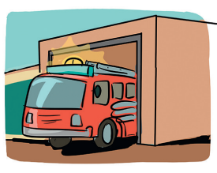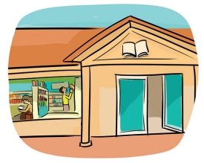

a) ___________________ b) ____________________ c) __________________

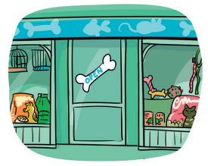
d) _____________________ e) _____________________ f) __________________

4. Complete the table with the words from the box.
carpet shelf tools microwave mirror
TV set tap car bed sofa cooker desk desk

Garage | Kitchen | Bedroom | Living room | Bathroom | Study

PART 2

- Complete the sentences with the reflexive pronouns from the box.
ourselves myself herself himself

a) She is always telling________________________ to buy a new flat.
b) We enjoyed_______________________________at the party.
c) He cut___________________________while making a sandwich.
d) I told______________________ that one day I’d go to a camping site.

2. Complete the sentences using the verbs from the box.
ate went saw didn’t spend spoke did… buy had

a) Maria and I_____________________ to the cinema last night.
b) I__________________ to her about the history test.
c) Yesterday John________________ a strawberry ice cream.
d) She__________________ much time looking for a house.
e) Last Friday Maria ________________ an accident.
f) Last summer I_____________ lots of paintings at the museum.
g) __________ you_____________ a flat in the city?

PART 3

• Write a text about your house. Use at least 5 words from the box below.
• bedroom • sofa • balcony • kitchen • detached house • flat • roof • stairs • cupboard • city

____________________________________________________________________________________________________________________________________________________________________________________________________________________________________________________________________________________________________________________________________________________________________________________________

B
READING, GRAMMAR AND WRITING

PART 1
Read the text about John.
Hi there! My name is John and I live in a small town in England. I live in a big old house with lots of space. It has three floors, two balconies and an attic. I like it very much!
In my town there are different types of houses. There are detached houses, semi-detached houses and terraced houses. There aren’t any cottages, but there is an old mansion! It’s a small town, so there aren’t any blocks of flats, but there is a campsite. It has some bungalows, but in summer there are tents where people spend their holidays.
During the weekend and after school, there are a lot of fun things you can do. There is a library, a small shopping centre and, of course, a skate park. It’s a small town, but it’s nice to live in. The only strange thing is my neighbour’s house. The windows are always closed! I’m planning to buy him a present for his birthday. He sometimes looks very sad. I did the same last year and he looked really happy!

1. Complete the sentences with information from the text.

- John lives _______________________________________.
- His house has ___________________________ balconies.
- John's town doesn't have ___________________________.
- There are a lot of fun things people can do at ____________________.
- His neighbour looks _______________.

2. Answer the following questions.
- Is John's house big? Say why/why not.
____________________________________________________________.
____________________________________________________________.
- Where can people spend their summer holiday?
____________________________________________________________.
____________________________________________________________.
- What is John’s neighbour like? ___________________________________________________________.
___________________________________________________________.
- Why is the neighbour’s house strange?
___________________________________________________________.
___________________________________________________________.

3. Complete the sentences with the words from the box.
bank clothes shop library gift shop

- John buys presents at the_________________________.
- When people want to read a book, they go to the__________________.
- He is going to buy a sweater at the __________________________.
- The _______________________ is where you keep your money.

4. Match the words below with the sentences (a-d).
living room bathroom study garage

- This is where my family and I watch TV. _________________________
- My dad has his tools here. ________________________________________
- I have a shower in this room. __________________________________
- Here I prepare myself for my tests and do my homework. ____________

PART 2

1. Complete in the gaps with the correct reflexive pronoun.
- I always tell ____________________: be a good boy today!
- Do you want a glass of water? Get it ______________________!
- They protected________________from the rain.
- She tells ___________________ that one day she will live by the sea.
- My computer turned off by ______________________.

2. Complete the sentences with the past simple.

- Last year my parents_____________(be) very happy with their new furniture. It _________________ (not/be) expensive.
- They _____________________ (not/spend) lots of money in the old flat when they _____________________ (get) married, in 2000.
- My father has a new job. ____________you____________ (know) about that?
- When I went to New York, I ________________ (see) lots of mansions there.
I ________________ (be) so surprised!
- All my friends _________________(go) camping last weekend and they __________________ (drive) go-kart near the campsite.

PART 3
• Write a text about your favourite room/place inside or outside your house. (about 40 words)

_______________________________________________________________________________________________________________________________________________________________________________________________________________________________________________________________________________________________________________________________________________________________________________________________________________________________________________________________________
____________________________________________________________________________________________________________________________________________________________________________________________________________________________________

C
READING, GRAMMAR AND WRITING

PART 1
Read this dialogue at the gift shop between Dylan and the shop assistant.
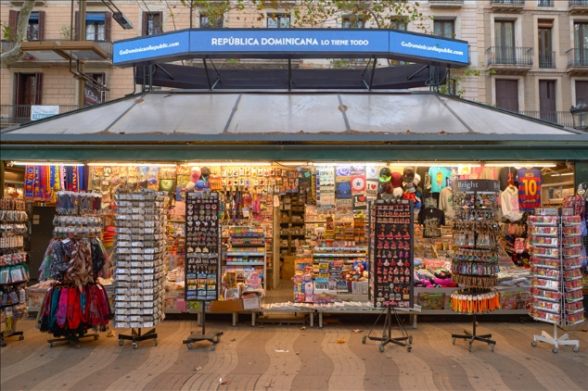
Shop assistant: Good morning! Can I help you?
Dylan: Yes, I’m looking for a present.
Shop assistant: Did you see our online page?
Dylan: Yes, I saw it on the library computer, but I need your help.
Shop assistant: Who is going to be surprised?
Dylan: It’s for my mother. I told myself: this year I want to surprise her!
Shop assistant: OK, let’s see how I can help you.
Dylan: I’m looking for something for our new flat. We live near the supermarket in those blocks of flats behind the library.
Shop assistant: We have these small vases here. Over there we also have bigger ones. They look really good on balconies.
Dylan: I love the small ones! How much are they?
Shop assistant: £4,50 each. They aren’t expensive.
Dylan: Nice! I will take two! Here’s £10.
Shop assistant: Here’s your change. Thank you. I hope your mother is happy with your present! Have a nice day.
Dylan: Thank you. Bye!

1. Mark the sentences true (T) or false (F).
a) Dylan is looking for a birthday present.
b) The present is for his mother.
c) He lives in a semi-detached house.
d) He didn’t like the vases.
e) The vases cost ten pounds.
2. Answer these questions about the text.
- Where did Dylan go to buy a present? __________________________________________
b) Did he see the shop’s catalogue? _____________________________________________
c) Where does he live? ________________________________________________________
d) What types of vases has the gift shop got? _______________________________________
e) Were the vases expensive? __________________________________________________
3. Find synonyms in the text for the following words.
- apartment ______________________
b) glad ______________________
4. Think about your town.
Where should you go to…?
a) read a book  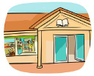 |   b) send a letter |   c) transfer money | 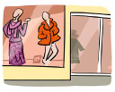  d) buy a shirt | e) see a film 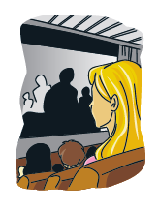
5. Look, read and match.
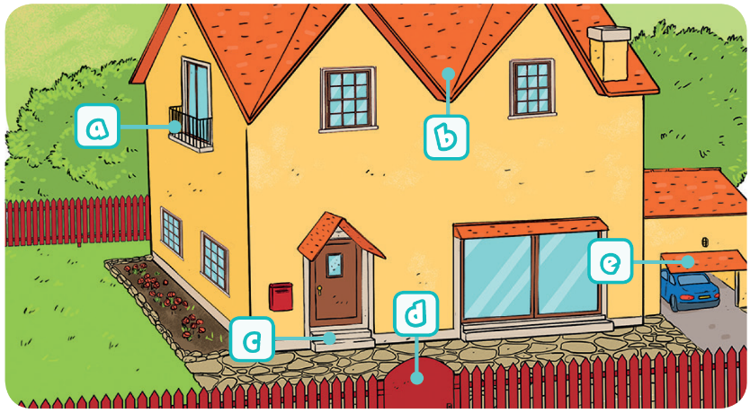
House Parts
1.  Roof
2. Garage
3. Balcony
4. Gate
5. Steps

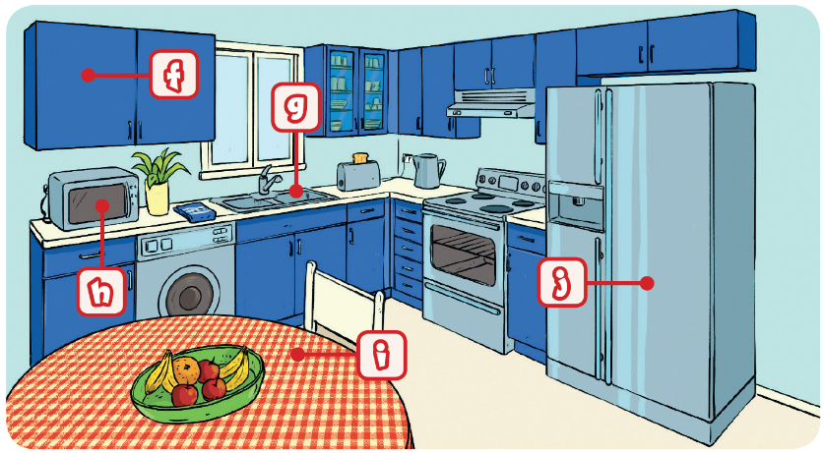
Kitchen equipment
6. Fridge
7. Table
8. Sink
9. Cupboard
10. Microwave

PART 2
1. Complete with the suitable reflexive pronoun.
- They always think for ______________________.
- We must tell ________________ to pay attention in class.
- To have more money, you must tell _______________to stop buying clothes.
- The dog can’t defend ____________________.

2. Complete the sentences with the past simple.
- The vales _________________ (not / be) very expensive.
- He _________________ (not / know) what he _____________ (buy) last Christmas.
- Last year all my family _______________ (get) together for the holidays! They __________ (look) very happy!
- Last weekend I ____________ (go) to Lisbon. _________you_________(see) my message?
- e) I ____________ (eat) an ice cream at the shopping centre yesterday.

PART 3
- Imagine you are at a clothes shop buying a birthday present. Write a dialogue similar to the text.

You Shop assistant
1. Greet the shop assistant. 2. Answer/greet and offer assistance.
3. Say what you want to buy. 4. Ask colour and size.
5. Say what you want: size and colour. 6. She/He brings it and gives it to you.
7. Say you like it and ask the price. 8. Say the price.
9. Give the money. 10. Give the change and say goodbye.
11. Say goodbye.

_______________________________________________________________________________________________________________________________________________________________________________________________________________________________________________________________________________________________________________

SCRIPT
LISTENING A and B

Shop assistant: Good morning. Can I help you?
Keri: Hello. Yes, please. I’m looking for a pair of jeans.
Shop assistant: Come with me, please. Here you can find all our jeans.
Keri: Wow! So many colours!
Shop assistant: What colour do you want?
Keri: Hmmm… Not black, not grey… Light blue.
Shop assistant: What size?
Keri: Small.
Shop assistant: We have these two pairs.
Keri: Great! Can I try them on?
Shop assistant: Of course. The changing rooms are on the right.
Later…
Shop assistant: Do they fit?
Keri: Yes, but I can only buy one pair. I’ll take these.
Shop assistant: Perfect. That’s £29.95, please.
Keri: Here you are.
Shop assistant: Here’s your change. Thanks! Have a lovely day.
Keri: You too! Bye!

ANSWERS
LISTENING A
LISTENING B

1.
1.
a) Keri wants to buy a pair of jeans.
b) She wants to buy blue jeans.
c) She wants a small size.
d) The shop assistant shows her two pairs.
e) The changing rooms are on the right.
f) Keri buys one pair of jeans.
2.
a) … of jeans
b) … black
c) … one pair
d) … £29.95

1. c
2. a
3. b
4. c
5. a
2.
a) 3
b) 2
c) 5
d) 4
e) 1
READING, GRAMMAR AND WRITING A

PARTE 1

Types of houses you can find there
Detached houses
Semi-detached houses
Terraced houses
Old mansion
Bungalows
Types of houses you can’t find there
Cottage
Blocks of flats
2. (Right options)
a) is b) has c) tents d) gave
3.
a) post office; b) fire station; c) library; d) pet shop; e) hospital; f) bank.
Garage | tools | car
Kitchen | microwave | cooker
Bedroom | bed | carpet
Living room | sofa | TV set
Bathroom | mirror | tap
Study | shelf | desk

PARTE 2

2.
a) went
b) spoke
c) ate
d) didn’t spend
e) had
f) saw
g) Did … buy

1.
a) herself
b) ourselves
c) himself
d) myself

PART 3
Personal answer.
READING, GRAMMAR AND WRITING B

PART 1
1.
a) in a small town in England
b) two
c) any cottages / blocks of flats
d) the weekend and after school
e) very sad
2.
a) Yes, it is. It has three floors, two balconies and an attic.
b) They can spend their summer holidays at the campsite.
c) He looks sad sometimes.
d) The neighbour’s house is strange because the windows are always closed.
3.
a) gift shop
b) library
c) clothes shop
d) bank
4.
a) living room
b) garage
c) bathroom
d) study

PART 2
1.
a) myself
b) yourself
c) themselves
d) herself
e) itself
2.
a) were; wasn’t
b) didn’t spend; got
c) Did … know
d) saw; was
e) went; drove
PART 3
Personal answer.

READING, GRAMMAR AND WRITING C

PART 1
2.
a) Dylan went to the gift shop.
b) No, he didn’t. He saw their online page.
c) He lives in a flat near the supermarket behind
the library.
d) The shop has got small and bigger vases.
e) No, they weren’t.

e

1.
a) F
b) T
c) F
d) F
e) F

3.
a) flat
b) happy
4.
a) Library
b) Post office
c) Bank
d) Clothes shop
e) Cinema
5.
1. b; 2. e; 3. a; 4. d; 5. c; 6. j; 7. i; 8. g; 9. f; 10. h

PART 2
1.
a) themselves
b) ourselves
c) yourself
d) itself
2.
a) weren’t
b) didn’t know; bought
c) got; looked
d) went; Did you see
e) ate

PART 3
You: Hello!
Shop assistant: Hello! Can I help you?
You: Yes, I want to buy a T-shirt.
Shop assistant: OK. What size and colour do you want?
You: Red and it’s a large size.
Shop assistant: Here you are.
You: I really like it. How much is it?
Shop assistant: It’s 15 pounds.
You: Here’s 20 pounds.
Shop assistant: Here’s your change. Have a nice day.
You: Thank you. Bye!

SPEAKING
PART 1
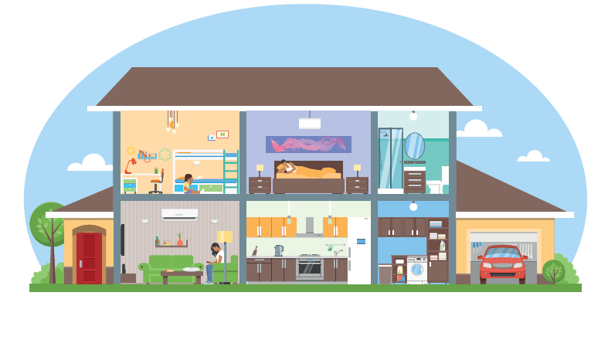
PART 2



PROCEDURES
ANSWER KEY
Part 1
Part 1 – B
There is a big sofa, an armchair, a lamp, a small table and a shelf.

Part 2
It’s the hospital.
It’s the post office.
It’s the bank.
It’s the cinema.
It’s the library.

Part 3
Personal answers.
The teacher greets the learner and checks his/her
name.
A. The teacher shows the learner a picture and
asks the learner to point to the items:
the garage / the kitchen / the bedroom /
the bathroom / the living room.
B. The teacher asks a question about the picture:
What five things can you see in the living room?

Part 2
The teacher shows the learner some smaller pictures
and asks:
What’s this public place?

Part 3
The teacher asks the learner some personal
questions related to the topic:
What type of house do you live in?
What public places are there near your house?
How many rooms are there in your house?
What’s your favourite room? Why?

