PROGRESS TEST 6

Name_________________________________________________ No. ______ Class_______
Date _____ / _____ / _____ Mark______________________ Teacher______________________

LISTENING
A

Monica is telling her friend Amy what she’s going to do and visit during her
summer holiday.

1. Listen to the dialogue and match the sentences.
1. Monica is going to a) go to Madrid.
2. Amy prefers Lisbon b) visit her grandparents.
3. Madrid is c) bigger than Lisbon.
4. Amy also wants to d) to Madrid.

2. Listen again and circle the correct option.
a) Monica is calling Amy to say hello / goodbye.
b) She is going to visit her parents / grandparents.
c) They will stay in Madrid for some days / two weeks.
d) She thinks it’s going to be boring / fantastic.
e) Amy can’t / can speak Spanish.
f) Monica wants to see a Fado / Flamenco show.


B
LISTENING

Monica is telling her friend Amy what she’s going to do and visit during her
summer holiday.

1. Who says what? Write Monica, Amy or both next to the sentences.
a) She is calling her friend to talk about her holidays. _____________________
b) She will miss her friend. _____________________
c) She forgot where her friend is going. _____________________
d) She thinks her holidays will be fantastic. _____________________
e) She doesn’t know Madrid. _____________________
f) She has to end the phone conversation. _____________________

2. Now, listen again and complete the chart.
Cities | Places | People | Languages

LISTENING
A
READING, GRAMMAR AND WRITING B
READING, GRAMMAR AND WRITING B
PART 1
Oliver is at the train station and he wants to buy a
ticket to visit his uncle Jeff and his aunt Celia.

Oliver: Good afternoon. Can I have a ticket
to Manchester, please?
Clerk: Hello! Are you travelling alone?
Oliver: Yes, only one ticket, please.
Clerk: When do you want to travel?
Oliver: I’m leaving tomorrow.
Clerk: What time do you want to leave?
Oliver: In the morning, before ten o’clock.
Clerk: Well… you can take the half past
nine train. You’ll arrive in Manchester
two hours and a half later.
Oliver: OK, it seems fine to me. I want to buy a ticket.
Clerk: Sure. Do you want a single ticket or a return ticket?
Oliver: Single, please.
Clerk: It’s £23, please.
Oliver: Here you are. Which platform is it?
Clerk: Platform 9. Enjoy your trip.
Oliver: Thanks a lot.
Clerk: You’re welcome! Goodbye.
Oliver: Goodbye.

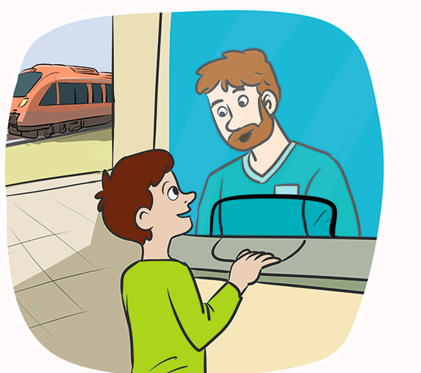

- Fill in the table with information from the dialogue.
Means of transport | Day | Time | Price | Duration of the trip | Platform

2. Mark true (T) or false (F).

a) Oliver is leaving today.
b) He is going to Manchester alone.
c) He wants to leave in the afternoon.
d) The train arrives in Manchester at midday.
e) Oliver buys a return ticket.

3. Find the words and match them with the pictures.

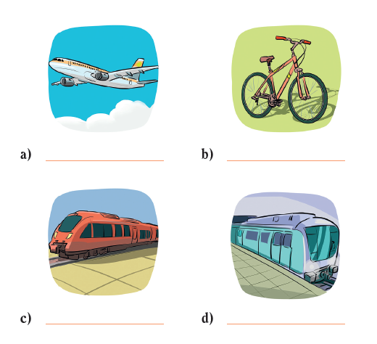

NPELA
ANTRI
UDRDERONUNG
CLYICEB

- _______________ b) _______________

- _______________ d) _______________

PART 2
1. Put the words in order to make sentences.
a) going / you / travel / are / alone / to /
___________________________________________________________________
b) you / to / who / visit / going / are /?
___________________________________________________________________
c) not / spend / money / am / to / going / I / a lot of /.
___________________________________________________________________


2. Complete the sentences with the comparative of
superiority or equality of the adjectives in brackets.
a) My city is_______________ (big) than yours.
b) A train isn’t _______________ (small) than a car.
c) Alex is_______________ (tall) as Camilla.
d) She is _______________ (pretty) than me.
e) A plane ticket is _______________ (expensive) than a train ticket.

3. Cross out (✗) the wrong option.
a) Brad is the most short / shortest boy in my class.
b) I am the youngest / most young student in year 6.
c) My grandpa is the most old / oldest person in my family.
d) Einstein was the most intelligent / intelligentest man of his time.

4. Look at the pictures and choose the correct preposition of movement from the box.
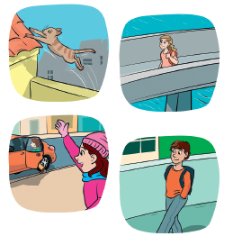
to across into onto

a) The cat jumped_____________ the roof.
b) Yesterday I walked_____________ the bridge.
c) I called her, but she was already
getting_____________ the car.
d) I go_____________ school on foot every day.

PART 3
Help Oliver write
• When / What time he is going
• People he is going to visit
• Places he is going to visit: Museum of Science and Industry;
John Ryland’s library; National Football Museum.
• Restaurant: fish and chips
a message to his
friend Ned about
his holiday plans
in Manchester.
Write about:

READING, GRAMMAR AND WRITING B
B

Part 1
Oliver is at the train station and he wants to buy a
ticket to visit his uncle Jeff and his aunt Celia.

Oliver: Good afternoon. Can I have a ticket
to Manchester, please?
Clerk: Hello! Are you travelling alone?
Oliver: Yes, only one ticket, please.
Clerk: When do you want to travel?
Oliver: I’m leaving tomorrow.
Clerk: What time do you want to leave?
Oliver: In the morning, before ten o’clock.
Clerk: Well… you can take the half past
nine train. You’ll arrive in Manchester
two hours and a half later.
Oliver: OK, it seems fine to me. I want to buy a ticket.
Clerk: Sure. Do you want a single ticket or a return ticket?
Oliver: Single, please.
Clerk: It’s £23, please.
Oliver: Here you are. Which platform is it?
Clerk: Platform 9. Enjoy your trip.
Oliver: Thanks a lot.
Clerk: You’re welcome! Goodbye.
Oliver: Goodbye.

1. Ask the questions.
a) ___________________________________________________________________?
Oliver is going to buy a ticket.
b) ___________________________________________________________________?
He is going to Manchester.
c) ___________________________________________________________________?
He is going to travel by train.

2. Complete the sentences about the text.
a) Oliver is leaving for Manchester________________________________________.
b) He wants to buy ____________________________________________________.
c) He wants to leave___________________________________________________.
d) The train takes _______________hours_______________ to arrive in Manchester.
e) Oliver pays ______________________________________________for the ticket.

3. Write the names of the means of transport.
a) It has two wheels. We use our feet to move it.
_______________________________
b) It is a large machine that runs along a railway line.
_______________________________
c) It is a machine that can fly in the sky.
________________________________
d) It is a car with a driver. You pay the driver to take you where you want to go
________________________________

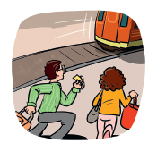
PART 2
1. Fill in the gaps with the correct form of be going to
and the verbs in brackets.
a) I__________________ (travel) to Portugal next month.
b) He __________________ (buy) me a souvenir.
c) they __________________ (write) me a postcard?
d) They__________________ (not/catch) the train.
e) You left your phone at home. You__________________ (not/take) any photos.

2. Form sentences using the comparative of equality or superiority with the words given.
a) My mother / young / than / your mother
_____________________________________________________________________
b) I / as / short / as / you
_____________________________________________________________________
c) Cars / dangerous / planes
_____________________________________________________________________
d) He / look / happy / than / you
_____________________________________________________________________

3. Fill in the gaps with the superlative of the adjectives in brackets.
a) A holiday near the beach is the ________________ (good) thing for me right now.
b) Robbie is the________________ (handsome) boy in class.
c) I am going to the Maldives. I am the ________________ (happy) girl in the world!
d) London is the ________________ (beautiful) city I know.

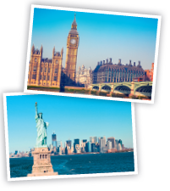
4. Complete the sentences with prepositions of movement.
a) Julie is jumping ________________the water.
b) The map fell ________________the floor.
c) My mum walked ________________my bedroom.
d) I go________________ New York once a year.

PART 3
Write an email to a friend describing your holiday plans.
Don’t forget to mention: means of transport, people, places, weather, hotel, etc.

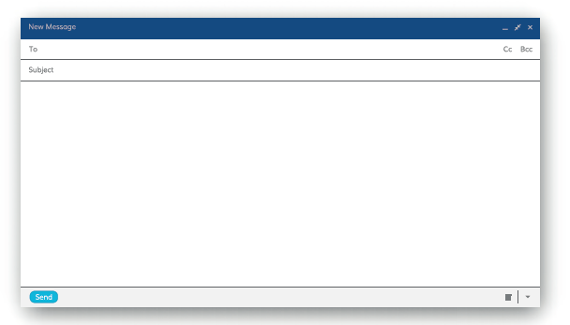

READING, GRAMMAR AND WRITING B
C

PART 1
Lizzie

Max
Max

This summer holiday I’m going to
the beach with my parents. We’re
going to travel by car every day
because we don’t live far away.

I’m going to play beach volleyball
and I’m going to swim a lot. I want
to be a professional swimmer. My
parents are going to buy me
a surfboard and I’m going to
have surf lessons before the
summer starts. It seems
really fun!

I also want to eat a lot of ice
cream and lie in the sun
while I wait for the time to
go into the sea. This summer
holiday is going to be great!

This summer I’m going to a
summer camp. I can’t wait to sleep
in a tent! It’s going to be fantastic.
I’m going with my younger brother,
Kyle. I’m twelve and he’s eleven. It’s
a group of twenty kids and three
monitors and we’re going to travel
by train. At night I’m going to
tell spooky* stories about the
forest. Everyone will be scared.

There is a river nearby and I’m
going to swim there because
I’m a great swimmer. I’m
going to teach my brother
Kyle how to swim. He’s going
to love this holiday.

*spooky – assustadoras




1. These sentences are false. Find evidence in the text.
a) Max doesn’t want to sleep in a tent.
“__________________________________________________________________ ”
b) Kyle is older than Max.
“ __________________________________________________________________”
c) Kyle can swim.
“ __________________________________________________________________”
d) Lizzie doesn’t like sports.
“__________________________________________________________________ ”
e) She doesn’t like ice cream.
“__________________________________________________________________ ”

2. Answer the questions.
a) What is Max doing this summer?
_________________________________________________________________
b) Who is he going with?
_________________________________________________________________
c) What is he going to do at night?
_________________________________________________________________
d) Why are Lizzie and her parents going to travel by car?
_________________________________________________________________
e) What are her parents going to buy her?
_________________________________________________________________
f) What does she think about this summer holiday?
_________________________________________________________________

3. Label the means of transport.


- ____________ b) ____________ c) ____________ d) ____________

PART 2

1. Answer the questions by using be going to and the verbs in brackets.
a) Are you going to swim?
No, _____________________. I _________________________ (sleep).
b) Are your parents going to travel by plane?
No, __________________. They __________________ (drive) their car.
c) Is your sister going to a summer camp?
No, ________________. She______________________ (stay) at home.

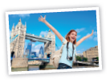
2. Fill in the gaps with the comparative of the adjectives in brackets.
a) London is_____________________ (big) than Porto.
b) Everest is _____________________ (high) than Serra da Estrela.
c) This sweater was _____________________ (expensive) as the other one.
d) Driving carefully is_____________________ (important) than driving fast.
e) A car is_____________________ (heavy) than a bicycle.

3. Complete the sentences with the superlative of the adjectives in brackets.
a) Mr Gladstone is the _____________________ (rich) man in town.
b) My parents bought the_____________________ (big) cake in the shop.
c) January is the _____________________ (cold) month of the year in my country.
d) The motorbike is the _____________________ (dangerous) means of transport.

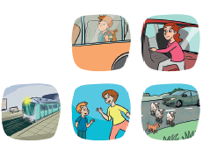
4. Circle the correct preposition of movement for each picture.
a) I always go to / across school by bus.
b) Margaret is getting onto / into the car.
c) The underground is coming through / across the tunnel.
d) My mum is walking across / towards me.
e) The animals are going across / into the road.
We have to stop and wait.

PART 3
Imagine you are on holiday with your parents. Write a postcard to a friend telling
him/her what you are going to do, visit, etc.
____________________________________________________________________
____________________________________________________________________
____________________________________________________________________
____________________________________________________________________
____________________________________________________________________
____________________________________________________________________
____________________________________________________________________
____________________________________________________________________

SCRIPTS

LISTENING - A and B

Phone conversation
This summer Monica is going to visit her grandparents.
She’s telling her friend Amy what she’s going to do on her visit.

Monica: Hi, Amy! I am calling you to say goodbye before I go on holiday!
Amy: Hey! I’ll miss you.
Monica: I’ll miss you too, but time flies!
Amy: Where are you going this year? I know you told me, but I forgot.
Monica: I am going to visit my grandparents in Lisbon, as usual. This year they want
to go to Madrid for some days too. It’s going to be fantastic!
Amy: Great! I don’t know Madrid, but I think I prefer Lisbon. It’s smaller than
Madrid and I can’t speak Spanish!
Monica: I don’t know Madrid either, but I already have plans! I am going to visit a lot of museums, I am going to eat paella and I also want to see a Flamenco show.
Amy: Wow! Can I go too? Hahaha!
Monica: Maybe someday we can travel to Spain together. I have to go now.
My dad is calling me.
Amy: Have lots of fun! Bye!
Monica: Bye! Talk to you soon.
ANSWERS
LISTENING - A
LISTENING - B

1.
1.
1. b)
2. d)
3. c)
4. a)
2.
a) goodbye
b) grandparents
c) some days
d) fantastic
e) can’t
f) Flamenco
a) Monica
b) both
c) Amy
d) Monica
e) both
f) Monica
2.
Cities: Lisbon, Madrid
Places: Museums
People: Monica, Amy, grandparents, dad
Languages: Spanish

READING, GRAMMAR AND WRITING - A

PART 1 PART 2

- 1.
Means of transport: train
Day: tomorrow
Time: half past nine
Price: £23
Duration: two hours and a half
Platform: nine
2.
a) F; b) T; c) F; d) T; e) F
3.
a) plane; b) bicycle; c) train;
d) underground

a) You are going to travel
alone. b) Who are you going to
visit? c) I am not going to
spend a lot of money.
2.
a) bigger; b) smaller; c) as tall;
d) prettier; e) more expensive
3. (Right answers)
a) shortest; b) youngest;
c) oldest; d) most intelligent
4.
a) onto; b) across; c) into; d) to

PART 3
Possible answer
Hi, Ned!
How are you?
Tomorrow I’m going on holiday to Manchester. The train arrives in Manchester at twelve
o’clock. I’m going to meet my uncle and aunt there.
I’m going to visit two museums: the Museum of Science and Industry and the National
Football Museum. It’s going to be really cool. I also want to visit John Ryland’s library.
My aunt told me we’re going to a fish and chips restaurant. It’s the best in Manchester.
I have to go now.
Bye

READING, GRAMMAR AND WRITING - B

PART 1 PART 2

1.
a) What is Oliver going to buy?
b) Where is he going to?
c) How is he going to travel?
2.
a) tomorrow
b) a train ticket
c) before ten o’clock
d) two … and a half
e) 23 pounds
3.
a) bicycle
b) train
c) plane / helicopter
d) taxi

1.
a) am going to travel
b) is going to buy
c) Are they going to write
d) are not going to catch
e) are not going to take
2.
a) My mother is younger than
your mother.
b) I am as short as you.
c) Cars are more dangerous
than planes.
d) He looks happier than you.
3.
a) best
b) most handsome
c) happiest
d) most beautiful

PART 3
Personal answer
4.
a) into
b) onto
c) into
d) to

READING, GRAMMAR AND WRITING - C

PART 1

1.
a) “I can’t wait to sleep in a tent! It’s going to be fantastic.”
b) “I’m going with my younger brother Kyle.”
c) “I’m going to teach my brother Kyle how to swim.”
d) “I’m going to play beach volleyball and I’m going to swim a lot.”
e) “I also want to eat a lot of ice cream.”
2.
a) This summer Max is going camping.
b) He is going with his younger brother Kyle, other kids and three monitors.
c) At night he is going to tell spooky stories about the forest.
d) They are going to travel by car because they live near the beach.
e) They are going to buy her a surfboard.
f) She thinks this summer holiday is going to be great.

3.
a) motorcycle; b) boat; c) ferryboat; d) plane

PART 2
1.
a) … I’m not. I am going to sleep.
b) … they aren’t. They are going
to drive their car. c) … she isn’t.
She is going to stay at home.
2.
a) bigger; b) higher; c) as
expensive; d) more important; e) heaver

3.
a) richest; b) biggest; c) coldest;
d) most dangerous
4.
a) to; b) into; c) through;
d) towards; e) across

PART 3
Personal answer.

SPEAKING
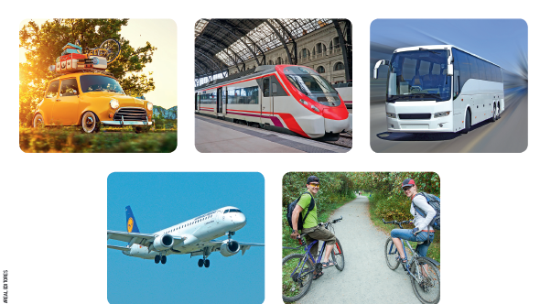
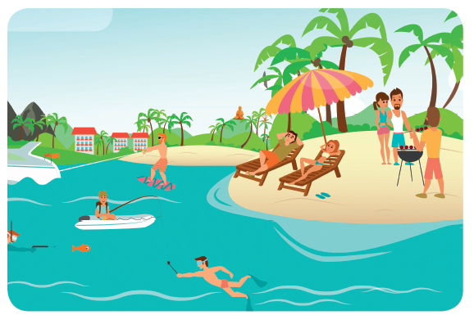
PART 1

PART 2

PROCEDURES
Part 1
The teacher greets the learner and checks his/her name.
A. The teacher shows the learner a picture and
asks the learner to point to the items:
the sea / the sand / a palm tree / someone
sunbathing / someone making a barbecue.
B. The teacher asks questions about the picture:
Is it a summer or a winter holiday?
What is the weather like?
What are the three people in the sea doing?
Part 2
The teacher shows the learner some smaller pictures and asks:
What type of transport is it?
Describe it with an adjective.
Part 3
The teacher asks the learner some personal questions related to the topic:
What is your favourite holiday season?
Where do you usually go? Who with?
What do you pack in your bag?
What are your plans for the next holiday?
ANSWER KEY

Part 1 – B

It’s a summer holiday.
It’s sunny and hot.
A boy is fishing, another boy
is swimming and
another boy is surfing.

Part 2

It’s a car. It’s easy.
It’s a train. It’s comfortable.
It’s a coach. It’s cheap.
It’s a plane. It’s fast.
It’s a bicycle. It’s slow.
Part 3
Personal answers.

