WORKSHEET 22 | ADJECTIVE + PREPOSITION
Name |  | No. | Class
Date | Mark | Teacher


- Read and match.
Mary is very good | 1 | • | • | a | for school.
I’m not interested | 2 | • | • | b | for its monuments.
We are never late | 3 | • | • | c | at maths.
Lucas is afraid | 4 | • | • | d | to your classmates.
Paul is very bad | 5 | • | • | e | of reading aloud.
Please, be kind | 6 | • | • | f | at music. He can’t sing.
London is famous | 7 | • | • | g | in arts and crafts.


- Fill in the gaps with the correct prepositions.

- I am interested ________ history.
- Are you good ________ geography?
- She’s excellent ________ Portuguese.
- Marta and Sophie are brilliant ________ art.
- My classmates are always kind ________ me.
- My school is famous ________ sports competitions.
- We don’t want to be late ________ school. Hurry up!
- I’m not afraid ________ swimming in the pool.

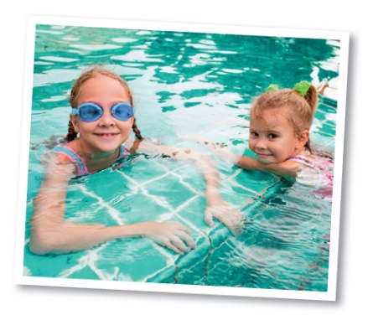
- Complete the dialogue with the right prepositions.
A: What sports are you interested (1) __________________?
B: Well… I’m not bad (2) __________________ basketball, but I prefer water sports. I’m very good (3) __________________ swimming. I’m also interested (4) __________________ surfing, but I’m still afraid (5) __________________ big waves.

ANSWERS

- Read and match.
Mary is very good | 1 | • | • | a | for school.
I’m not interested | 2 | • | • | b | for its monuments.
We are never late | 3 | • | • | c | at maths.
Lucas is afraid | 4 | • | • | d | to your classmates.
Paul is very bad | 5 | • | • | e | of reading aloud.
Please, be kind | 6 | • | • | f | at music. He can’t sing.
London is famous | 7 | • | • | g | in arts and crafts.

- Fill in the gaps with the correct prepositions.

- I am interested in history.
- Are you good at geography?
- She’s excellent at Portuguese.
- Marta and Sophie are brilliant at art.
- My classmates are always kind to me.
- My school is famous for sports competitions.
- We don’t want to be late for school. Hurry up!
- I’m not afraid of swimming in the pool.

- Complete the dialogue with the right prepositions.
A: What sports are you interested (1) in?
B: Well… I’m not bad (2) at basketball, but I prefer water sports. I’m very good (3) at swimming. I’m also interested (4) in surfing, but I’m still afraid (5) of big waves.

