WORKSHEET 11 | Adverbs of frequency
Name |  | No. | Class

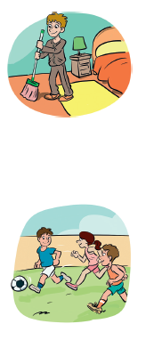
1. Put these adverbs of frequency in the right place.
1. He does the housework with his mother. (often)
___________________________________________________

2. The children are late for school. (rarely)
___________________________________________________

3. Do you eat soup at dinner? (usually)
___________________________________________________

4. We go to the beach in winter. (never)
___________________________________________________

5. My dog waits for me at the door. (always)
___________________________________________________

6. Jim plays football with his friends. (sometimes)
___________________________________________________

2. Answer the quiz and write the sentences.
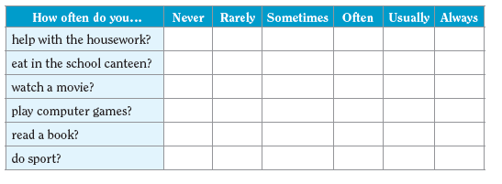

_________________________________________________________________

_________________________________________________________________

_________________________________________________________________

_________________________________________________________________

_________________________________________________________________

ANSWERS
1. Put these adverbs of frequency in the right place.
1. He does the housework with his mother. (often)
He often does the housework with his mother.
2. The children are late for school. (rarely)
The children are rarely late for school.
3. Do you eat soup at dinner? (usually)
Do you usually eat soup at dinner?
4. We go to the beach in winter. (never)
We never go to the beach in winter.
5. My dog waits for me at the door. (always)
My dog always waits for me at the door.
6. Jim plays football with his friends. (sometimes)
Jim sometimes plays football with his friends.

2. Answer the quiz and write the sentences.

Personal answers__________________________________________________

________________________________________________________________

_________________________________________________________________

_________________________________________________________________

_________________________________________________________________

_________________________________________________________________

