WORKSHEET 14 | When and while
Name |  | No. | Class
1. Complete the sentences with when or while.
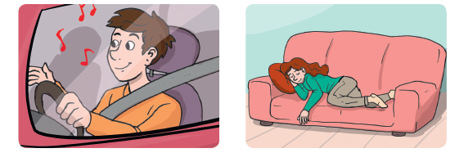

1. He always listens to music_________
he’s driving.
2.________ she sits on the sofa, she
usually falls asleep.
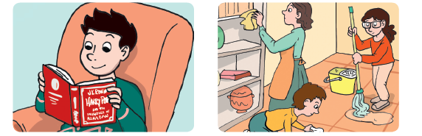

3. _________he reads a book, he
forgets everything.
4. _________the mother is cleaning,
the kids are washing the floor.



5. He likes reading the newspaper
_________he’s waiting for the bus.
6. I like staying at home_________ it’s
cold.
Answers
1. Complete the sentences with when or while.

1. He always listens to music while
he’s driving.
2. When she sits on the sofa, she
usually falls asleep.

3. When he reads a book, he
forgets everything.
4. While the mother is cleaning,
the kids are washing the floor.

5. He likes reading the newspaper
while he’s waiting for the bus.
6. I like staying at home when it’s
cold.

