WORKSHEET 17 | School rooms/Reading
Name |  | No. | Class

1. What’s the room?
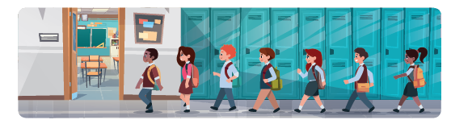

1. There are a lot of books in the l_______________.
2. The PE lessons are in the g_______________.
3. The students have lunch in the c_______________.
4. The teachers meet at the s_______________.
5. You can do experiments in the l_______________.
6. During breaks you can play in the p_______________.

2. Read the text and answer the questions.

Hello! My name is David. I am in year 8. I like
my school very much. It is big and modern.
There are a lot of rooms, but my favourite is the
art room. I love painting and drawing. I also like
the library because I enjoy reading and I can
borrow many books. In the future, I want to go
to university and be an architect.

1. What year is David in? ___________________________________________.
2. Does he like his school? _________________________________________.
3. What’s his favourite room? Why? __________________________________
______________________________________________________________.
4. What are his plans for the future? __________________________________
_______________________________________________________________.

Answers
1. What’s the room?

1. There are a lot of books in the library.
2. The PE lessons are in the gym(nasium)
3. The students have lunch in the canteen.
4. The teachers meet at the staffroom.
5. You can do experiments in the lab(oratory)
6. During breaks you can play in the playground.

2. Read the text and answer the questions.
Hello! My name is David. I am in year 8. I like
my school very much. It is big and modern.
There are a lot of rooms, but my favourite is the
art room. I love painting and drawing. I also like
the library because I enjoy reading and I can
borrow many books. In the future, I want to go
to university and be an architect.

1. What year is David in? He is in year 8.
2. Does he like his school? Yes, he does. / Yes, he likes his school very much.

3. What’s his favourite room? Why? His favourite room is the art room because he
loves painting and drawing.
4. What are his plans for the future? In the future, he wants to go to university and
be an architect.

