WORKSHEET 18 | Adverbs of manner
Name |  | No. | Class

1. Find six adverbs in the grid.
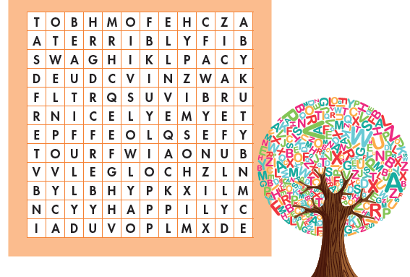

2. Complete the sentences with the adverbs in exercise 1.
1. You should drive__________________.
2. She sings__________________ What a voice!
3. Speak__________________ to your classmates.
4. Work with the scissors__________________.
5. My team is losing the game. They are playing __________________.
6. They are smiling__________________.
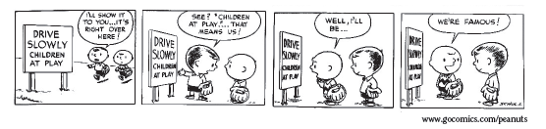

ANSWERS

1. Find six adverbs in the grid.
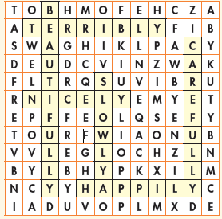

2. Complete the sentences with the adverbs in exercise 1.
1. You should drive slowly.
2. She sings beautifully What a voice!
3. Speak nicely to your classmates.
4. Work with the scissors carefully.
5. My team is losing the game. They are playing terribly.
6. They are smiling happily.

