WORKSHEET 19 | Possessive pronouns/Whose
Name |  | No. | Class


1. Underline the possessive pronouns in the sentences.
1. Where is my schoolbag? This one isn’t mine.
2. I didn’t have my book, so Vera lent me hers.
3. Your English is much better than his.
4. I found this pen. Is it yours?
5. We have a computer, but this isn’t ours.
6. This isn’t the students’ room. Theirs is next to the library.
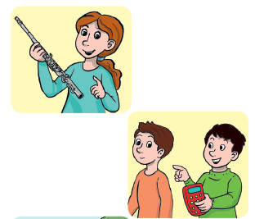
2. Ask and answer about possession. Follow the example.
1. ____Whose________ flute ______is this______?
It’s mine_______________________________.

2. _________calculator____________________.?
______________________________________.

3. ______________ pencils ___________________?



_______________________________________.

4. ______________. coat_____________________?
________________________________________.

5. _______________.dog ____________________?
_______________________________________.

ANSWERS
1. Underline the possessive pronouns in the sentences.
1. Where is my schoolbag? This one isn’t mine.
2. I didn’t have my book, so Vera lent me hers.
3. Your English is much better than his.
4. I found this pen. Is it yours?
5. We have a computer, but this isn’t ours.
6. This isn’t the students’ room. Theirs is next to the library.

2. Ask and answer about possession. Follow the example.
1. ____Whose________ flute ______is this______?
It’s mine_______________________________.

2. Whose calculator is this?
It’s his.

3. Whose pencils are these?
They’re theirs.

4. Whose coat is this?
It’s hers.

5. Whose dog is this?
It’s mine.

