WORKSHEET 22 | Sports Club/Should or shouldn’t
Name |  | No. | Class

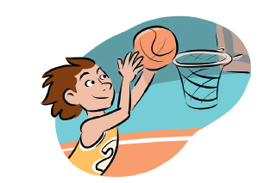
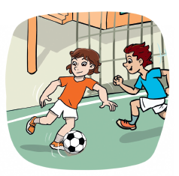
1. Complete the names of the sports.


B__ __ __ __ __ __ __ __ __

F__ __ __ __ __ __ __
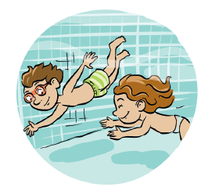
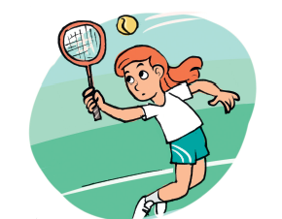

T__ __ __ __ __
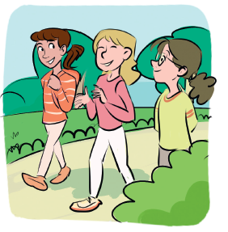
S__ __ __ __ __ __ __ 2. Should or shouldn’t? Follow the examples.
1. A: I like football.
B: You ___should___ join the Sports Club.
2. A: It’s raining.
B: You ____shouldn’t____ play outside.
3. A: I prefer team sports.
B: You_____________ choose tennis.
4. A: It’s very hot.
B: You_____________ drink water.
5. A: I’m late for the match.
B: You_____________ take a taxi.
Answers
1. Complete the names of the sports.

B A S K E T B A L L

F O O T B A L L

T E N N I S
S W I M M I N G
2. Should or shouldn’t? Follow the examples.
1. A: I like football.
B: You ___should___ join the Sports Club.
2. A: It’s raining.
B: You ____shouldn’t____ play outside.
3. A: I prefer team sports.
B: You shouldn’t choose tennis.
4. A: It’s very hot.
B: You should drink water.
5. A: I’m late for the match.
B: You should take a taxi.

