WORKSHEET 24 | Past simple (regular verbs)
Name |  | No. | Class

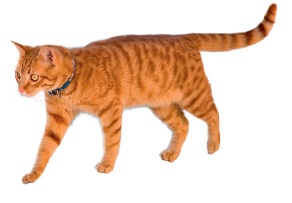
1. Present or past?
1. My school starts at 8.30. ________________________
2. The cat walked around very slowly. ________________
3. He plays the piano very well. ______________________
4. They watched the film again. ______________________
5. My sister and I love pizza. ________________________
6. Mr Smith works as a teacher. ______________________
7. We arrived at school on time. ______________________
8. The students loved the school party. _________________

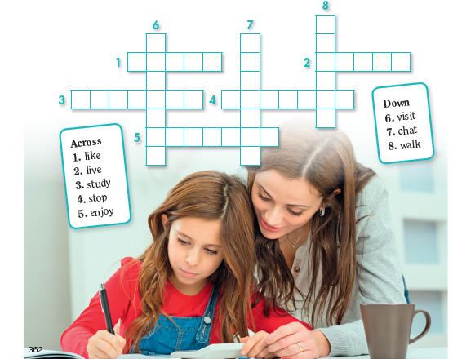
2. Complete the puzzle with the past simple of the verbs below.

Answers
1. Present or past?
1. My school starts at 8.30. Present.
2. The cat walked around very slowly. Past.
3. He plays the piano very well. Present.
4. They watched the film again. Past.
5. My sister and I love pizza. Present.
6. Mr Smith works as a teacher. Present.
7. We arrived at school on time. Past.
8. The students loved the school party. Past.

2. Complete the puzzle with the past simple of the verbs below.

Across: 1. liked; 2. lived; 3. studied; 4. stopped; 5. enjoyed
Down: 6. visited; 7. chatted; 8. walked

