WORKSHEET 26 | Types of homes
Name |  | No. | Class

1. Label the pictures.
bungalow block of flats castle detached house

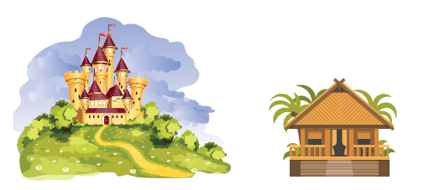

- ________________________ 2. _________________________

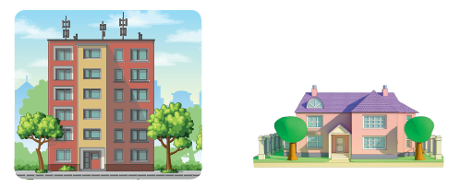

- _________________________ 4. _________________________

2. Circle parts of the house.
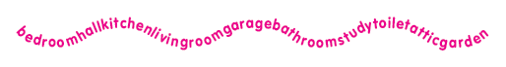

ANSWERS
1. Label the pictures.
bungalow block of flats castle detached house

- castle 2. bungalow

3. block of flats 4. detached house

2. Circle parts of the house.

bedroom / hall / kitchen / living room / garage / bathroom / study / toilet / attic / garden

