WORKSHEET 27 | Past simple (irregular verbs)
Name |  | No. | Class

1. Find the past simple of the verbs.
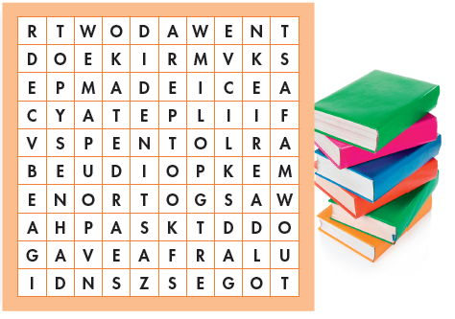
do
get
eat
give
go
have
make
see
spend
read
take

2. Use the past simple of some of the verbs above to complete the sentences.
1. They_____________ hamburgers and chips yesterday.
2. I_______________ an interesting book.
3. All the students______________ their homework.
4. Last Sunday, we____________ to the cinema.
5. They_____________ the dog for a walk.
6. The family________ __ their holidays at the seaside.

7. They__________ a lot of fun together.

ANSWERS

1. Find the past simple of the verbs.
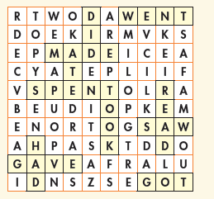
do
get
eat
give
go
have
make
see
spend
read
take



2. Use the past simple of some of the verbs above to complete the sentences.
1. They ate hamburgers and chips yesterday.
2. I read an interesting book.
3. All the students did their homework.
4. Last Sunday, we went to the cinema.
5. They took the dog for a walk.
6. The family spent their holidays at the seaside.
7. They had a lot of fun together.

