WORKSHEET 29 | Reflexive pronouns
Name |  | No. | Class

1. Link to form reflexive pronouns. Write them in the box.
self

selves
________________________________________________________________________________________________________________________________________________________________________

my
your
him
her
it
our
your
them

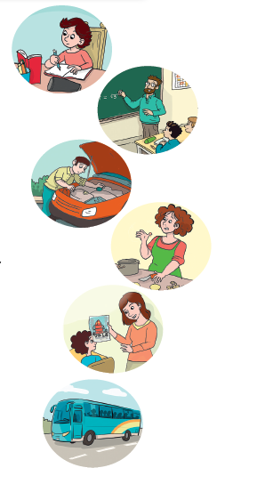
2. Complete the sentences with a reflexive pronoun.
1. I did the homework by _____________________.
2. The students behaved_____________________ in class.
3. My father repaired the car by_____________________.
4. She cut_____________________ while cooking.
5. Sam, did you do this drawing by_____________________?
6. We enjoyed_____________________ on the school trip.

Answers
1. Link to form reflexive pronouns. Write them in the box.
self

selves
myself
yourself
himself
herself
itself
ourselves
yourselves
themselves

my
your
him
her
it
our
your
them

2. Complete the sentences with a reflexive pronoun.
1. I did the homework by myself.
2. The students behaved themselves in class.
3. My father repaired the car by himself.
4. She cut herself while cooking.
5. Sam, did you do this drawing by yourself?
6. We enjoyed ourselves on the school trip.

